Labor Under Socialism: Debunking Capitalist Lies
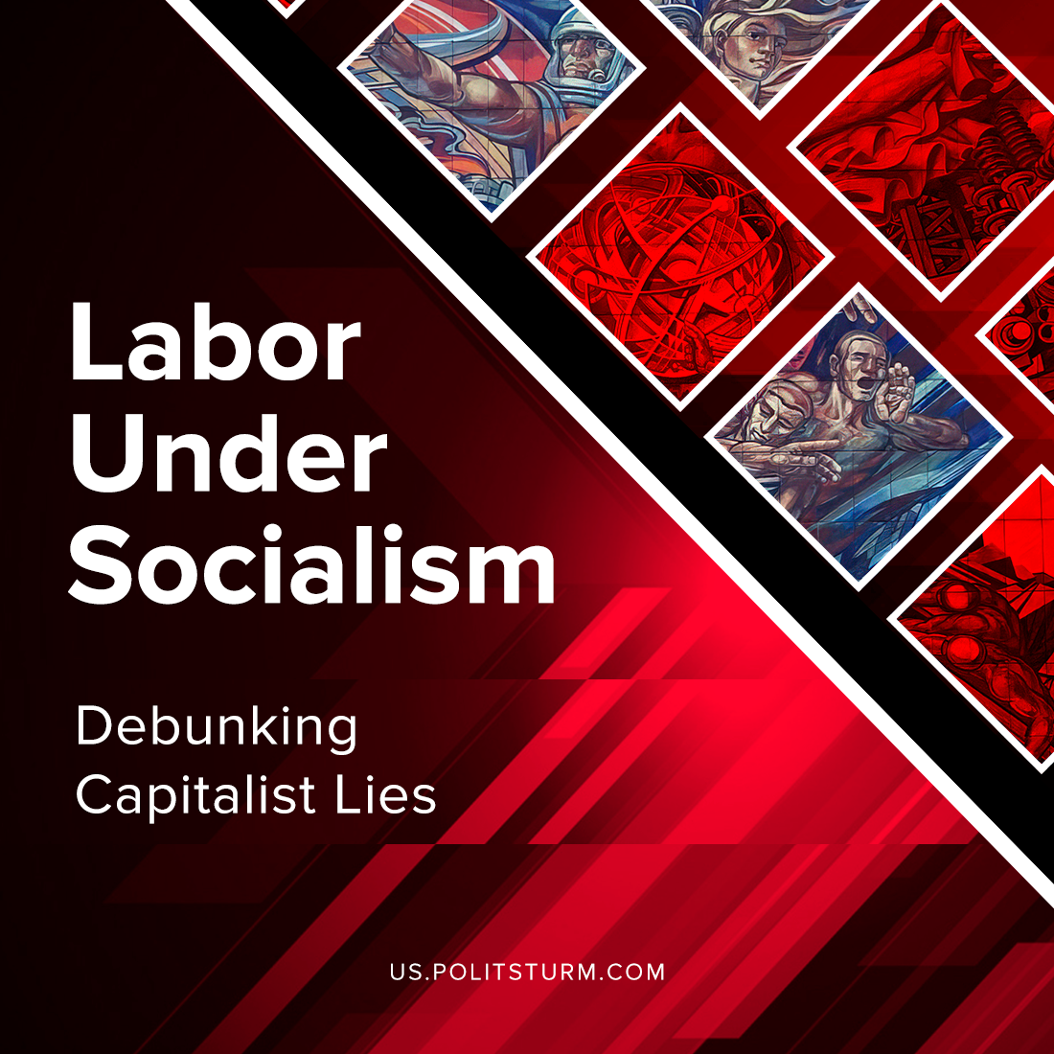

Original article
2021-10-04
5 min read

We bet you’ve heard right-wing talking heads parroting Thatcher’s line: “The trouble with Socialism is that eventually, you run out of other people’s money”. Capitalist propaganda claims that most people are just lazy and the only thing that can motivate them to work and improve their skills is the market system. They accuse socialism of being unprofitable, encouraging people to be “lazy”. But is it really so?
Under any system, people consume different material goods produced by the society in order to survive. Under capitalism, these products are bought with money. Therefore, for workers, the motivation to work is based on their dire needs. We work because otherwise we would be poor. The results of labour do not belong to the worker, but to the employer. The wage reimburses only the cost of existence, so that the worker continues to work. The capitalist imposes strict discipline in the enterprise, hires foremen overseers and lies to the worker so that the latter will continue to work even under these bad conditions.
The self-employed work for themselves. Their motivation is also based on need, and those who are doing better hope to become rich one day. Less dependence on the oligarchs and a slightly better situation than being a hired worker is reassuring, but 80% of them go bankrupt without working for many years.
Error loading image
For the capitalists, the motivation to run a business is to increase profits, but in today’s environment, this motivation no longer drives innovation. Businessmen hire experienced managers and do nothing useful for the society, but get profit. Business empires operate without the owners’ efforts, who only appropriate profits and make sure that the managers don’t steal some.
Workers produce everything we use, but get pennies for it, while the shareholders collect millions and billions of dollars.
That’s how things work in reality under capitalism. Now let’s take a look at the socialist system.”From each according to his ability, to each according to his labor” – this is the main principle that socialism puts forward. Contrary to the fables of capitalist propaganda, communists did not demand to equalize everything. In the Soviet Union people were paid a variety of wages, the amount depending on their skill level and the bonuses that were paid for exceeding the plan. The state guaranteed every worker a minimum wage, so that the hardworking, but incapable person, working at least as a janitor was useful for the society and lived with dignity and security.
Under socialism, goods are still bought with money, so people are not free from labor, but are protected from unemployment and abject need. Everyone has the right and obligation to work to their ability. The results of labour belong to the workers, and the working day is progressively reduced. Workers receive much higher wages, and part of the surplus value is returned in the form of social objects. Each worker feels involved in a common cause.
Error loading image
A new attitude to labour is expressed by the socialist competition. Competition exposes shortcomings in the organization of production. Socialist competition is an expression of self-criticism. Competition is alien to the spirit of rivalry, it presupposes comradely assistance to the laggards on the part of the advanced in order to achieve an overall development.
Stalin wrote:
“The most remarkable feature of emulation is the radical revolution it brings about in people’s views of labour, for it transforms labour from a degrading and heavy burden, as it was considered before, into a matter of honour, a matter of glory, a matter of valour and heroism. There is not, nor can there be, anything of the sort in capitalist countries. There, among the capitalists, the most desirable thing, deserving of public approval, is to be a bondholder, to live on interest, not to have to work, which is regarded as a contemptible occupation. Here, in the USSR, on the contrary, what is becoming the most desirable thing, deserving of public approval, is the possibility of being a hero of labour, the possibility of being a hero in shock-brigade work, surrounded with an aureole of esteem among millions of working people.” (“Political Report of the Central Committee to the Sixteenth Congress of the C.P.S.U.(B.)
Labour becomes meaningful; it gradually turns from the extraction of means of subsistence into a matter of honour. Production activity grows, participation in public life is increasing, the ranks of inventors and innovators multiply. Instead of the old labour discipline built on coercion, a new, conscious discipline, based on the understanding of each worker’s contribution to the common cause and personal interest in labour, is strengthened.
After all, greater productivity of labour and the greater interest of each worker, is the reason why socialism is necessary today.
This is motivation under socialism, and despite the capitalist lies, we have clear proof that such a system can exist for improving people’s lives.

Original article

