Labor Protests Spread Across Iran
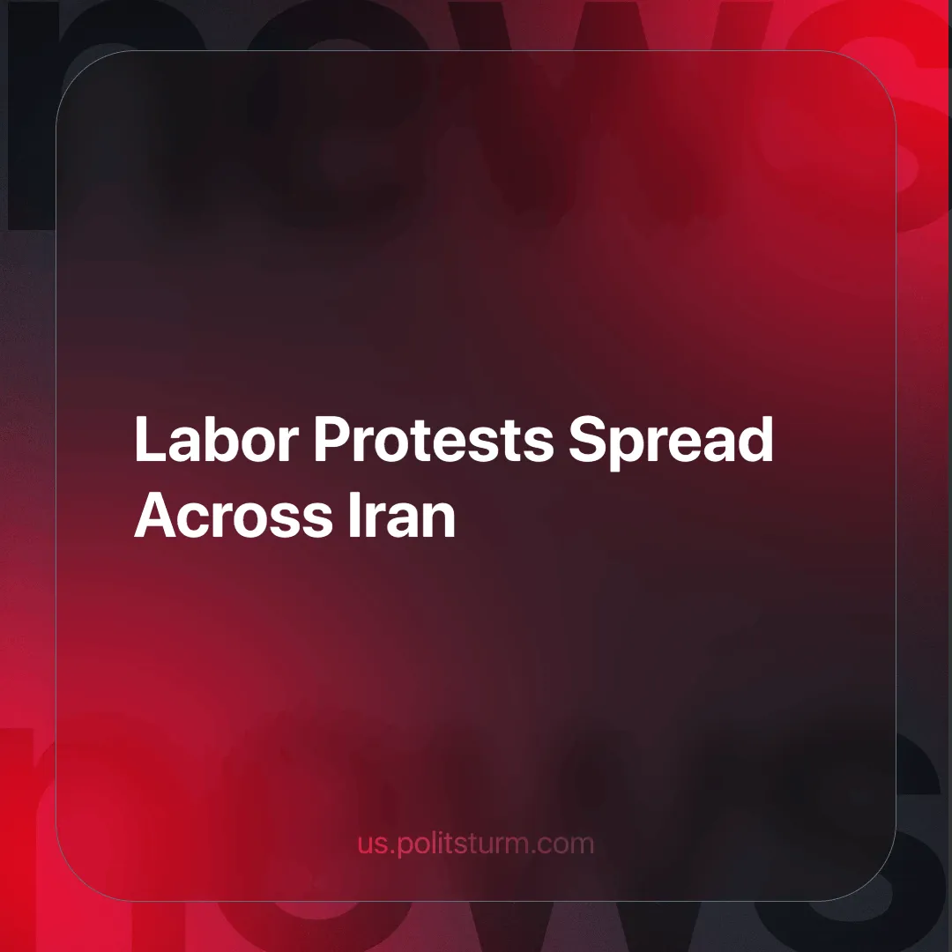

Original article
2024-09-04
3 min read

Oil and gas workers have joined the ongoing wave of protests and strikes in Iran. They include workers in industries and services ranging from health care and municipal services to cement, transportation and fossil fuels. The demands highlight a broader outcry against deteriorating working conditions and low wages.
Last Tuesday, the workers of the South Pars Gas Complex (SPGC) organized a protest focusing on incomplete wage payments. Their slogan: "oil is produced, our salaries are reduced".
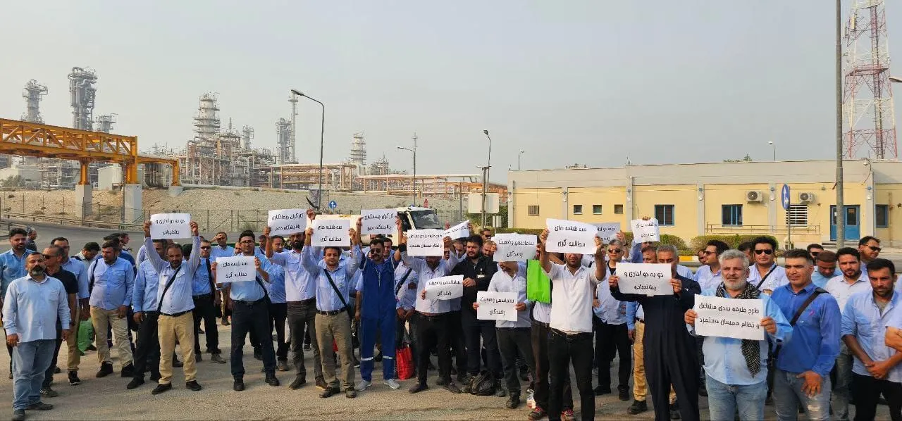
South Pars Gas Complex (SPGC) workers' strike
This was followed by a protest march by permanent employees of the Pars Oil and Gas Company (POGC) and most recently by workers of the Aghajari Oil & Gas Production Company (AOGPC). All subsidiary companies of the state-owned National Iranian Oil Company (NIOC).
They are protesting meager wages and demanding two weeks of work and two weeks of rest (as was the tradition in Iranian oil refineries and petrochemical plants for permanent employees) [1].
Iranian Workers have begun to form underground organizations because the Islamic Republic does not tolerate independent unions. These protests are part of a larger wave of worker agitation spreading across various sectors in Iran, coordinated by these underground unions and loosely organized social media groups.
The Kangan Cement workers are striking for 1) the permanent employment of temporary contract workers and 2) the immediate implementation of comprehensive job classification [2].
The workers of Wagon Pars went on strike for the second time to protest against the postponement of wages, non-payment of insurance premiums and lack of job security. According to the workers, despite the high production, the employer has reduced their benefits and delayed their wages [3].
A common demand is the implementation of the Job Classification Plan, a labor law created with the aim of "preventing exploitation" and "creating justice" in wage payments, as well as a "correct" relationship between wages and job descriptions.
In the classification plan, different job groups are defined and the wage for each job group is specified, this establishes a standard wage and insurance policy for labor. It stops capitalists from overworking due to non-standardized contracts and extracting more surplus value than specified by the state [4].
But the Islamic Republic relies on the goodwill of the employers involved to cooperate with the Job Classification Committee to implement it.
Municipal workers in the southwestern province of Ilam have protested in the streets three times in the last two days, as they have not received wages and insurance premiums for four months! Like other Iranian workers, they are demanding job security and protesting temporary contracts with private managers [5].
Nurses across Iran have also taken to the streets since early August (See: Iranian Nurses' Protest Faces Government Crackdown), demanding a livable wage, improved conditions and humane working hours.
Such a surge in labor protests reflects the miserable state of Iran's working class, who have been grappling with economic hardships, low and late wage payments, and poor working conditions for decades.
Despite a past tradition of militant labor organizing that achieved the aforementioned two-week work system in oil production, that supported Mossadeq's attempt at oil nationalization in the 1950s, or that broke the back of the Pahlavi regime in 1979, Iranian workers have largely lost this tradition. As a result of this discontinuity, which now leads to a lack of organization, they are unable to use most of their power as a class in struggle against the employers.
The reformation of disciplined unions and the vanguard party of the working class remains to be achieved by advanced workers and communists. Politsturm is a step towards this goal, join us today!
Links: 1 | 2 | 3 | 4 | 5

Original article

