Labor Migration in the Russian Federation
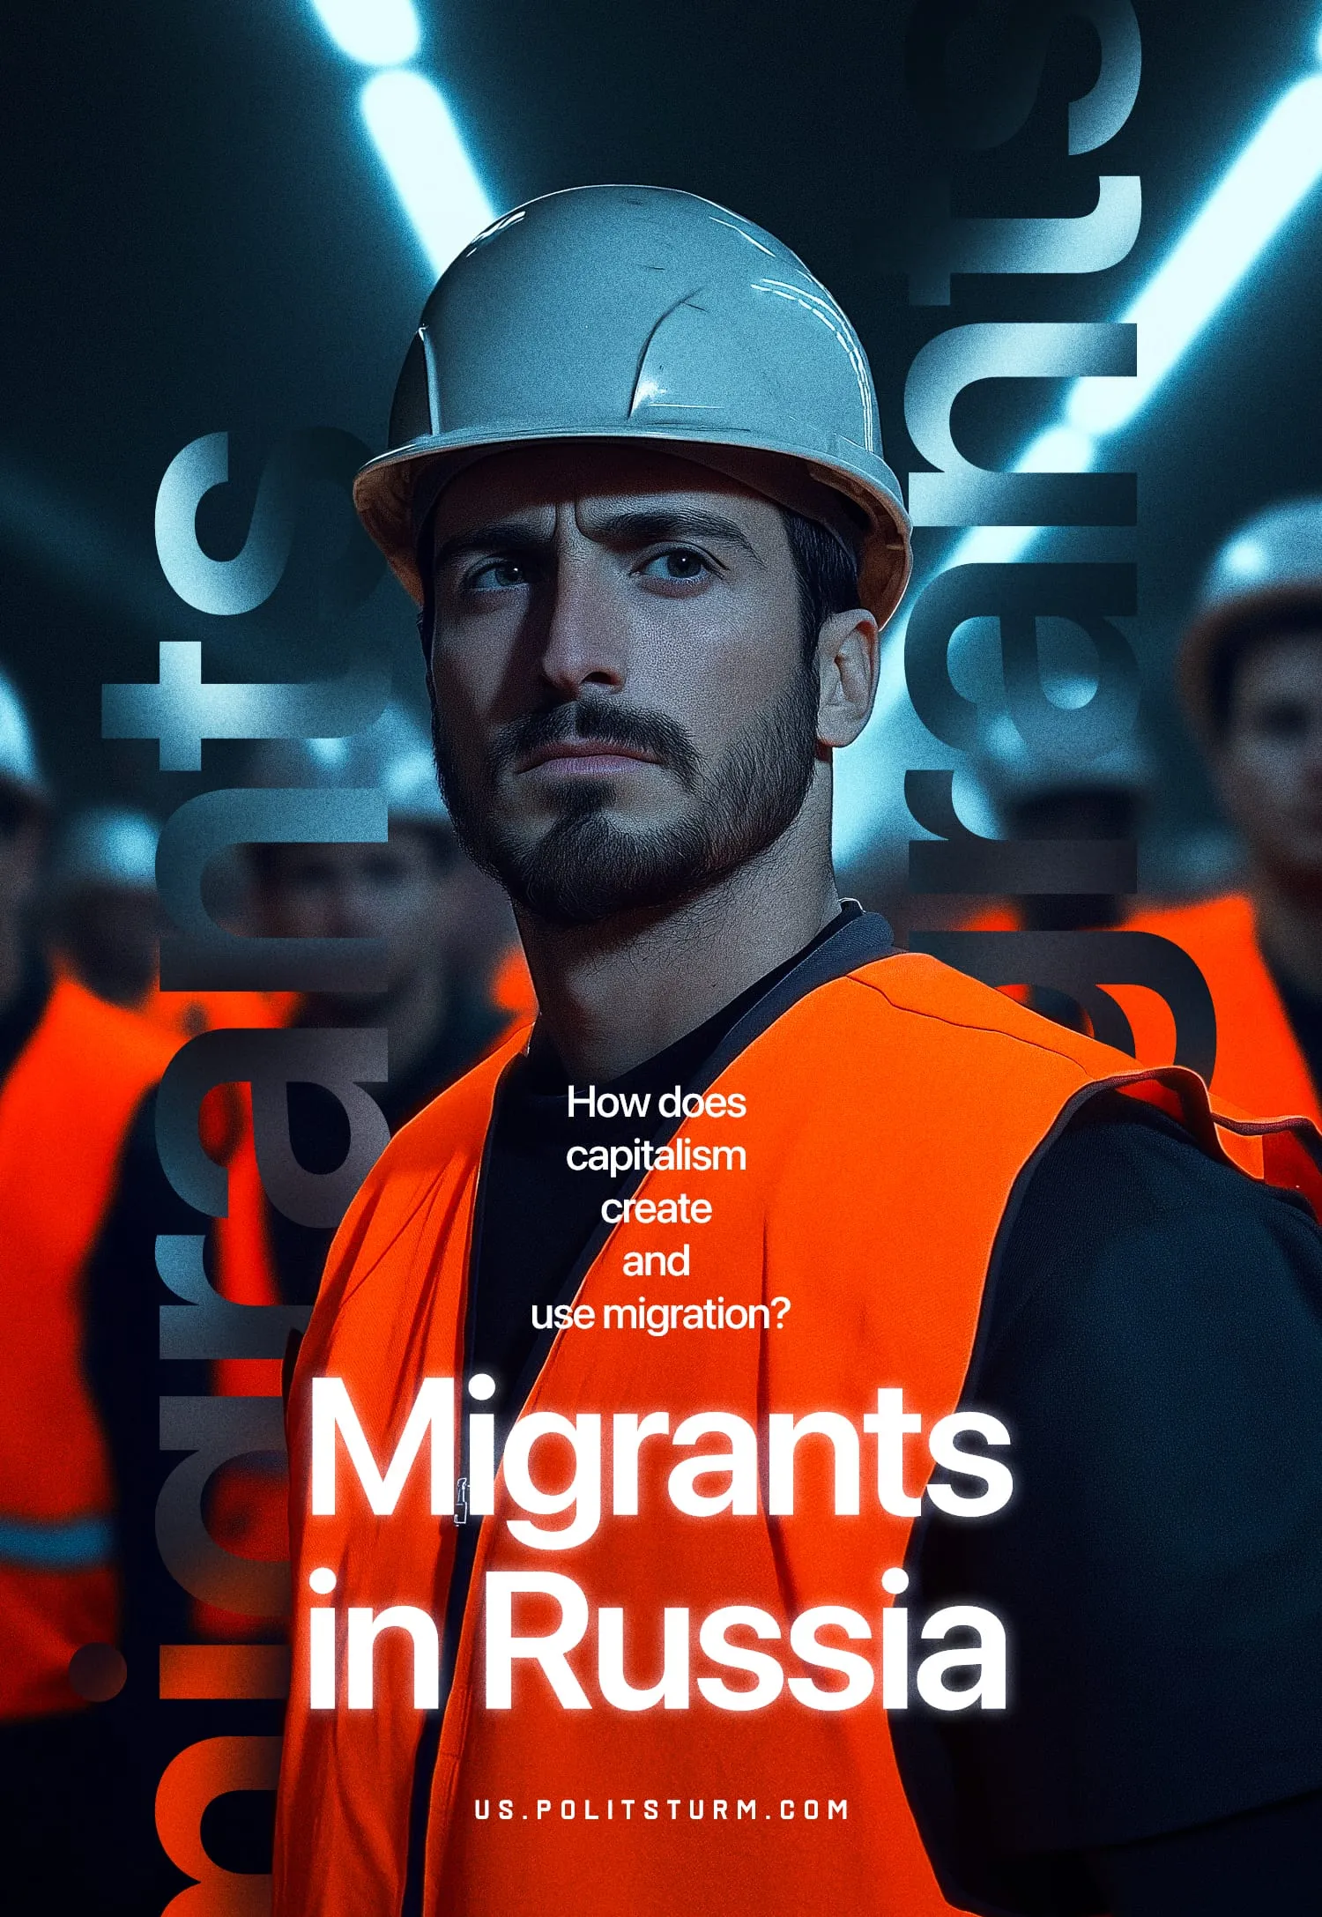

Original article
2025-04-26
51 min read

Labor migration in Russia is inextricably linked to the country's economic landscape. Drawn primarily from Central Asia, migrants seek employment in the Russian Federation, frequently filling low-paying positions. Despite their economic contributions, migrants often face xenophobia, chauvinism, and dehumanizing propaganda from nationalist and official media outlets, which portray them as a "threat." Such attitudes expose the inherent contradictions of the capitalist system, where the demand for inexpensive labor clashes with its social stigmatization.
- Migrant workers are crucial in addressing labor shortages in Russia, especially in low-skilled industries. While their presence is vital for sustaining the economy, it also generates strain on the local labor market due to variations in labor costs.
- Widespread misconceptions about migrants link them to crime and suggest they displace the native population from employment opportunities. However, evidence indicates that migrants commit only a small fraction of crimes and in terms of employment, the issue lies with the capitalist system, which keeps wages low in sectors like construction or services, making these jobs unattractive to locals. The local population faces pressure as capital prefers hiring cheaper migrants, a trend increasingly spreading across more sectors. Migrants fill these gaps, complementing the labor market, while capital uses them as a tool to cut costs and boost profits.
- Official authorities and political factions exploit anti-migrant sentiment for political gain, fostering the spread of xenophobia and negative stereotypes. This practice fuels social tensions and intensifies the inherent contradictions within capitalist society.
- Migrant workers frequently endure precarious living and working conditions, exacerbated by the deterioration of the healthcare and social welfare systems.
- Despite the aggressive rhetoric employed by official media and far-right figures, labor migration remains essential to the Russian economy within the context of its capitalist structure, and the ruling class is unlikely to abandon it.

I. Who are Migrants?
In Russia, the term "migrant" typically refers to labor migrants – individuals employed in a country where they are not citizens. This definition highlights two key aspects:
- Migrants are subject to different legal frameworks compared to citizens.
- As non-citizens, labor migrants face pressure from the dominant culture, requiring them to adapt or resist assimilation.
From a Marxist perspective, migrants are as much a part of the proletariat as any native wage earner. However, their circumstances place them in a more specific and complex position. Capital utilizes migrants primarily for two purposes:
1. To fill the labor shortage in a particular sector of the economy. Capital continuously flows between sectors, often transcending national borders. This flow draws labor with it, creating labor migration.
A prime example is the collapse of the USSR. The dismantling of the socialist economy led to the closure of "unprofitable" production facilities, creating large pools of inexpensive workers in former Soviet republics. These individuals were compelled to migrate to more economically developed centers within the former USSR or abroad. This dynamic is inherent to capitalism, suggesting that labor migration will persist so long as the current socio-economic system remains.
2. Pressure on already employed laborers. Migrants, especially if their labor is cheaper than that of the local workforce, become an additional source of pressure on the domestic proletariat. Capitalists exploit the fear of job loss to drive down wages by threatening to hire cheaper migrant workers. This economic reality fuels nationalist and xenophobic sentiments.
Consequently, migrants face dual pressure: economic and political. The ruling classes of different countries may adopt varying policies towards migrants. During periods of economic prosperity, they might implement multiculturalism to facilitate the integration of foreigners into the labor force and accelerate labor mobility. Conversely, during times of crisis, they might embrace nationalistic policies to divert attention from underlying problems, transforming social tensions into interethnic conflicts.
As can be seen in Russia, the ruling class can both attract migrants to fill low-wage jobs and employ chauvinistic rhetoric. This enables capital to cut labor costs by bringing in migrants, while chauvinistic rhetoric divides society, redirecting public anger and further depressing migrants’ wages.
Faced with widespread labor shortages [1], often due to the depletion or near-exhaustion of traditional resource pools, the ruling class is compelled [2] to attract increasing numbers of migrants, particularly from Africa and Asia. At the same time, the political climate encourages the state to expand the scope of restrictive and discriminatory measures [3] to redirect growing social unrest away from the existing power structure and towards a seemingly safer target.
Nevertheless, such inherent contradictions, often generating friction between different factions and representatives of the ruling class, signal a deepening internal crisis and a weakening of previous forms of political control.

II. Myths About Migrants
The topic of migration has become a wellspring of nationalist rhetoric and propaganda, readily exploited by politicians and activists across the spectrum, from mainstream figures to those on the fringes. They frequently rely on deeply ingrained myths about migrants to further their agendas.

2.1 "All Migrants Are Criminals"
One of the most persistent myths surrounding migrants is the assertion that bringing workers from other countries leads to increased crime rates. Moreover, chauvinistic and nationalistic groups in Russia often attribute a disproportionate share of crimes to migrants.
For example, Alexander Bastrykin, Chairman of Russia's Investigative Committee, once stated [4]:
“Often there are group attacks in public places and educational institutions, where schoolchildren are subjected to intimidation and forceful pressure from newcomers. Many offenders feel their impunity and count on support from representatives of ethnic diasporas. All this creates social tensions and leads to an escalation of negative attitudes in society”.
The belief that migrants increase crime rates is prevalent among over half the Russian population [5], demonstrating a high degree of xenophobia and, specifically, migrantophobia.
However, there's no statistical evidence to support a direct correlation between migration and crime. On the contrary, migrants account for at most 2% of all crimes committed, and the majority of these are directed against members of their own communities [6].
Yet, fear is a powerful force, and every high-profile case involving a foreign perpetrator is amplified in the media. The impression that migrants constitute a distinct "criminal class" is fostered through the deliberate promotion and extensive media coverage of crimes committed by them. Both mainstream and nationalist media outlets, driven by the pursuit of circulation, fuel anti-migrant sentiment by widely disseminating such information and exaggerating its importance within the overall news cycle.
On the one hand, this emphasis on migrant crime can be attributed, in part, to purely economic motives. The media, prioritizing circulation and viewership over the quality of information, operate according to capitalist principles. Fear, as a commodity, sells well. Thus, by highlighting crimes committed by migrant workers, the media, through informational pressure, actively contribute to chauvinism and animosity towards migrants.
On the other hand, nationalist and far-right media organizations deliberately use this pressure as part of their propaganda efforts. They disseminate migrant-phobic sentiments and nationalist rhetoric, injecting news with emotionally charged language and manipulating the fears of the Russian public.
A prime example is Tsargrad, a media outlet controlled by the "Orthodox oligarch" Konstantin Malofeev.
"Another story involving an illegal migrant from Tajikistan demonstrates that foreign 'specialists' couldn't care less about Russian laws. A 26-year-old taxi driver was detained in Izhevsk," writes [7] Tsargrad.
In another article, a Tsargrad author even goes so far as to label [8] Tajikistan an "existential threat" to Russia:
"Once one of the most financially secure Soviet republics, Tajikistan has become one of the most significant existential threats to Russia... Migrants from this republic commit a huge number of crimes, including serious ones. Moreover, the Crocus terrorists just happen to be from Tajikistan. Russia continues to pay this country tens of billions of rubles annually and maintains a visa-free regime and a number of other agreements with it, which are now working to destroy our state."
Conversely, when crimes are committed by native-born citizens, the perpetrator's nationality and origin suddenly become irrelevant, even if the crimes are just as brutal. This was the case with the highly publicized murders [9] in Kuban and in Tyumen [10], along with countless other similar news stories. Yet, neither the authors nor the editors of the relevant media outlets, nor the nationalists themselves, rush to portray Russians or other indigenous peoples of Russia as an "existential threat" to the country. No one infers an "ethnic propensity" for crime or the "social inferiority" of the native population from news reports about crimes committed by locals, despite their being far more numerous than those involving migrants.
Moreover, over half of all reported crimes in Russia are property crimes. In 2016, this figure was 57.1% [11], equivalent to 1,232,421 crimes classified under Chapter 21 of the Criminal Code of the Russian Federation. The majority of these crimes are thefts, accounting for approximately 70% of all property crimes. The motivation behind these crimes is usually rooted in economic hardship, not a supposed "special" inclination towards cruelty or violence.
That is, the capitalist system itself encourages people to commit crimes, whether they are Russian citizens or migrants. So it is not migration that leads to an increase in crime, but the very existence of capitalism that puts people in a position where they see no other way out.
Of course, the economy is not the only factor contributing to the criminogenic situation. It is influenced by many factors: the political and social environment, the level of cultural development, etc., but since both society and politics exist on the basis of the system of capitalism, it should be considered the root cause.
Russian nationalists and the ultra-right often challenge the common assertion that "crime has no nationality," arguing the opposite and emphasizing the nationality of migrant perpetrators. However, even a cursory analysis of crime statistics and their underlying causes reveals this to be a crude manipulation and, indeed, blatant hypocrisy. Nationalists conveniently ignore the nationality of Russian criminals, overlook the vast number of crimes committed by the native population, and highlight only those facts that fit their predetermined narrative in which migrant labor is the primary source of crime in Russia. Finally, nationalist rhetoric ignores the real causes of crime: economic deprivation, labor exploitation, social environment, political environment, etc.

2.2 The Myth of Migrants Stealing Jobs
A persistent and perhaps equally widespread myth is that migrants steal jobs from native-born workers. This idea is more nuanced than it appears because it contains a kernel of truth.
It's true that migrant labor is often cheaper, undercutting the wages of local workers. Ultimately, this can lead to migrants filling positions previously held by native workers. However, the responsibility for this lies with national capitalists who, driven by economic self-interest, choose to hire the cheapest labor available.
It is the Russian entrepreneur who, motivated by the cold rationality of capitalist logic, precipitates the loss of jobs for the local population: "Nothing personal, just business." Capitalism, as a system, fosters competition for jobs. Despite shared class interests and similar circumstances, workers of different nationalities, struggling to survive, often blame each other for problems created by the economic system itself.
However, under the current conditions of capitalist Russia, migrants have become vital to the economy, and their removal could cause it to collapse.
First, migrants are used to address a critical labor shortage. Experts estimate that by 2030, this shortage could reach approximately 2.4 million workers [12]. The causes of this labor shortage in the former Soviet Union are directly tied to the transition to a capitalist mode of production, namely:
- The demographic dip created in the 1990s, followed by a subsequent decline in the birth rate.
- High mortality rates during the COVID-19 pandemic, directly related to cuts in healthcare spending.
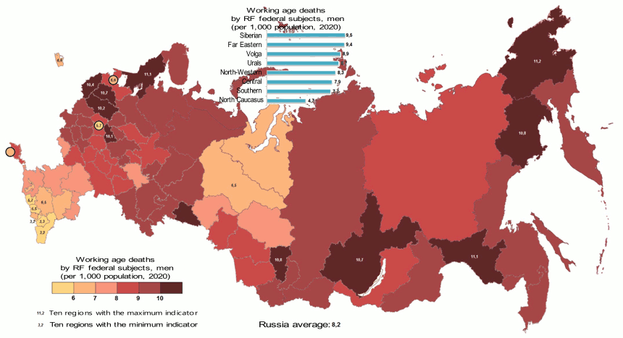
Infographic from the article “Mortality of the working-age population of Russia”
- Partial mobilization during the Russia-Ukraine conflict.
- The disruption of labor migration from Ukraine, which played a significant role in the country’s economy.
- A low degree of automation [13] in many sectors.
Therefore, in the current situation, the issue is no longer simply about intensifying pressure on the proletariat by replacing native workers with cheaper migrants. It is a matter of filling a fundamental labor deficit — one that has emerged from contradictions specific to capitalist underdevelopment, demographic collapse, and war mobilisation. This does not negate the structural existence of unemployment under capitalism — a necessary feature of labour-power as a commodity — but rather reflects a situation in which the existing reserve army is insufficient, mismatched, or immobile relative to the needs of capital.
Second, migrant labor is primarily employed in low-skilled jobs that are often considered undesirable by the native population. However, this undesirability is not due to the nature of the work itself, but rather to the extremely poor pay and conditions under capitalism — conditions that were vastly better during Soviet times. The use of migrant labor in these sectors allows capitalists to avoid improving conditions, thus maintaining their profitability. This creates competition among low-skilled workers and, frequently, among migrants themselves.
It’s also important to note that the presence of migrant workers affects not only the supply of labour but also overall economic activity. Through their participation in production and their consumption of goods and services, migrants contribute to the expansion of commodity circulation and value creation. The following data illustrates the measurable impact of documented migrant labour on Russia’s GDP between 1995 and 2013.
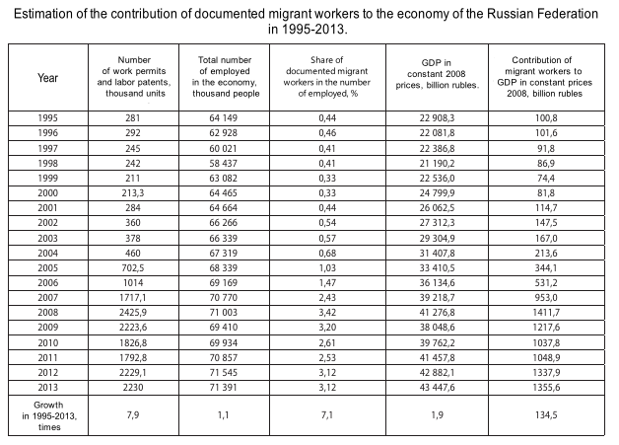
Table from the article "Contribution of Labour Migration to the Economy of Russia"
This viewpoint is supported [14] by Dmitry Morkovkin, Associate Professor in the Department of Economic Theory at the Financial University under the Government of the Russian Federation:
“Labor migrants are attracted to the Russian Federation not to increase the total population (although migration growth is taken into account by Rosstat when calculating this indicator), but to cover the labor shortage. The fact is that until recently foreign citizens were hired for rather hard work with relatively low wages, which on the one hand was undoubtedly beneficial to employers, and on the other hand created competition in the local labor market, especially outside major cities, where jobs are harder to find. Recently, with the growth of average salaries in the regions and the country as a whole, the situation with attracting migrants to the labor market is changing. Already, many large domestic companies hire Russian citizens, refusing to employ foreign workers, and in our opinion, they will do it more often and on a larger scale. The reason is simple - it is more profitable and easier for employers to hire their own citizens, who often come from different regions of Russia. In this case, the employer saves on high transaction costs associated with the reception of migrant workers, their accommodation, provision of overalls and catering”
While this claim reflects a certain empirical tendency, it omits a fundamental reality of capitalism: namely, that capitalists are not structurally obligated to provide for workers’ housing, food, or integration — only to pay a wage. In many cases, such "costs" are passed on to the worker directly, especially if they are unorganised or lack rights, as in historical examples of the "company town." Hence, the decline in migrant hiring may reflect shifting profitability or regional labour dynamics, not the removal of “transaction costs” as a general principle.

2.3 Myths About Migrants and Disease Transmission
Migrants are often unfairly stigmatized as vectors of dangerous diseases. From 2011 to 2015, official records show [15] 13,594 deportation decisions based on pre-existing health conditions, with 45% of those cases involving tuberculosis, 38% HIV infections, and the remaining 17% attributed to other sexually transmitted infections.
However, the question of disease transmission is fundamentally linked to the strength and accessibility of the existing healthcare system, as well as the vigilance of responsible authorities in maintaining sanitary standards in working and living environments.
It's clear that migrants are not the primary drivers of disease outbreaks. The recent pandemic, for example, affected everyone, regardless of their origin. Prioritizing profit over public health – whether concerning migrants or native-born populations – is a consequence of underlying capitalist structures.
Migrant workers, understandably fearing deportation, may conceal illnesses, which hinders effective monitoring by health agencies. Furthermore, employers often undermine disease control efforts by employing migrants informally, outside of official registration systems.
Consider the situation with HIV. According to data from the Federal Scientific and Medical Center for AIDS Prevention and Control [15], both the number of migrants screened and the number of new HIV cases detected among them have decreased annually in Russia. In 2012, just under 2 million migrants were screened, revealing 200 new cases per 100,000 people examined. By 2017, 2.5 million were screened, with 100 new cases detected per 100,000 people examined.
Meanwhile, the overall rate of new infections is accelerating.
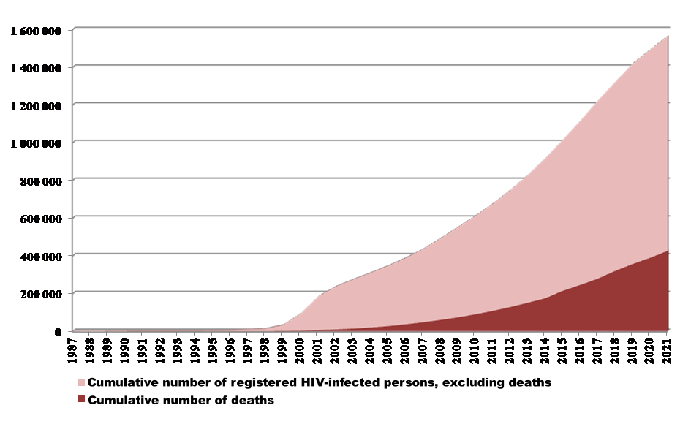
Infographic from the article "Epidemiological situation in HIV infection in the Ivanovo region"
Therefore, even if some migrants conceal serious illnesses like HIV, this doesn't make migrants the root of the problem. It is also crucial to avoid generalizing the behavior of individual migrants to the entire migrant worker population.
Such behavior stems from a number of objective factors rooted in the socio-economic structure of the capitalist system itself: a lack of transparency, corruption, pressure from law enforcement, and the performance and efficacy of the healthcare system.
These are three of the most prevalent myths surrounding migrant workers. Many more exist, all variations on the same theme: migrants are criminals and disease carriers who steal jobs from the local population.
In each of these myths, we encounter either a misinterpretation of economic processes (as with job competition); a generalization of the characteristics of a few migrants to the entire group (as with criminality); or a confusion of cause and effect, even an obfuscation of the real reasons behind a given problem (as with the spread of disease).
Despite (or perhaps because of) their distorted portrayal of societal problems, such myths are effectively used by various political movements to advance their agendas.

III. How the Authorities and the Far Right Exploit the Migration Issue
We have repeatedly emphasized that the Russian Federation’s economy, like any capitalist system, relies heavily on labor migration: cheap labor delivers outsized profits. For capitalists, stemming the flow of migrants is economically counterproductive. Yet, beyond the pursuit of profit, the ruling class places great value on political stability. Capital dreads crises, as they bring uncertainty — and with uncertainty comes the risk of shrinking profits.
Consequently, attitudes toward migrants hinge on two key factors: economic necessity and political strategy. Amid the ongoing crisis of the global capitalist system, these factors frequently come into conflict, forcing the authorities to strike a delicate balance between economic “efficiency” and maintaining a semblance of calm among the populace.
Russia is currently wrestling with a cascade of challenges: sanctions, the Special Military Operation, a labor shortage, a plummeting national currency, and a marked decline in the population’s material well-being. In this fraught environment, migrants serve as a convenient outlet for deflecting social discontent.
Nor should we overlook the fact that politicians have little incentive to encourage unity within the working class — a group that includes labor migrants. Xenophobia, deliberately fueled at both the policy level and in the daily lives of ordinary citizens, proves a potent tool in preventing such solidarity.
The ruling class’s ambivalent approach to migrants — viewing them simultaneously as an indispensable economic asset and a handy target for channeling social frustration — is plain to see in the statements of government officials.
In 2020, Vladimir Putin, acknowledging the approaching acute labor shortage in the country, stated [16] that Russia requires a steady influx of migrants to support its economic growth. The president even argued against imposing artificial limits on migration flows.
In November 2024, Dmitry Peskov, the Russian president’s press secretary, emphasized [17] that migrants are essentially a vital asset to the economy amid a persistent labor shortage:
“Migrants fill a critical need. The reality is that we’re grappling with a severe demographic crunch. We live in the world’s largest country, yet our population is small. To drive dynamic growth and achieve our development goals, we clearly need more workers — and we welcome them wholeheartedly.”
Yet, such pronouncements from the nation’s top leaders have done little to halt [18] periodic crackdowns on immigrants or the intensifying wave of chauvinistic propaganda.
For example, in April 2023, Bastrykin, the Chairman of the Investigative Committee of Russia, asserted [19] that migration processes constitute a “problem,” fueling social unrest and heightening the risk of terrorist elements slipping into the country.
Seizing on this rhetoric, Kaliningrad region Governor Alikhanov proposed [20] repatriating at least 2.5 million ethnic Russians from abroad to address the economy’s labor needs, thus reducing dependence on foreign migrants. He also put forward the idea of a “Russian card,” which would grant simplified work conditions to members of Russia’s indigenous peoples who lack their own statehood. Meanwhile, Vyacheslav Volodin, Speaker of the State Duma, suggested [21] barring migrants from bringing their families to Russia.
Deputies Alexey Zhuravlev (Liberal Democratic Party of Russia), Mikhail Matveev (Communist Party of the Russian Federation), and Dmitry Kuznetsov (A Just Russia) introduced a bill [22] to the State Duma that would expand the list of aggravating circumstances under the Russian Criminal Code to include migration-related violations.
The bill’s explanatory note specifies that when investigating intentional crimes committed by foreigners or stateless individuals, authorities must examine potential breaches of entry or residency regulations in Russia. If such violations are found, they should be considered an aggravating factor in the criminal offense.
It’s worth noting that after the launch of the Special Military Operation, a new expectation arose for migrants — Bastrykin proposed [23] that they demonstrate their loyalty to the state by joining the military. Mikhail Matveev went further, suggesting [24] that those who dodge military registration, service duties, or mobilization should forfeit their acquired Russian citizenship.
In June 2024, Bastrykin found himself at odds [25] with the State Duma over migration controls. Frustrated by his inability to propose legislation regulating migrant inflows and the Duma’s apparent inertia on the matter, the head of the Investigative Committee quipped: “I’d love to know when our so-called state geniuses will finally pass some decent laws.” This barb prompted a fierce backlash from Duma figures, including Volodin, who charged Bastrykin with insulting the Russian people.
This incident lays bare a stark divide within the ruling elite on the issue of migration. The president and his close allies push for a simplified process with minimal barriers, yet they encounter clear resistance to this approach. Such tension signals a growing crisis in Russia’s political framework.
Even so, both factions appear united in promoting chauvinistic rhetoric, which has stoked widespread xenophobia toward migrants among Russians. Notably, the notion that migrants fuel rising crime rates in Russia enjoys support [5] from over half the population.
This anti-immigrant agenda is readily taken up by a range of right-wing and far-right movements and groups across Russia. Official authorities tend to avoid outright insults toward migrants — such language clashes with the polished political image they cultivate, and the consequences could be unpredictable.
By contrast, individuals beyond the official sphere, alongside right-wing and especially far-right organizations and bloggers, speak with unfiltered bluntness. This makes them an unofficial megaphone for the state, amplifying anti-migrant attitudes and fanning the flames of chauvinism. Ultimately, it’s through these right-wing channels that Russia’s ruling class outsources the grim task of vilifying migrants and escalating societal animosity.
First and foremost, it’s worth highlighting the Movement Against Illegal Immigration (MAII), an organization whose name is self-explanatory.
Established in 2002 by brothers Alexander Belov and Vladimir Basmanov, it arose from [26] a violent confrontation in a café in Krasnoarmeysk, a Moscow suburb, in July 2002. The incident began when an Armenian stabbed a Russian, sparking a massive fight between locals and Armenian newcomers that left more than 20 people injured. Several Russians involved in the mass beatings were arrested. A few days later, a massive rally outside the city administration demanded the release of all detained Russians and the deportation of the Armenians.
The MAII used “human rights” rhetoric and gained widespread attention [27] following the Ivannikova case, where a woman killed an ethnic Armenian during an attempted rape. The group’s response was unconventional: it awarded [28] her a 50,000-ruble prize “for bravery,” while Belov proclaimed that migrants’ disrespect toward Slavs was a widespread phenomenon requiring action.
The organization staged anti-migrant rallies, and Belov was the mastermind behind the “Russian March,” which debuted in the summer of 2005. Additionally, MAII activists ran [29] for municipal seats under the Communist Party of the Russian Federation (CPRF) banner.
Its ideology is clear-cut, steeped in xenophobia, and backed up by myths. One of its earliest and most infamous leaflets distills this into stark claims:
— Natives of the Caucasus, Central, and Southeast Asia form the spearhead of foreign expansion.
— They make money in Russia through shady or illegal means, then drain the economy by sending earnings back home. Russia is their cash cow and a staging ground for territorial takeover.
— At this pace, with immigrants’ high birth rates, they’ll soon be the “lords of Russian soil.”
In 2011, the movement was recognised as [30] extremist.
Another key nationalist organisation, the Russian National Unity (RNU), was founded [31] on October 16, 1990, by Alexander Barkashov, a former member of the National-Patriotic Front “Pamyat” (NPF “Memory”). Joining “Pamyat” in 1985, Barkashov swiftly rose to become deputy to leader Dmitry Vasilyev. But after clashing with Vasilyev, he split off in 1990 to create the RNU.
The RNU presented itself as an Orthodox-fundamentalist and nationalist outfit, dedicated to restoring Russia as a “national state” and “reviving the Russian nation.” Its platform insisted Russia be a unitary state of Russians — defined as Great Russians, Little Russians (Ukrainians), and Belarusians — alongside “Rossiyane,” a term referring to “non-Slavic indigenous peoples for whom Russia is their sole homeland.”
In 1992, the RNU co-founded the Russian National Assembly (RNA) with Alexander Sterligov, only to exit by March 1993, denouncing Sterligov’s “lingering communism.” That October, RNU delegates attended the Congress of National Salvation but opted out of further ties with the National Salvation Front (NSF), frustrated by its lack of bold moves.
Though migration wasn’t the RNU’s core focus, its stance is telling: even Hermann Sterligov came across as too mild for them. Sterligov once argued [32] in an interview that Russians, unlike Muslims, abort pregnancies at an alarming rate, handing control of Russia’s demographics to others. His ideal Moscow is [33] a tight-knit capital devoid of migrants, home only to officials, security personnel, pensioners, and their staff.
In 2003, during Moscow’s mayoral race, Sterligov teamed up [34] with the MAII. It’s worth noting that Hermann Sterligov, formerly a significant figure in business as the founder of [35] the Pulsar cooperative and the Alisa exchange [34], is presently distinguished by his regressive and reactionary views.
Among recent nationalist figures stands Maxim “Tesak” (a nickname meaning "cleaver" in Russian) Martsinkevich. In 2012, he predicted [36] a social eruption or revolt in Russia driven by the escalating migrant issue.
Martsinkevich’s deeds tell the tale. In 2005, he started [37] Format-18, a neo-Nazi group that shared videos of assaults on migrants and antifascists. Its name nods to Adolf Hitler’s initials—“1” for “A,” “8” for “H.”
The group posted [38] footage of attacks on non-Slavic individuals alongside staged clips preaching hatred toward migrants and antifascists. It was outlawed [38] in 2010.
Yegor Prosvirnin was another prominent “right-wing” voice. This Russian nationalist proposed [39] swapping migrants for regional Russian workers, yet couldn’t account for the labor shortage amid unemployment at a historic low for Russians.
Nationalist logic comes into focus in Prosvirnin’s 2017 interview [40] with The Village. He divided nations into “strong” and “weak,” asserting that “weak” ones migrate to the turf of the “strong,” whose “national vision” prevails.
However, Prosvirnin was silent about the reality that social inequality persists in any nation under capitalism. For a nationalist, who really “wins” historically under this system is not up for debate.
We should also mention Konstantin Malofeev, a right-leaning Russian oligarch. A fervent champion of the “Russian world” (a concept promoting Russian cultural and political dominance across Slavic and Orthodox regions) and Tsargrad’s board chairman (a platform known for promoting pro-Russian, anti-Western narratives), he ranks migration [41] as the second-biggest issue after the Special Military Operation.
Malofeev’s rhetoric is predictable, urging [42] a harsh crackdown on migrant crime. He gripes [43] that migrants enjoy undue privilege — more rights than native Russians, he says — since their work permit test is “far simpler than a ninth-grade exam.” Evidently, he cares more about teens’ job hurdles than their schooling.
He doubles down [44] elsewhere, baffled that ninth-graders can’t get a “maturity certificate” to bypass exams and work. Again, he fumes that migrants land jobs more easily than teens.
Malofeev’s media empire creates [45] migrantophobia, hyping up the scope of migrant crime. He’s also tied to funding militarized nationalist factions.
Late 2020 saw the launch [46] of the “Russian Community” project, co-founded by Yevgeny Chesnokov, once a coordinator of the anti-abortion “For Life” movement, alongside Andrey Tkachev, former Omsk city council deputy speaker, and Andrey Afanasyev, a SPAS TV journalist previously with Tsargrad. Tkachev and Afanasyev share close ties to Tsargrad founder and businessman Konstantin Malofeev.
In many regions, the “Russian Community” is registered as a volunteer militia, allowing it to “support” [47] police raids. A striking example [48] unfolded in Yekaterinburg in August 2024 when it aided in detaining illegal migrant fruit vendors. With the owners nabbed, militiamen handed out their seized fruit to passersby.
This showy “battle” against migrants has fueled the “Russian Community’s” growth, now spanning 150 regional branches. It partners with the Orthodox fundamentalist “Sorok Sorokov” and the far-right “Northern Man” movement.
In the 2010s, Afanasyev headed ultraright projects backed bymigrant Malofeev, like the “Russian Youth Organization” and “Double-Headed Eagle,” pushing imperial ideals, Orthodoxy, traditional values, and “ethnic crime” narratives. While Malofeev has funded numerous nationalist efforts in Russia, no evidence links him financially to the “Russian Community.”
Unopposed ultraright rhetoric and sentiment could soon spark anti-migrant pogroms and “street wars” with non-Russian groups. The Crocus attack (a deadly Islamist shooting at Crocus City Hall outside Moscow on March 22, 2024, claiming 145 lives), for one, triggered [49] a sharp spike in anti-migrant violence.
Another vivid case [50] hit Chelyabinsk Oblast in October 2024, where locals turned on a Romani community after a 17-year-old Romani youth killed a female taxi driver. The murder unleashed widespread fury, ending with Romani homes set ablaze.
It’s vital to see that mounting hatred toward non-Russian migrants could taint the views of non-Russian Russian citizens too. As ultraright sentiment swells, Russians might begin seeing all non-Russians as threats—a risk that could push non-Russian communities to retaliate with violence.
The authorities’ muddled rhetoric and hidden contradictions on migration brew a tense social atmosphere. Stoking nationalism and anti-migrant hate diverts focus from dire social and economic issues, paving the way for interethnic strife. Official and ultraright chauvinism feeds xenophobia, inviting blowback from non-Russian groups and risking infighting among workers.
Thus, today’s migration policies sow the seeds for ultraright growth, already igniting interethnic clashes and violence, with worse confrontations looming.

IV. Structure of Migrant Employment and Their Situation
Despite widespread myths about migration, populist rhetoric from politicians of varying stature, and ever-tightening laws, the number of migrants in Russia is driven more by economic demand than by the preferences of specific individuals.
Labor migration statistics [51] clearly mirror periods of economic growth and downturns.
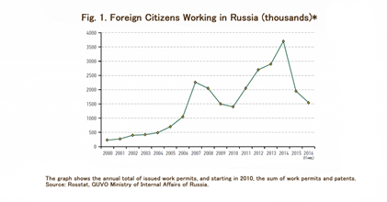
Infographic from the article "Russia 2017"
As of 2023, Russia was home to an estimated [52] 2.4 million labor migrants. However, these numbers fluctuate, as obtaining a precise count remains difficult due to gaps in data collection.
According to the All-Russian Research Institute of Labor Protection and Economics, Russia had 3.1 million labor migrants in 2022, as reported by Vedomosti. In an interview [53] with Dmitry Kiselyov on March 13, 2024, President Putin stated that labor migrants accounted for 3.7% of the total workforce. Rosstat data indicates that by the end of 2023, Russia’s employed population stood at 73.8 million, implying a labor migrant population of roughly 2.7 million.
Rosstat’s figures include only permanent migrants — those who have resided in Russia for more than nine months. Yet, about half of the country’s labor migrants are temporary. Their movements are monitored by the FSB and the Ministry of Internal Affairs and logged in the Central Database for Foreign Nationals. For example, as of May 1, 2020, 4.12 million foreigners were in Russia with “employment” listed as their purpose of entry, according to [54] Florinskaya, citing Ministry of Internal Affairs data. This number fell to 2.68 million by May 1, 2021, before climbing to 3.35 million by early May 2022.
Russia traditionally draws its workforce from CIS (Commonwealth of Independent States) countries, which supply the overwhelming majority of migrants. Ukraine was once featured among these labor sources, but the inflow from there halted after the onset of the Special Military Operation for obvious reasons.
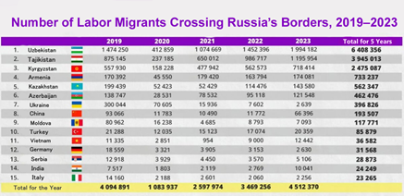
One key area of migrant employment is construction [55], which employs around 800,000 workers, predominantly from Tajikistan and Uzbekistan. However, worsening economic and political conditions have made Russia less appealing to workers from these nations, sparking competition for labor as an affordable resource.
Anton Glushkov, head of NOSTROY, highlighted this trend [55]:
“Workers over 40 still gravitate toward the Russian market, but younger generations, particularly those with language skills, increasingly favor culturally similar Muslim countries—especially since their Russian proficiency is often poor. For instance, during professional qualification exams in Uzbekistan, we had to translate all materials into Uzbek because the younger candidates struggled with Russian.”
The agricultural sector employs about 500,000 labor migrants, mainly from Uzbekistan, Tajikistan, and Kyrgyzstan, though workers from China, Vietnam, and South Korea are also present. These workers typically perform [56] low-skilled tasks like harvesting and crop care, jobs that are seasonal by nature.
The service sector is the largest employment category, encompassing roughly 40% of all workers. It spans a broad range of industries, including hospitality, food services, courier delivery, cleaning companies, hairdressing, and cosmetic services.
Russia primarily attracts workers with limited education. Around half of the migrants arriving in the country lack vocational training and are suited only for unskilled work. Rosstat data on migrants from CIS countries shows that 86,362 hold higher education degrees, 11,300 have incomplete higher education, 118,533 have secondary vocational or specialized training, 109,166 have completed general secondary education, and 22,831 have incomplete general education. For over 100,000 individuals, educational attainment is unspecified.
Migrants from Tajikistan, Uzbekistan, and Kyrgyzstan exhibit the lowest education levels, with 63.3% [57] possessing secondary education or less.

V. The real problems of migrants
Once in Russia, a migrant worker faces a wide range of problems that manifest their vulnerable position as a cheap foreign labor force. Let us list the most important ones.
Legal insecurity and illegal status. As mentioned above, many migrants work without employment or other contracts. This puts them [58] in a socially vulnerable position, often dependent on employers who may violate their rights. For example, [59] they cannot hold certain positions related to national security, vote in elections or referendums, or perform community service.
Obtaining legal status can be difficult because of the high costs involved, and corruption flourishes. Unscrupulous employers take advantage of migrants' vulnerable position. One of the most notorious such cases is an ordinary grocery store in a Moscow dormitory district that used [60] modern slave labor from citizens of Uzbekistan, Kazakhstan, and Tajikistan. In addition to labor slavery, people were subjected to sexual exploitation and abuse.
"I wasn't the only one who was beaten. They beat me with a stick, I have a scar. They never called an ambulance — they said if I called an ambulance they would cut off my arm," [61] said one of the women in slavery.
Modern slavery is a serious problem in Russia and around the word. While in 2013 the Russian Federation was in 49th place [62] in the peculiar rating of the number of modern slaves, already in 2023 [63] it was in 8th place.
The rise in modern slavery is a result of increasing immiseration under the world’s capitalist mode of production. The masses of working people have been driven into destitution, which enables the most unprincipled and predatory capitalists to take advantage of those who are unable to resist and coerce them to work for next to nothing under the most horrible cruelty.
In Russia, migrants are in a vulnerable position: lacking legal protections and facing difficulties in securing official work and documentation, they depend on employers and become easy targets for exploitation, often working in conditions which are very close to slavery.
The same legal problems can be attributed to difficulties in adaptation. A large number of bureaucratic procedures, ranging from Russian language tests to medical examinations and dactyloscopic registration [64], create difficulties for the migrant. Moreover, all these procedures are paid for out of their own pockets. Problems with migration registration and the legalization of status can also be attributed to bureaucratic difficulties.
A migrant's limited legal status implies limited access to health and social services. Due to the lack of legal status, a migrant may not receive the necessary medical care [64]. In addition, given the crowded living conditions and low wages, the spread of various diseases among migrants is naturally faster.
Non-payment of wages. Employers take advantage [65] of the migrant's situation and widely practice both partial payment of wages and long payment delays.
The extent of this problem can only be judged indirectly. For example, by news reports stating how hard was for the workers to obtain compensation for their work. For example, there was a recent case about 39 million roubles in unpaid wages returned [66] and another of 42 million roubles [67]. Usually, the repayment of debts can only be achieved through the courts, and it is clear that not all migrants want to or are able to do this, which is something that Russian employers take advantage of.
This situation is because migrants often work without a contract, which allows the employer to evade taxes on the one hand and, on the other, to exert pressure and intimidate them. It is a win-win situation for the employer.
The Center for Assistance in Resolving Labor Disputes in Russia conducted a survey among 900 workers from Tajikistan, Kyrgyzstan and Uzbekistan, which showed that more than half of them [68] work without a contract.
Response to social discrimination and racism. Society's attitude toward migrants as cheap, unskilled labor naturally provokes a reaction. People who have come to work in the Russian Federation perceive the native population as hostile, and as a result they close themselves off in insular groups.
We have already considered xenophobic attitudes among Russian citizens in the section on myths. Here it is only worth noting that the percentage of people who consider migrants to be a national problem has increased to 24%. The most worrying problems mentioned were price increases, SMO, terrorism, and raising the retirement age.
According to the Levada survey [70], the majority of Russians would prefer not to allow migrants to enter the territory of the Russian Federation at all. It is easy to see how these high indicators are reached during the deterioration of the economic situation.
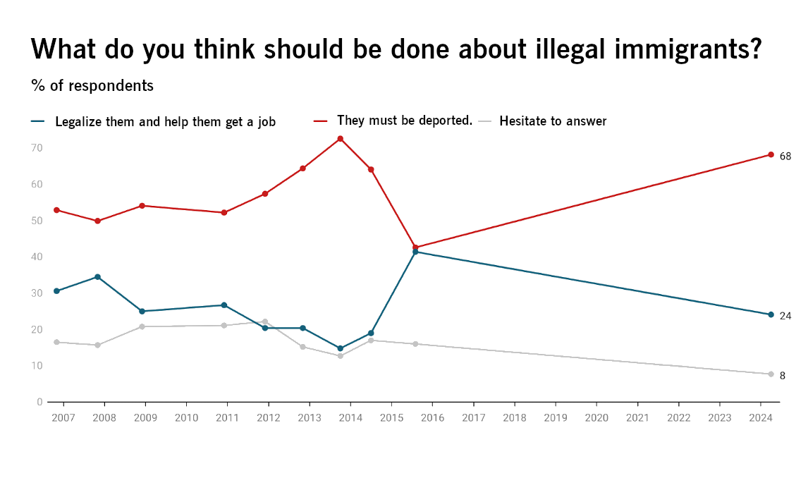
According to the SOVA research center, attacks on non-Slavic persons have also increased [71]. This outburst of violence was connected with the terrorist attack in Crocus:
“In far-right Telegram feeds after March 22, there were reports of at least 25 smaller street attacks with gas canisters on people of ‘non-Slavic appearance’ and on two girls in hijabs. Of these 25 incidents, five were explicitly labeled as ‘revenge for the terrorist attack’"
Corruption. Inadequate legislation, low efficiency and low transparency of the work of regulatory bodies, combined with the legal and economic vulnerability of migrants give rise to [72] corruption. This includes bribes to obtain work permits, to obtain various tests, migration records and registration. They also use various forms of financial exploitation, such as inflated fees for official documents, unnecessary services imposed at high costs, and arbitrary fines used as a means of extortion. In addition, migrants are susceptible [73] to raids and detention under threat of expulsion.
One of the most acute problems [72] is the widespread practice of buying forged documents, for example, certificates of Russian language proficiency, which actually open the way to obtaining Russian citizenship.
Migrants are often victims [74] of extortion by unscrupulous law enforcement officials. Fear of deportation or other legal consequences forces them to pay bribes, which only exacerbates the problem.
Corruption in the sphere of labor migration causes significant damage to the Russian economy [75]. The illegal employment of migrants results in losses for the state budget due to unpaid taxes and social contributions, allowing capitalists to cut costs and maximize profits while making workers' lives even harder. However, the government does not address the root causes of illegal employment, as the system benefits from maintaining a cheap and powerless labor force.

VI. The Future of Labor Migration in the Russian Federation
The labor shortage is one of the most acute issues being discussed today. Economists [76] estimate the labor shortage at 4 million. But the Russian economy has been experiencing a labor shortage since the early 1990s. The collapse of the USSR, followed by a sharp decline in the birth rate and an increase in the death rate, led to the emergence of the so-called "Russian cross".
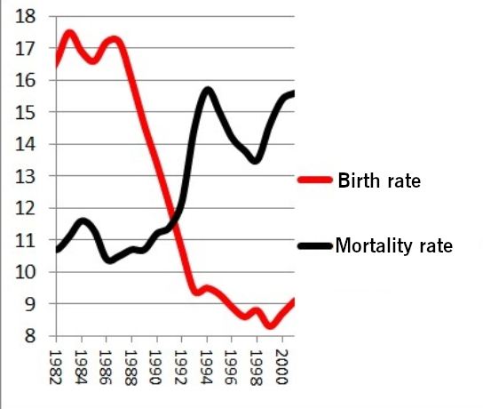
Graph taken from wikipedia
This led to a decrease in the number of workers available on the labor market among the local population. This situation was partly compensated by favorable conditions for migrants, which covered (but not completely) this want for labor.
Researchers have been predicting this state of affairs for a long time:
"In the conditions of the shortage of domestic labor, the attraction of migrant workers and foreign specialists is becoming a necessity. In addition, the increase in wages and further improvement of living standards make Russia an attractive country for labor migration. Thus, favorable conditions are created for the active expansion of migrants in the Russian labor market. The scope of their work will also expand. At the same time, without solving our internal structural problems, this can only aggravate the situation in the country".
The main problem in supplying the Russian economy with labor is the unsatisfactory solution of internal labor migration issues, which leads to high regional structural unemployment. Attracting labor migrants creates additional difficulties, including the influx of low-skilled labor, tensions in local labor markets, problems of migrants' adaptation, and the provision of social services. A significant increase in the number of migrants will be needed to compensate for labor shortages, but this may increase imbalances and problems in the labor market, especially in the context of growing illegal migration [77].
The authorities have been actively trying to address the looming labor shortage. This can be seen in the following chart.
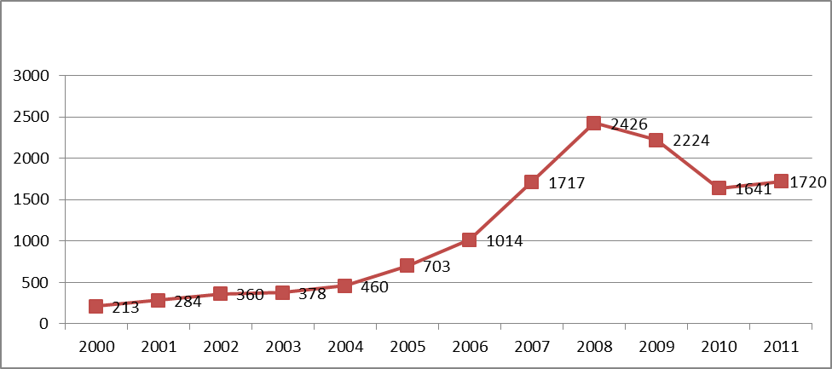
The number of foreign citizens who worked in Russia, in thousands of people. Graph from the article "The scale of labor migration to Russia"
It is estimated [76] that migrants generate between 7 and 10% of the country's GDP. However, the so-called “Special Military Operation”, mobilization, and especially the significant collapse of the national currency (which made the Russian market unattractive for many workers) have greatly exacerbated the deficit.
Elvira Nabiullina [78] identified labor shortages as the main problem of the Russian economy: "The limitation at the macro level is not money, but physical limitations of available factors of production". Nabiullina also noted [79] that technological backwardness, along with the deficit, is the main brake on the economy:
"I would now distinguish three types of constraints that are interrelated. One is labor. The situation shows us that we can no longer grow extensively, and growth can only come from labor productivity, and labor productivity is technology. And the constraint for us is access to technology, our own technological development".
Labor productivity in the RF lags far behind [80] the United States and even Kazakhstan. The economy of the Russian Federation is largely based on cheap migrant labor. In terms of the number of migrants, the RF is [81] second in the world after the USA. The use of migrant labor is normal for any capitalist economy, but this factor has become particularly important for Russia because of its peculiarities.
In light of these data, the question of whether Russia can do without migrants in a capitalist economy becomes rhetorical.
At the current stage, Russia cannot do without migrants, although it is actively looking for new sources of cheap labor. Thus, the use of child labor [82] is already becoming the norm. Prisoners are even more actively used [83].
Recently, workers have been imported from countries exotic for Russian latitudes.
"The first 10,000 workers will arrive in Russia from Kenya in the near future. An agreement with the Russian side has been reached," said [84] the official spokesman of the Kenyan State House, Hussein Mohamed.
Workers from Vietnam, China, India, DPRK are already actively represented in the Russian Federation [85] and this influx is planned to increase. But the new ethnic composition means new problems, new diseases [86], and new material for Russian politicians to improve their chauvinist rhetoric. However, Russia is also trying to fill the shortage of highly skilled workers by hiring programmers from Cameroon and Kenya.
Still, despite all the efforts, and as noted by Russian analysts themselves [88], the prerequisites for changing the current situation are not present:
"There are no conditions for changing the situation with unemployment in the short term, while the consequences of the demographic hole will continue in the foreseeable future. The demographic forecast of Rosstat (calculated until 2046), published in October 2023, presents data according to which the population of the country by the end of 2023 will decrease by almost 268 thousand people, which is due to natural population loss of 600 thousand people with an expected increase in migration of 233 thousand people. According to the forecast, the population loss will increase until 2027 due to the rise in natural decrease and a slight decrease in the positive migration balance. Sustainable growth of the working age population (and its share in the population structure) is planned only from 2026".]
Sources
[1] Politsturm – Workforce shortage – January 11, 2024
[2] Rambler Finance – Migrants from Africa and Asia will come to work in Russia – January 11, 2025
[3] RIA NEWS – Migrants in Russia: statistics and facts – August 23, 2024
[4] Rossiyskaya Gazeta – Alexander Bastrykin: There should be an instant reaction to migrant crimes – October 24, 2023
[5] Interfax – More than 50% of Russians believe that migrants increase the crime rate in Russia – November 18, 2021
[6] RBC – RAS Institute estimates crime rate among migrants in Russia – February 10, 2024
[7] Tsargrad – A migrant was kicked out of Russia, but he secretly worked as a cab driver and raped girls in Izhevsk – August 18, 2024
[8] Tsargrad – “We will rule here”: Tajik lessons for Russians. “Crocus” is not the end of the story – December 16, 2024
[9] News.ru – In Kuban, a man killed a policeman, raped his wife and set fire to an apartment – December 18, 2024
[10] Nashi Novosti, Tyumen – In a Tyumen village, an apartment tenant killed his landlady with a knife and fork – December 22, 2024
[11] G.F. Coimshidi, A.A. Litvinov, A.J. Sarkisyan. Crimes against property. Dynamics and forecast // Legal Sciences, No. 5, 2017, P. 168.
[12] hh.ru – Media Labor Market: digest June 2024 – July 8, 2024
[13] RBC – What will help the country's economy overcome the shortage of qualified personnel – June 20, 2024
[14] Konkir – Where does Russia's migration policy lead?
– May 10, 2023
[15] takiedela.ru – Are migrants bringing HIV and tuberculosis to Russia? – December 9, 2018
[16] Interfax – Putin says migrant influx is necessary for Russia's economic development – July 3, 2020
[17] RIA – Kremlin explains why Russia needs migrants – November 22, 2020
[18] TASS – 115 migrants will be expelled from Russia in Moscow Region after raid on Ozon warehouse – May 16, 2024
[19] Interfax – Alexander Bastrykin: Migrants have become one of the factors of social tension in the world and Russia – April 11, 2023
[20] TASS – Alikhanov: return of ethnic Russians to Russia will solve the problem of labor shortage – July 1, 2023
[21] RBC – Volodin opposed the right of migrants to bring their families to Russia – September 4, 2024
[22] Bill “On Amending Article 63 of the Criminal Code of the Russian Federation”
[23] Interfax – Bastrykin proposed to deprive migrants of citizenship if they refuse to participate in the SWO – October 19, 2023
[24] Kommersant – Evaders with foreign accents – August 28, 2023
[25] RBC – Volodin said, Bastrykin insulted the people with his words about the “State Duma” – June 27, 2024
[26] Russian Line – An Organization Against Illegal Immigration Founded in Krasnoyarsk – July 12, 2002
[27] Lenta. ru – Alexandra Ivannikova's case returned to court – November 1, 2005
[28] Izvestia – 50 thousand for murder of Armenian rapist – July 27, 2005
[29] Information and analytical center “SOVA”. – Xenophobic CPRF candidates in Moscow municipal elections – February 18, 2008
[30] Interfax – DPNI under ban – April 18, 2011
[31] Big Russian Encyclopedia
– "Russkoye Russian National Unity" – May 22, 2022
[32] Literary newspaper
– Depopulation – 2003
[33] Vesti – German Sterligov turned against migrants – June 7, 2018
[34] Delovoy Kvartral – German Sterligov
[35] 24SMI – German Sterligov
[36] Lenta. ru – I don't want to go to prison again "Lenta.ru" talked to nationalist and pedophile fighter Tesak – September 18, 2012
[37] Meduza – What Maxim Martsinkevich nicknamed Tesak is remembered for – the most talented media manipulator among Russian neo-Nazis – September 16, 2020
[38] Kommersant – A lot of appearances out of nothing – July 12, 2022
[39] Sputnik – Russia can't do without migrants – nationalists are against it, but they have no choice – October 8, 2018
[40] The Village – “If you want to be Russian, pay”: Interview with Egor Prosvirnin – July 13, 2017
[41] Riamo – “Problem No. 1 after the SWO”: Malofeev spoke out on the migrant issue – July 31, 2024
[42] VRNS – Malofeev on migrant crimes: “The threat to the Russian state itself has grown” – October 25, 2023
[43] Kapital Strana – Malofeev: Migrants are above Russians, they have been given special rights in Russia – February 8, 2024
[44] Tsargrad – "They will resist: Migrants in Russia can do things that even Russian children can't – June 8, 2024
[45] Tsargrad – “Grabbed on the street, there is video, the police did not take a statement”: These attacks by migrants will not be included in the MIA's reports – June 8, 2024
[46] BBC NEWS Russian Service – “We are Russians, God is with us”. How the new far-right appeared in Russia and how they differ from the old – June 7, 2024
[47] Kommersant – Migrants are asked to rise from their knees – January 24, 2024
[48] 66.RU – The “druzhynniks” handed out fruit taken from traders to passers-by in front of police officers. Is it legal? – August 8, 2024
[49] Lenta.ru – “We need to restore order” How did the terrorist attack at Crocus change attitudes towards migrants and almost quarrelled Russia and Tajikistan? – May 30, 2024
[50] RBC – Riots broke out in Korkino after the murder of a female cab driver – October 24, 2024
[51] Yulia Florinskaya – Labor Migration from Central Asia to Russia in the Current Economic Conditions / Russia 2017 Annual Report
[52] Vedomosti – Where labor migrants come from to Russia – May 3, 2024
[53] EMBASSY OF THE RUSSIAN FEDERATION IN THE KINGDOM OF BELGIUM – Interview with Vladimir Putin to Dmitry Kiselev. – March 13, 2024
[54] Industrial Trade Union – POINT OF VIEW: Where do migrant workers come to Russia – 2024
[55] Vedomosti – NOSTROY: Every fifth migrant in Russia works on construction sites – June 6, 2024
[56] Liberty Radio – "Migrants work everywhere". The labor market in Russia after the pandemic – May 27, 2020
[57] Vorobyeva I.V. – Labor migrants in Russia: problems of employment of foreign labor workers // Vestnik of RSUH. Series "Philosophy. Sociology. Art History". 2020. № 1. С. 85-95.
[58] Е. С. Krasinets – Problems of labor migration and migration policy of Russia / PopulationNo. 2 2012 P. 28 – 32
[59] Korona – What rights do foreign citizens have in Russia – July 25, 2023
[60] RBC – “Golyanovsky slaves” complained to the ECHR about torture – December 6, 2016
[61] Novaya Gazeta – “The master said: if I call an ambulance, they will cut off this hand” – May 12, 2016
[62] RG. RU – Russia ranked 49th in the world by the number of “slaves” – October 17, 2013
[63] DOXA – Russia ranked 8th in the world rating of modern slavery, overtaking Afghanistan and Kuwait – May 28, 2023
[64] A.S. Gaeva. Problems faced by migrants in Russia and possible ways to overcome them // Post-Soviet Continent, 2020, February 2, P. 71 – 84.
[65] Valdai – Problems of adaptation of foreign migrants in Russia: a view from Tajikistan – January 23, 2023
[66] 24. KG – More than 39 million rubles of unpaid wages helped to get migrants in Russia – October 17, 2024
[67] Radio Azattyk – Moscow parliamentarian met and helped migrants – February 15, 2018
[68] Achkabar – Migrants in Russia admitted that they receive wages in envelopes – April 5, 2024
[69] Levada Center – Mass perceptions of the problems of Russian society: March 2024 – April 9, 2024
[70] Levada Center – Level of xenophobia and interethnic tension, attitude to newcomers – 2024, May 14
[71] SOVA Information and Analytical Center – Russian nationalism and xenophobia. Results of March 2024 – April 3, 2024
[72] Kapital Strana – Migrants in Russia face corruption – June 4, 2024
[73] RSMD – Coming out of the shadows: corruption factor in migration policy – January 16, 2019
[74] E.V. Mikhailova, V.E. Khazova – Corruption factor in migration policy of the Russian Federation // Bulletin of the Moscow University of the Ministry of Internal Affairs of Russia. 2020(2), С. 97-102.
[75] RIAMO – Labor migrants in the Russian Federation: how they affect the economy and whether Russia can do without them – April 4, 2024
[76] NSN – “Colossal amounts”: Migrants' contribution to Russia's GDP estimated at 7-8% – March 5, 2024
[77] Korovkin A.G., Dolgova I.N., Korolev I.B. – DEFICIT OF WORKING POWER: RUSSIAN CROSS-2 / Demoscope Weekly – 2007
[78] Lenta.ru – Nabiullina named the main obstacle to the development of production in Russia – September 15, 2023
[79] Kommersant – Nabiullina named the main limitations for the development of the Russian economy – July 3, 2024
[80] FundsHub. ru – Labor productivity in Russia lags far behind Europe and the US – May 20, 2013
[81] TASS – Illegal migration in Russia – August 21, 2014
[82] CITY-N.RU – Russia will once again allow child labor to be used not only in labor lessons – July 21, 2023
[83] Vedomosti – Russian companies have started hiring convicted forced laborers more actively – August 1, 2023
[84] RG. RU – Migrants from Africa and Asia will come to work in Russia, Rambler reports – January 17, 2024
[85] URA.RU – Vedomosti has learned where migrant workers are coming from in Russia – May 3, 2024
[86] Nezavisimaya – New guest workers bring exotic diseases to Russia – March 11, 2024
[87] Cnews – Russia hires cheap programmers from Africa en masse to bring down high salaries of domestic IT workers. – October 1, 2024
[88] IALM.RU – The Future of Migrant Workers in Russia – April 15, 2024

Original article

