Lenin on Imperialism's Development of Militarism
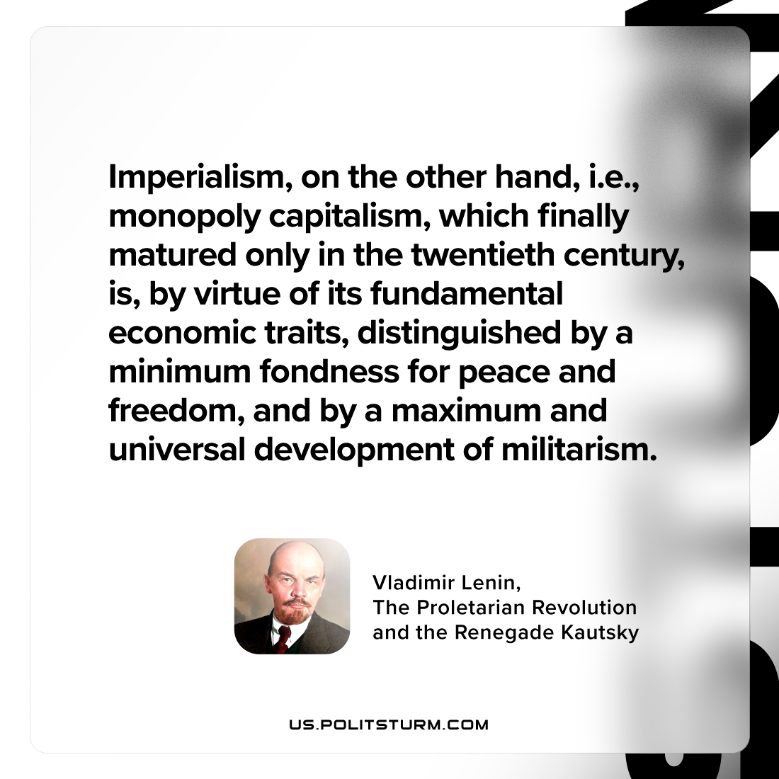

Original article
2024-06-15

"Imperialism, on the other hand, i.e., monopoly capitalism, which finally matured only in the twentieth century, is, by virtue of its fundamental economic traits, distinguished by a minimum fondness for peace and freedom, and by a maximum and universal development of militarism."
Vladimir Lenin, The Proletarian Revolution and the Renegade Kautsky

Original article

