Lenin on the Party Being Based on Practical Work
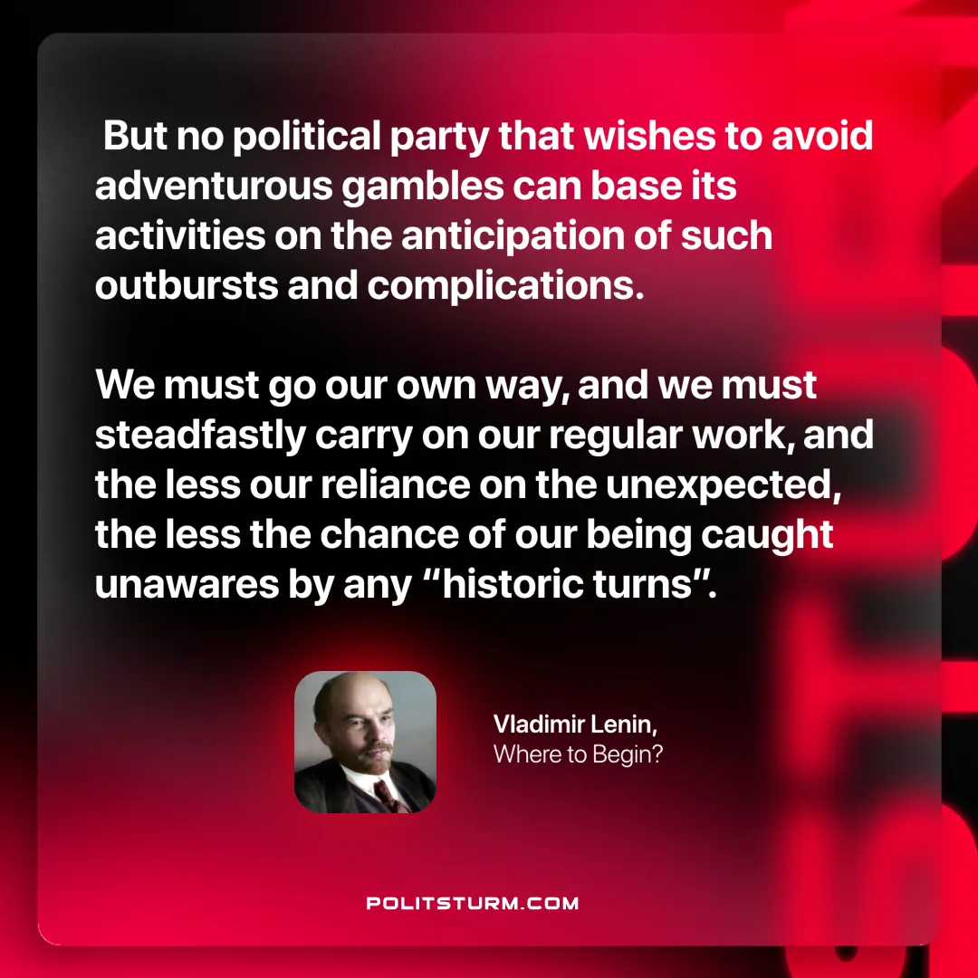

Original article
2024-12-17

“But no political party that wishes to avoid adventurous gambles can base its activities on the anticipation of such outbursts and complications. We must go our own way, and we must steadfastly carry on our regular work, and the less our reliance on the unexpected, the less the chance of our being caught unawares by any “historic turns”.”
Vladimir Lenin, Where to Begin?

Original article

