Lenin on How Terror Disorganizes the Revolution
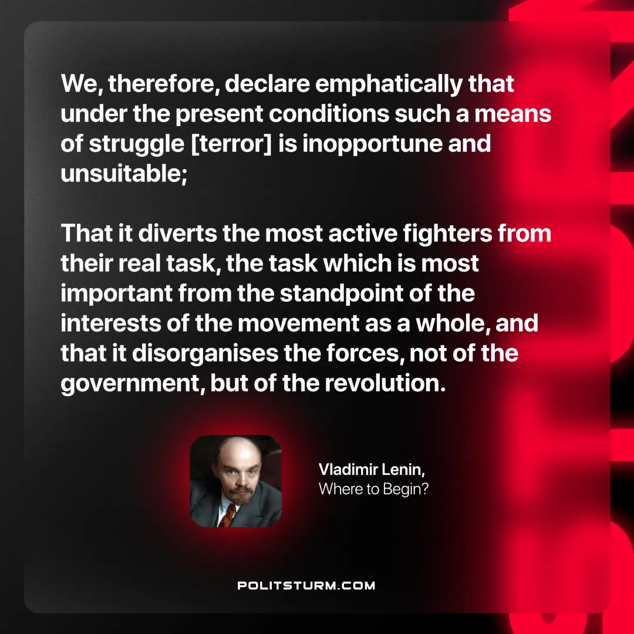

Original article
2024-12-15

“We, therefore, declare emphatically that under the present conditions such a means of struggle [terror] is inopportune and unsuitable; that it diverts the most active fighters from their real task, the task which is most important from the standpoint of the interests of the movement as a whole; and that it disorganises the forces, not of the government, but of the revolution.”
Vladimir Lenin, Where to Begin?

Original article

