Lenin on the Proletariat Against the Imperialist Bourgeoisie
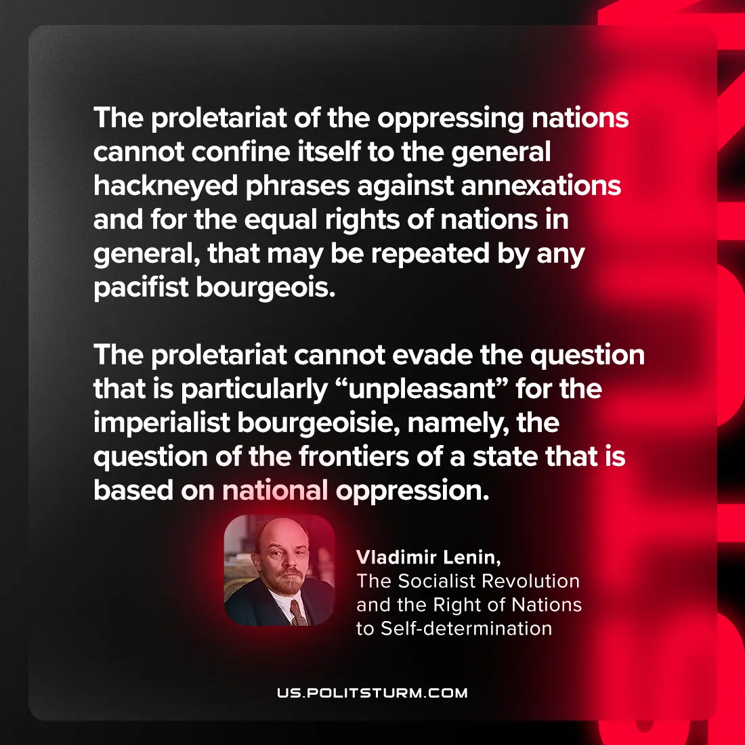

Original article
2024-09-19

“The proletariat of the oppressing nations cannot confine itself to the general hackneyed phrases against annexations and for the equal rights of nations in general, that may be repeated by any pacifist bourgeois. The proletariat cannot evade the question that is particularly “unpleasant” for the imperialist bourgeoisie, namely, the question of the frontiers of a state that is based on national oppression.”
Vladimir Lenin, The Socialist Revolution and the Right of Nations to Self-determination

Original article

