Lenin on the Task of Communists Against Opportunism
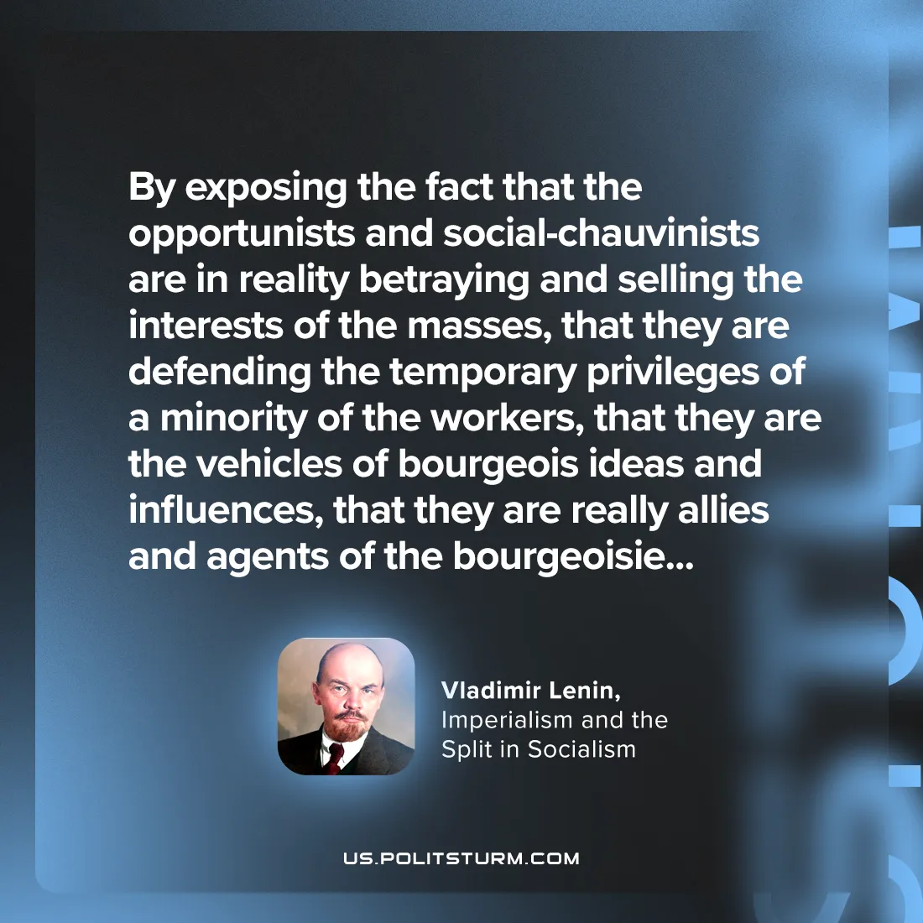

Original article
2024-08-29

"By exposing the fact that the opportunists and social-chauvinists are in reality betraying and selling the interests of the masses, that they are defending the temporary privileges of a minority of the workers, that they are the vehicles of bourgeois ideas and influences, that they are really allies and agents of the bourgeoisie…”
Vladimir Lenin, Imperialism and the Split in Socialism

Original article

