Lenin on the Marxist View Towards Bourgeois Nationalism
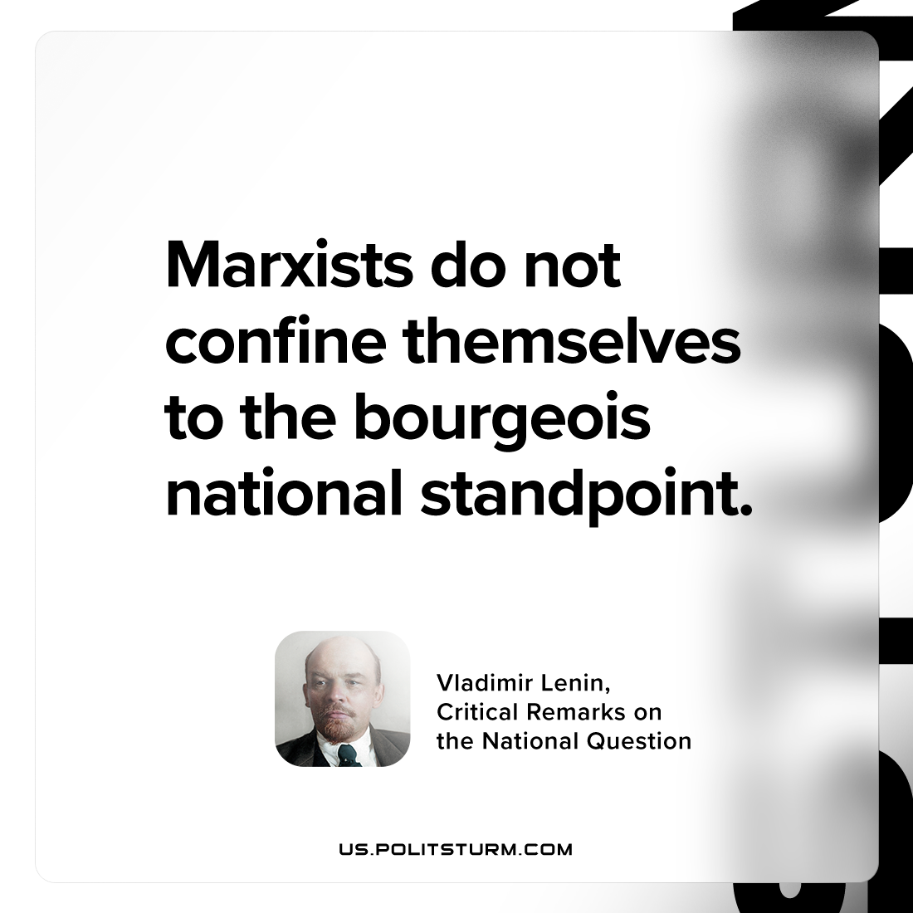

Original article
2024-07-07

"Marxists do not confine themselves to the bourgeois-national standpoint."
Vladimir Lenin, Critical Remarks on the National Question

Original article

