Stalin on 'Personal Liberty' Under Capitalism
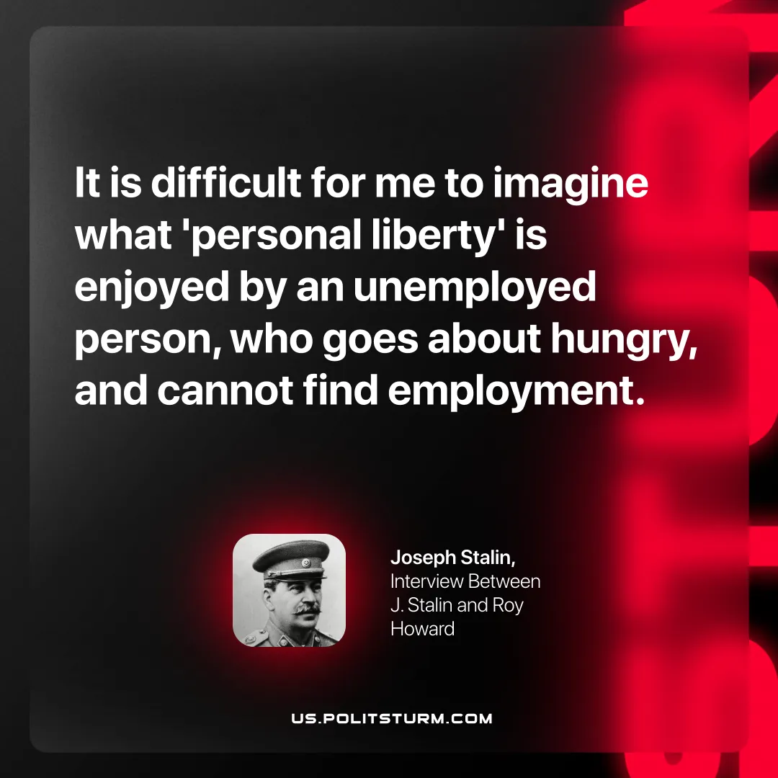

Original article
2026-03-24

"It is difficult for me to imagine what 'personal liberty' is enjoyed by an unemployed person, who goes about hungry, and cannot find employment.”
Joseph Stalin, Interview Between J. Stalin and Roy Howard

Original article

