Lenin on the Necessity for a Regular Communist Media Outlet
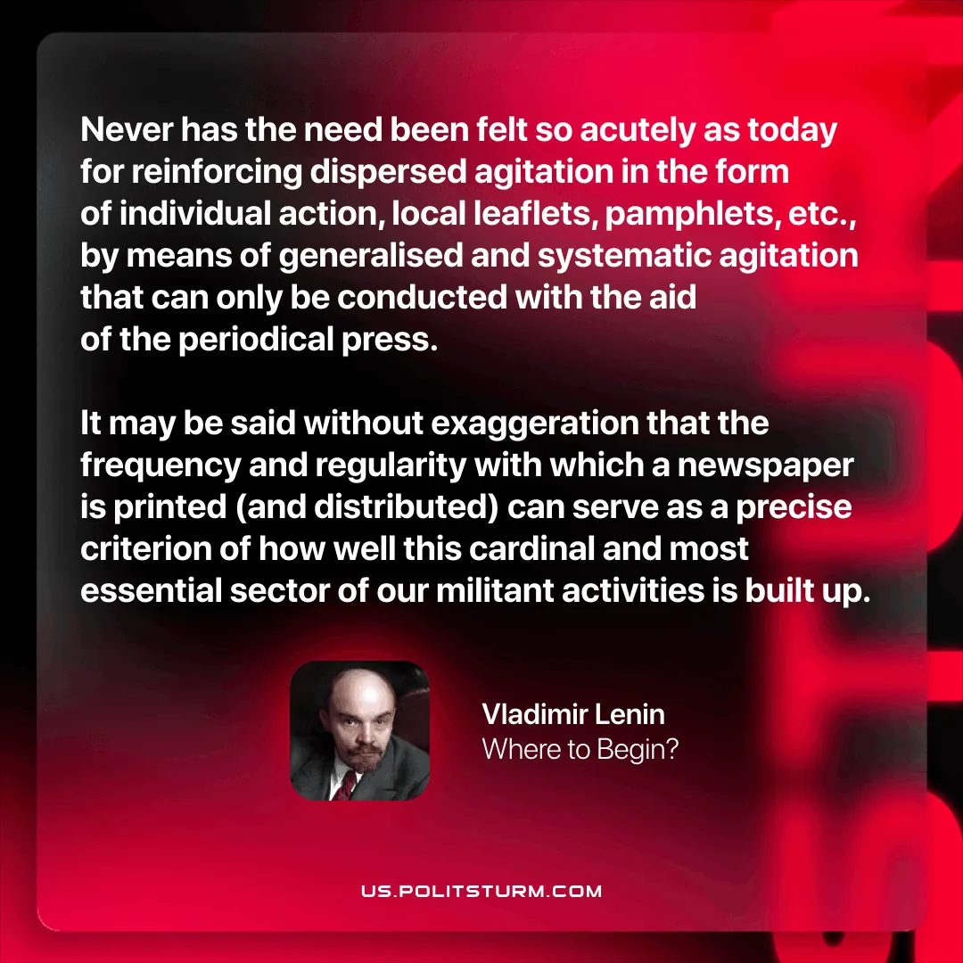

Original article
2025-11-27
1 min read

Never has the need been felt so acutely as today for reinforcing dispersed agitation in the form of individual action, local leaflets, pamphlets, etc., by means of generalised and systematic agitation that can only be conducted with the aid of the periodical press. It may be said without exaggeration that the frequency and regularity with which a newspaper is printed (and distributed) can serve as a precise criterion of how well this cardinal and most essential sector of our militant activities is built up.
Vladimir Lenin, Where to Begin?

Original article

