Lenin on Unity With Opportunists Enslaving the Labor Movement
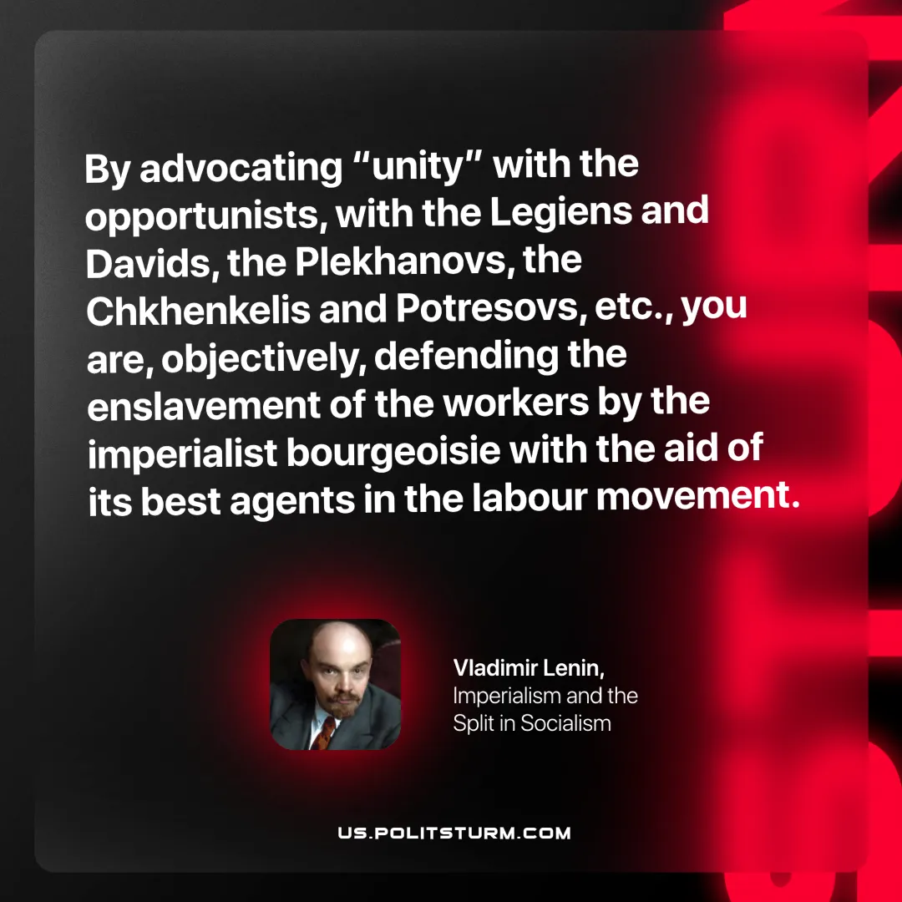

Original article
2025-06-24

"By advocating “unity” with the opportunists, with the Legiens and Davids, the Plekhanovs, the Chkhenkelis and Potresovs, etc., you are, objectively, defending the enslavement of the workers by the imperialist bourgeoisie with the aid of its best agents in the labour movement."
Vladimir Lenin, Imperialism and the Split in Socialism

Original article

