Lenin on Open Advocacy of Revolution
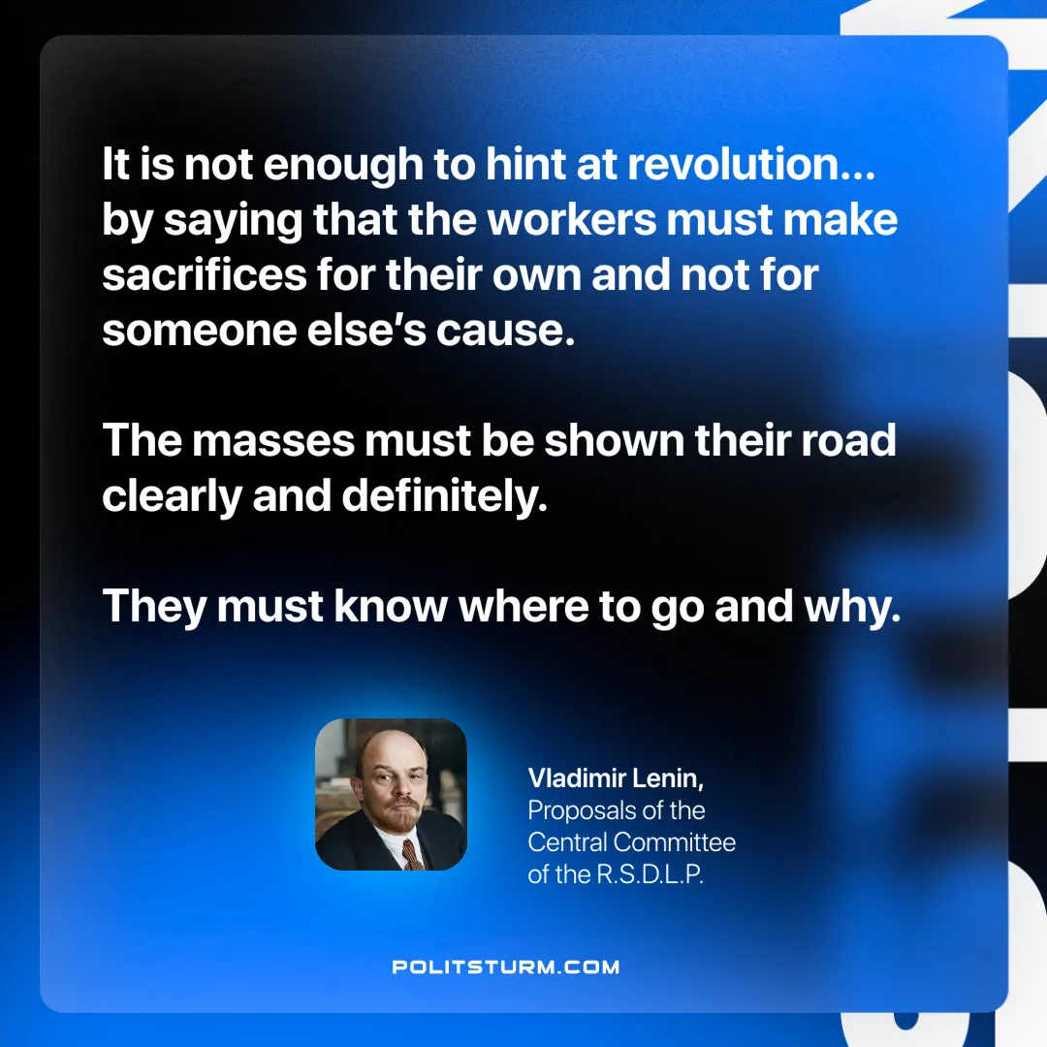

Original article
2025-05-27

“It is not enough to hint at revolution… by saying that the workers must make sacrifices for their own and not for someone else’s cause. The masses must be shown their road clearly and definitely. They must know where to go and why.”
Vladimir Lenin, Letter From the Committee Abroad

Original article

