Lenin on Adhering to Revolutionary Principles
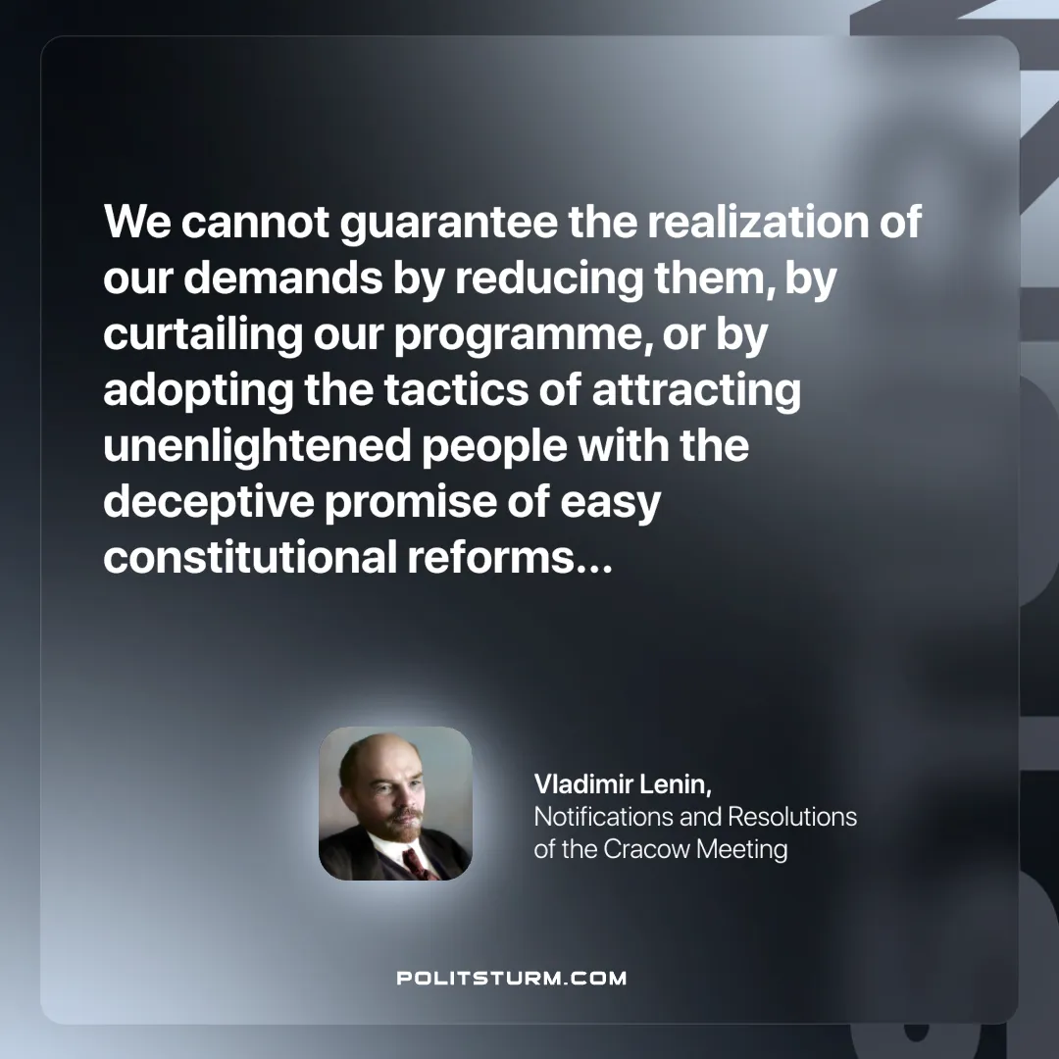

Original article
2025-04-05

"We cannot guarantee the realization of our demands by reducing them, by curtailing our programme, or by adopting the tactics of attracting unenlightened people with the deceptive promise of easy constitutional reforms..."
Vladimir Lenin, Notification and Resolutions of the Cracow Meeting

Original article

