Lenin on the Strength of Social-Chauvinism
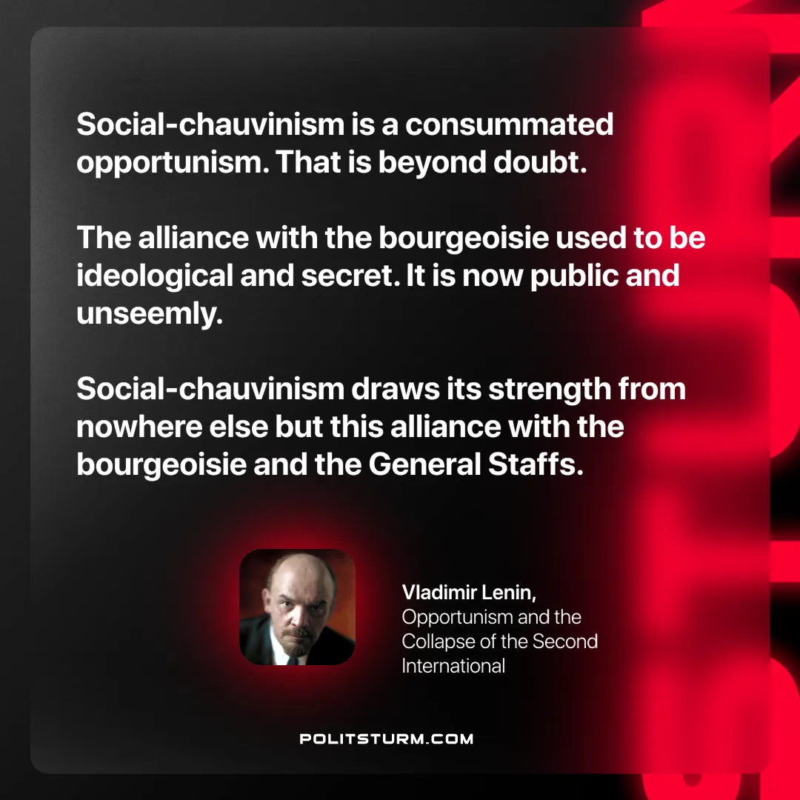

Original article
2025-03-25

“Social-chauvinism is a consummated opportunism. That is beyond doubt. The alliance with the bourgeoisie used to be ideological and secret. It is now public and unseemly. Social-chauvinism draws its strength from nowhere else but this alliance with the bourgeoisie and the General Staffs.”
Vladimir Lenin, Opportunism and the Collapse of the Second International

Original article

