Konstantinov on the Victory of Socialism
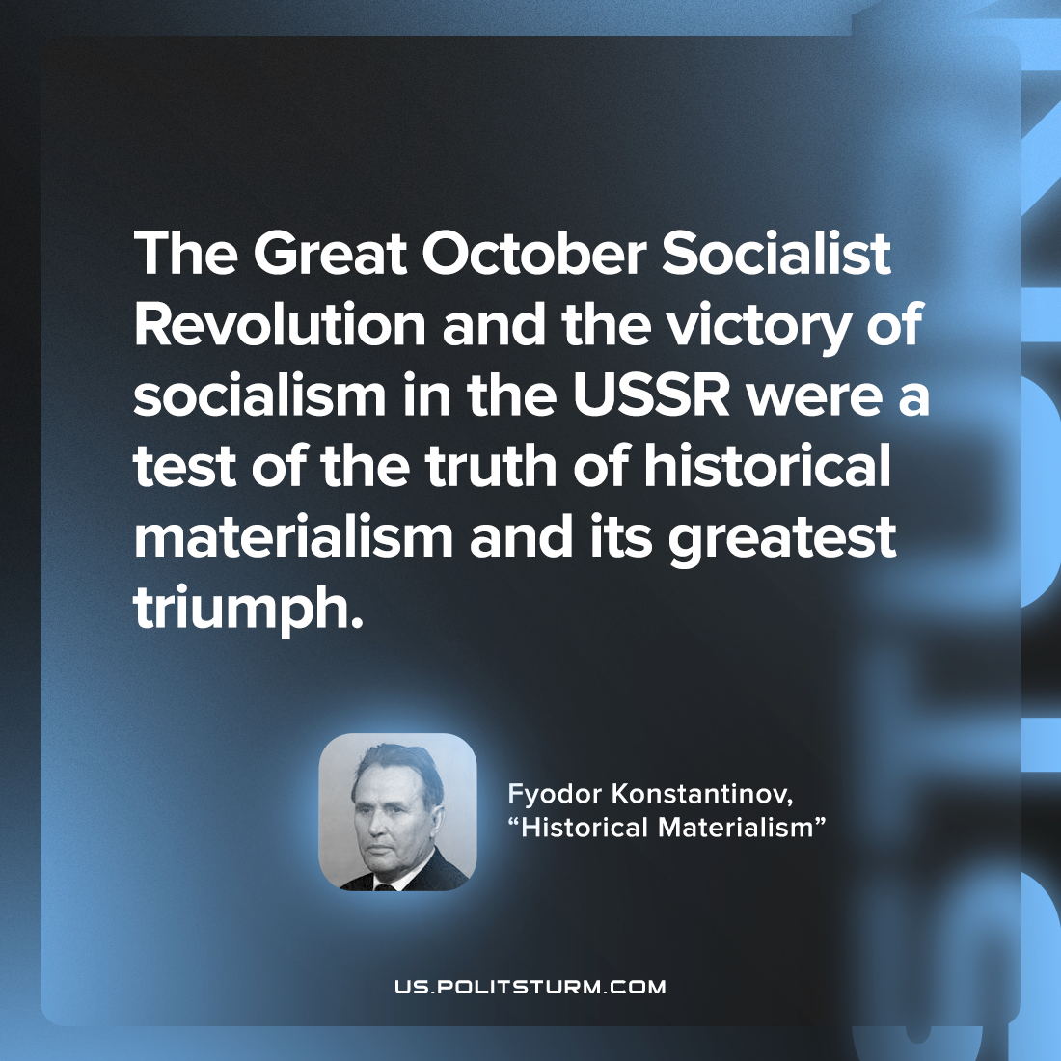

Original article
2022-09-15

The Great October Socialist Revolution and the victory of socialism in the USSR were a test of the truth of historical materialism and its greatest triumph.

Fyodor Konstantinov, “Historical Materialism”

Original article

