Konstantinov on the Transition from Capitalism to Socialism
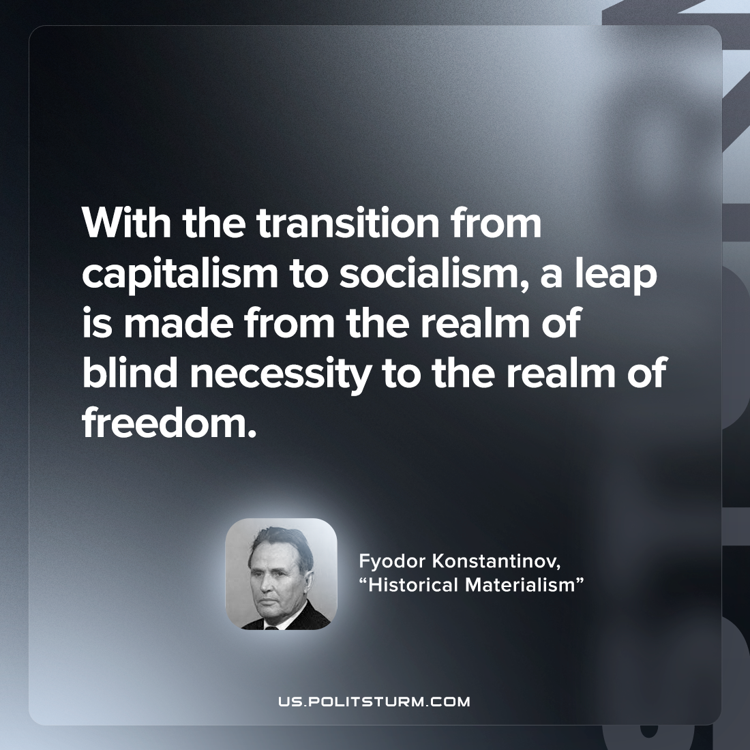

Original article
2022-10-06

With the transition from capitalism to socialism, a leap is made from the realm of blind necessity to the realm of freedom.

Fyodor Konstantinov, “Historical Materialism”

Original article

