Konstantinov on the Lessons of Historical Materialism
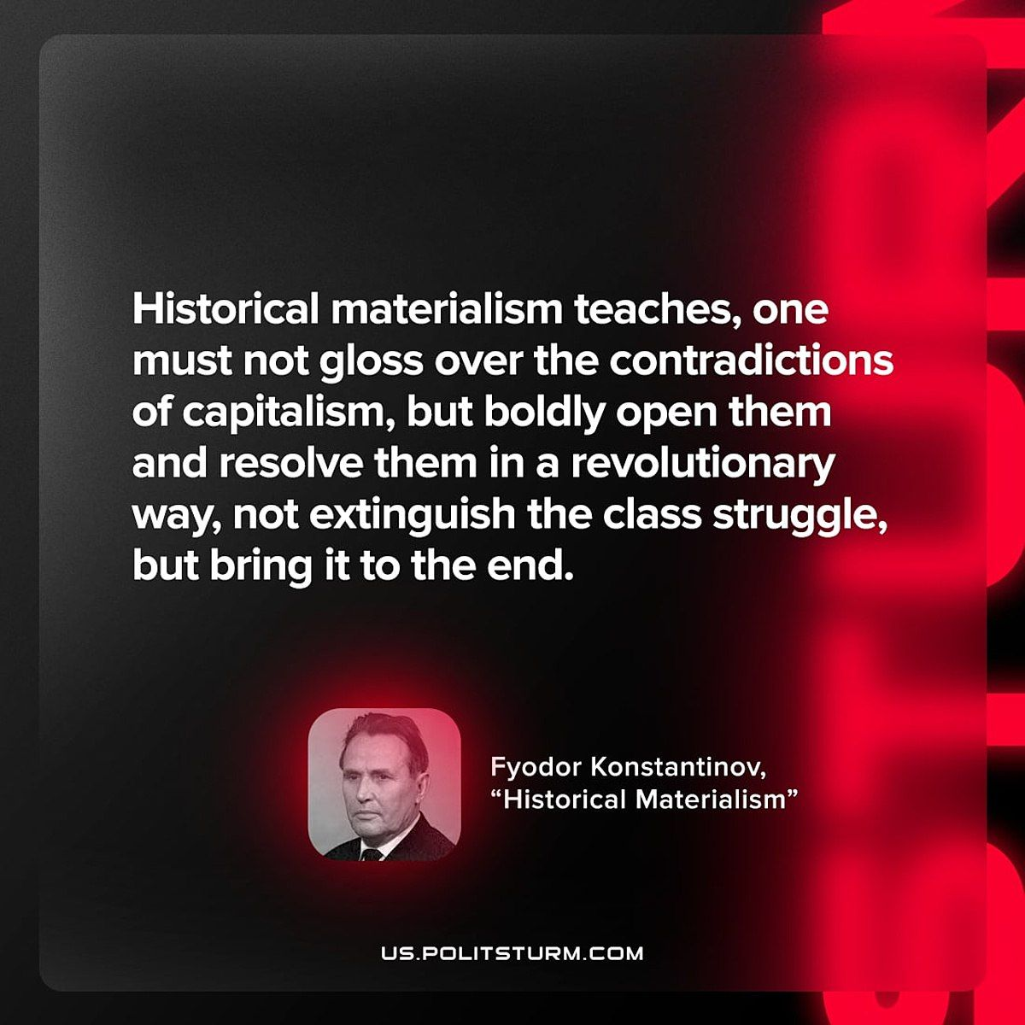

Original article
2023-02-05

"Historical materialism teaches, one must not gloss over the contradictions of capitalism, but boldly open them and resolve them in a revolutionary way, not extinguish the class struggle, but bring it to the end."
Fyodor Konstantinov, "Historical Materialism"

Original article

