Konstantinov on the Communist Ideology
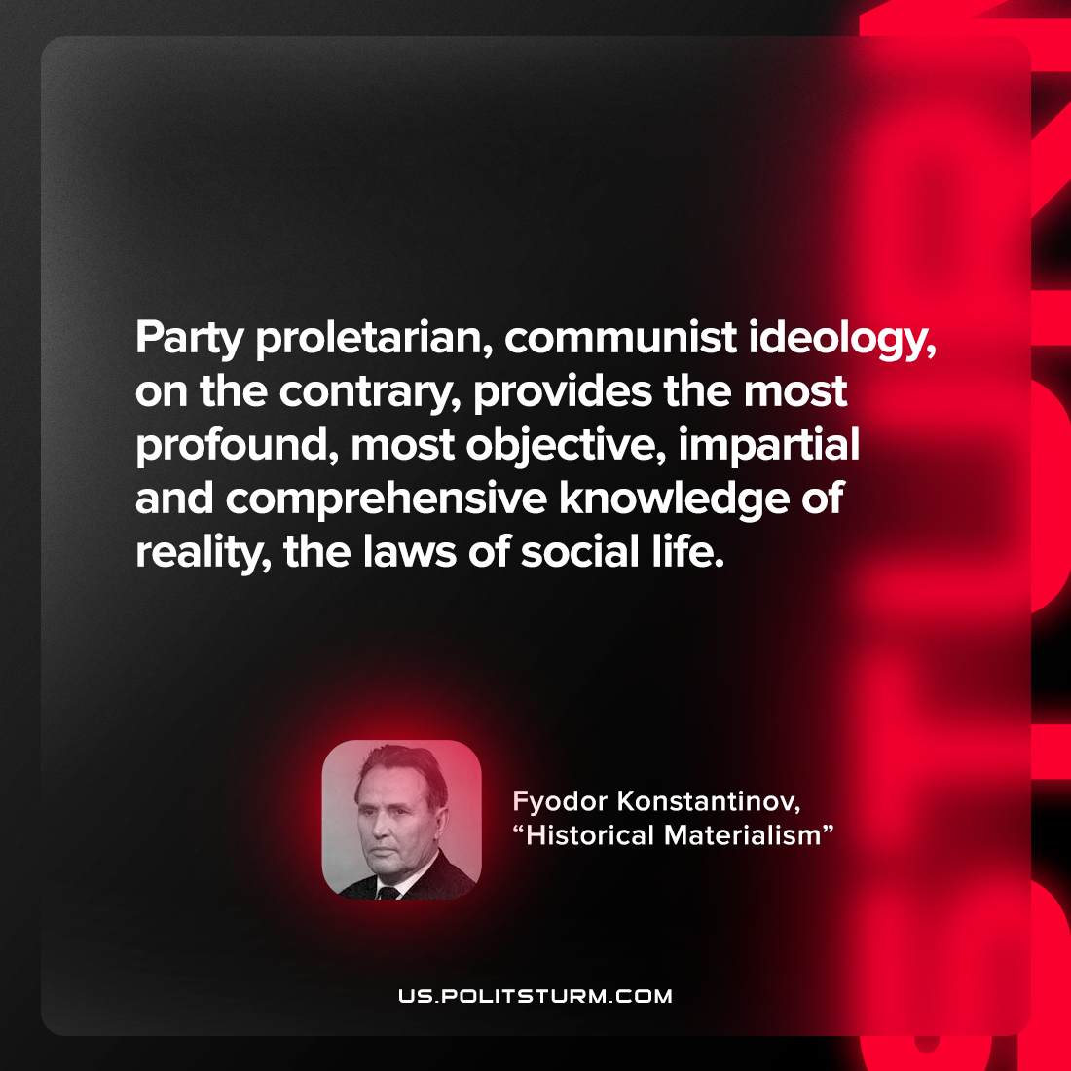

Original article
2022-11-02

Party proletarian, communist ideology, on the contrary, provides the most profound, most objective, impartial and comprehensive knowledge of reality, the laws of social life.

Fyodor Konstantinov, “Historical Materialism”

Original article

