Konstantinov on Pre-Marxian Materialism
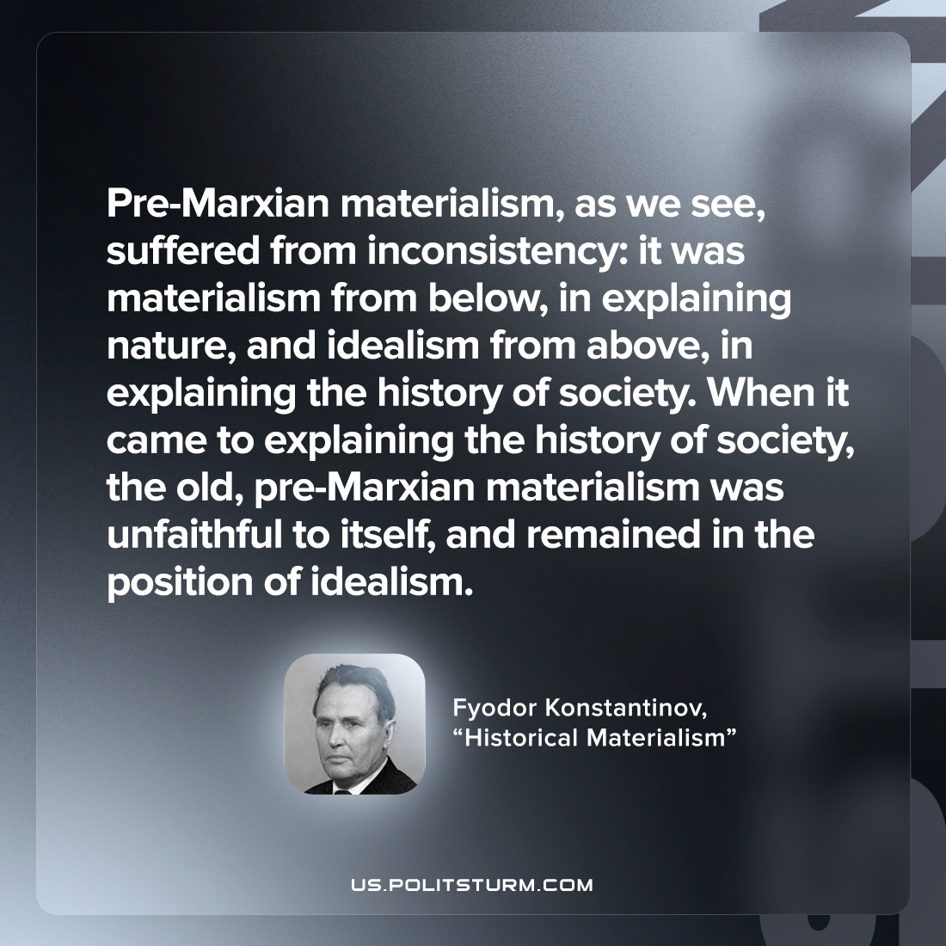

Original article
2022-09-07

Pre-Marxian materialism, as we see, suffered from inconsistency: it was materialism from below, in explaining nature, and idealism from above, in explaining the history of society. When it came to explaining the history of society, the old, pre-Marxian materialism was unfaithful to itself, and remained in the position of idealism.
Fyodor Konstantinov, “Historical Materialism”

Original article

