Konstantinov on Marxist Social Theory
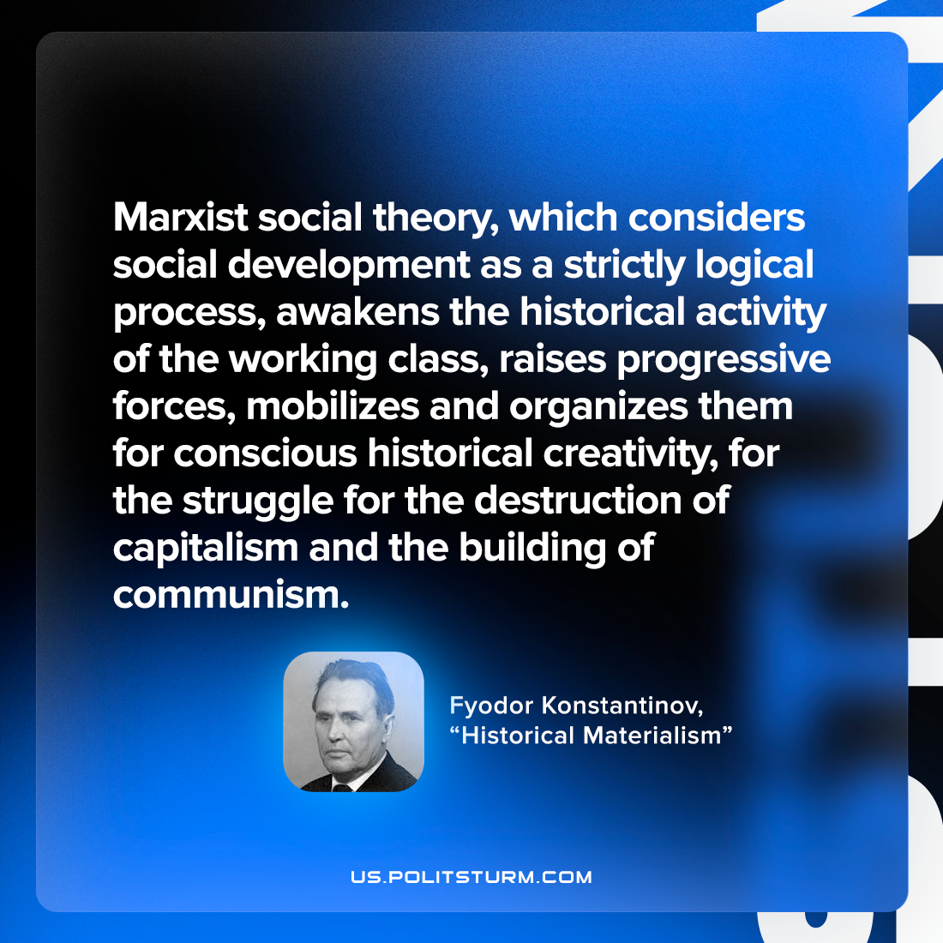

Original article
2022-09-23

Marxist social theory, which considers social development as a strictly logical process, awakens the historical activity of the working class, raises progressive forces, mobilizes and organizes them for conscious historical creativity, for the struggle for the destruction of capitalism and the building of communism.

Fyodor Konstantinov, “Historical Materialism”

Original article

