Konstantinov on Historical Materialism
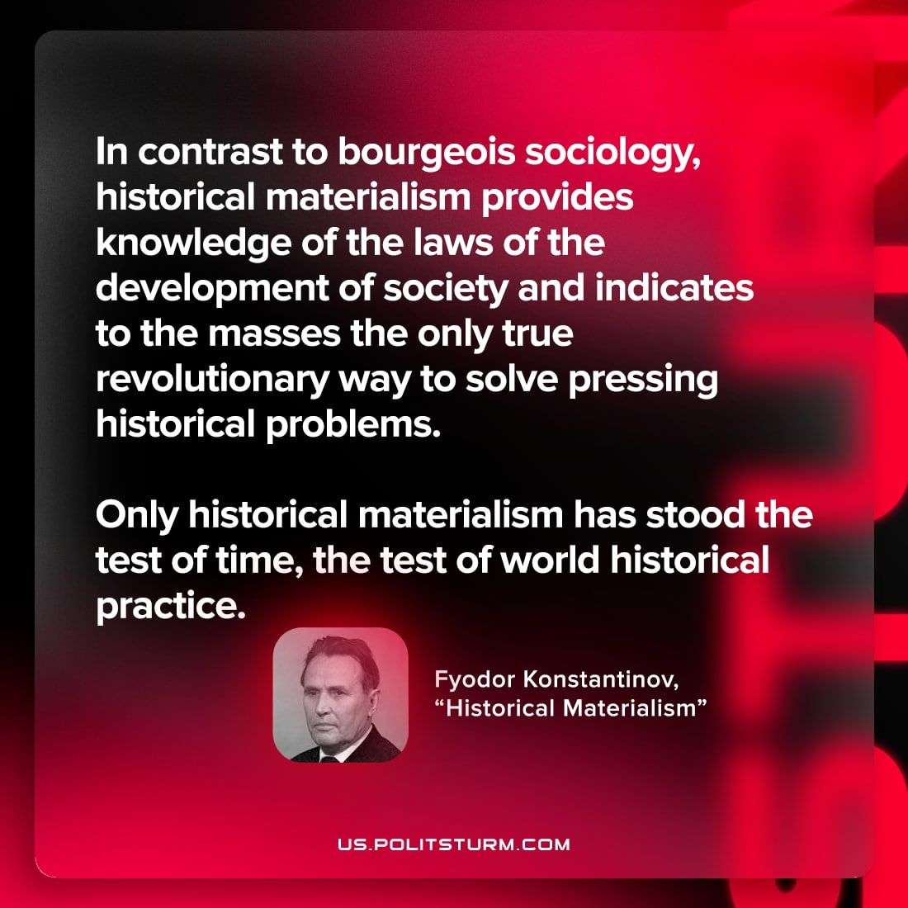

Original article
2023-01-10

"In contrast to bourgeois sociology, historical materialism provides knowledge of the laws of the development of society and indicates to the masses the only true revolutionary way to solve pressing historical problems. Only historical materialism has stood the test of time, the test of world historical practice."
Fyodor Konstantinov, "Historical Materialism"

Original article

