Konstantinov on Bourgeois Sociologists
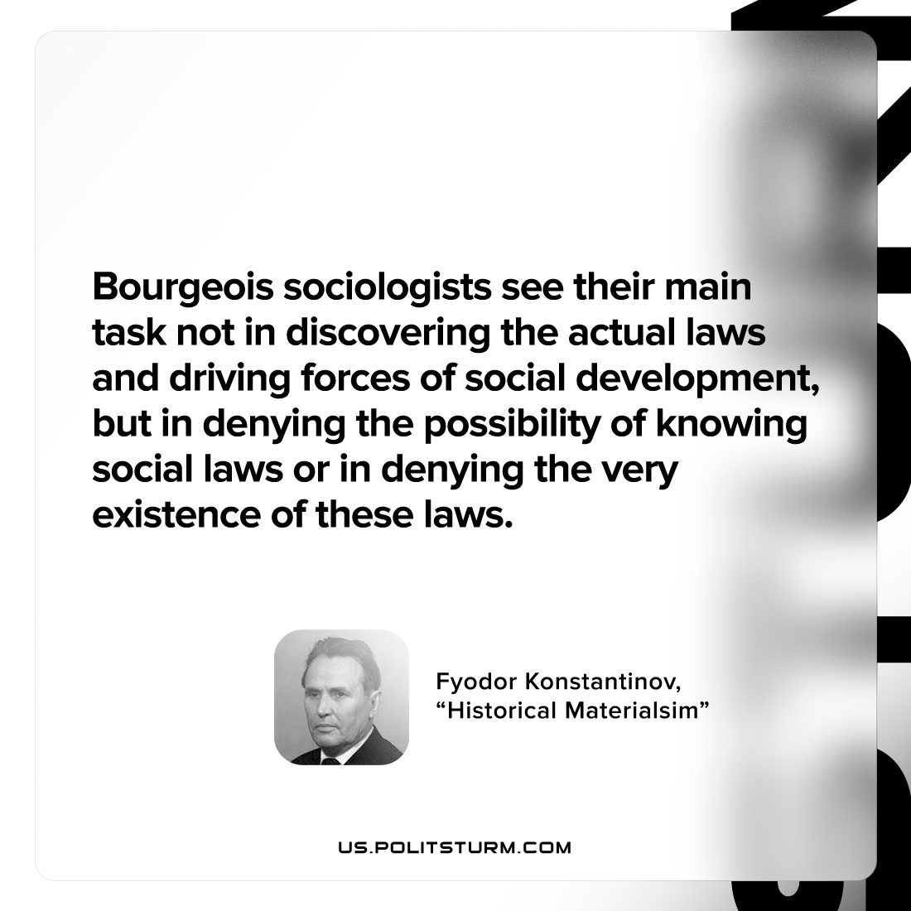

Original article
2022-11-15

Bourgeois sociologists see their main task not in discovering the actual laws and driving forces of social development, but in denying the possibility of knowing social laws or in denying the very existence of these laws.

Fyodor Konstantinov, “Historical Materialism”

Original article

