Konstantinov on Bourgeois Ideology
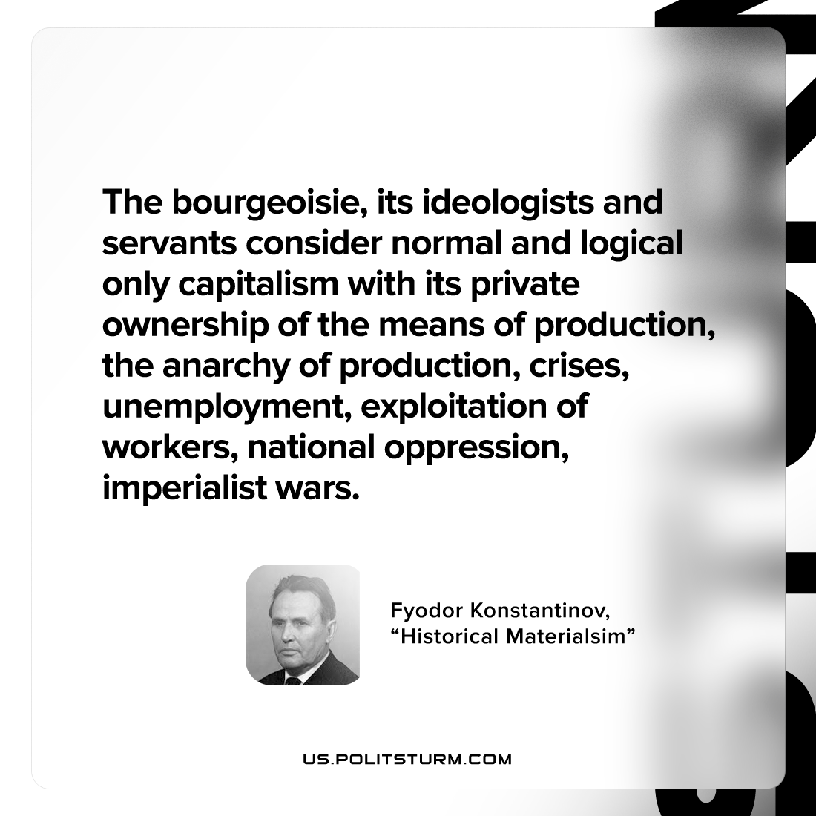

Original article
2022-09-03

The bourgeoisie, its ideologists and servants consider normal and logical only capitalism with its private ownership of the means of production, the anarchy of production, crises, unemployment, exploitation of workers, national oppression, imperialist wars.

Fyodor Konstantinov, “Historical Materialism”

Original article

