Konstantinov on Aggravation of Contradictions
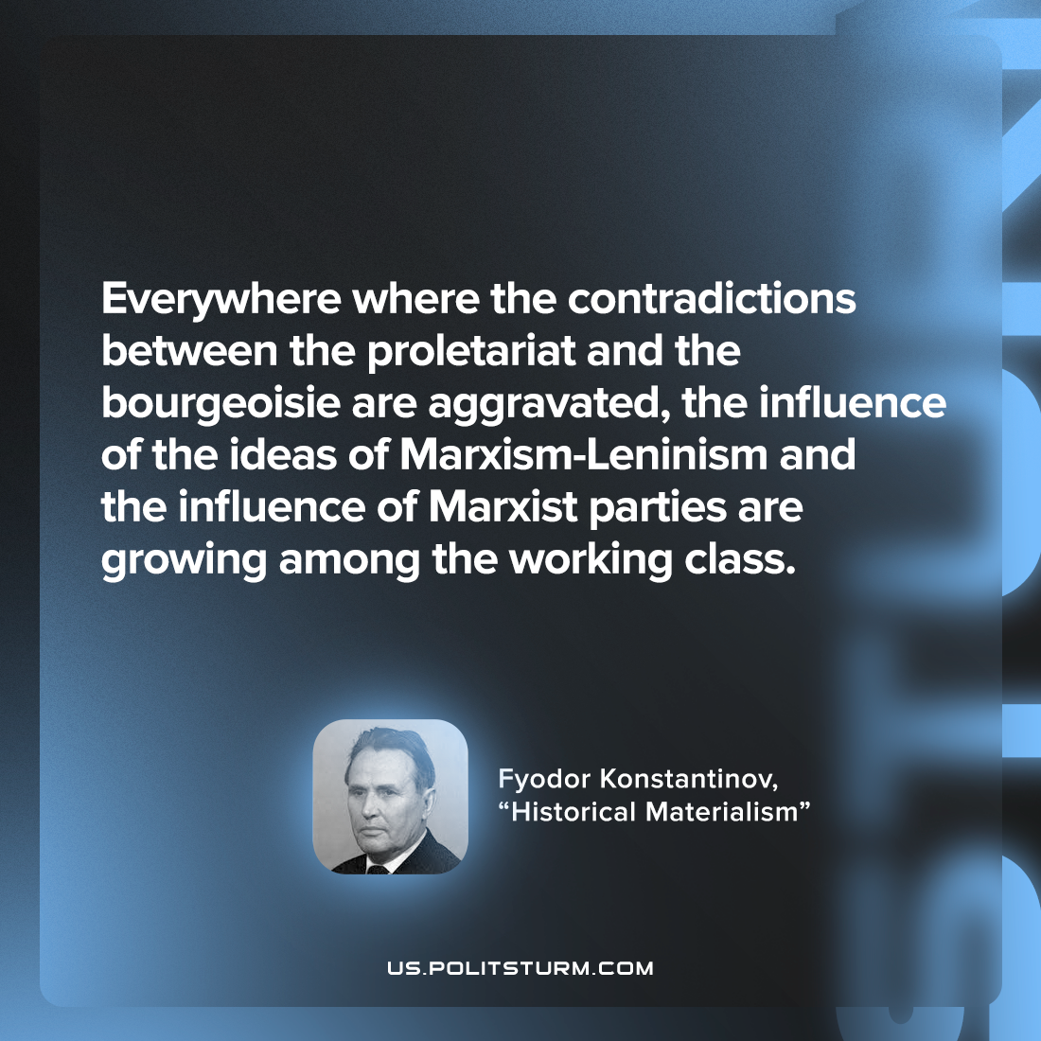

Original article
2022-09-29

Everywhere where the contradictions between the proletariat and the bourgeoisie are aggravated, the influence of the ideas of Marxism-Leninism and the influence of Marxist parties are growing among the working class.

Fyodor Konstantinov, “Historical Materialism”

Original article

