Kingston Coal Ash Cleanup Workers Sue Jacobs Engineering
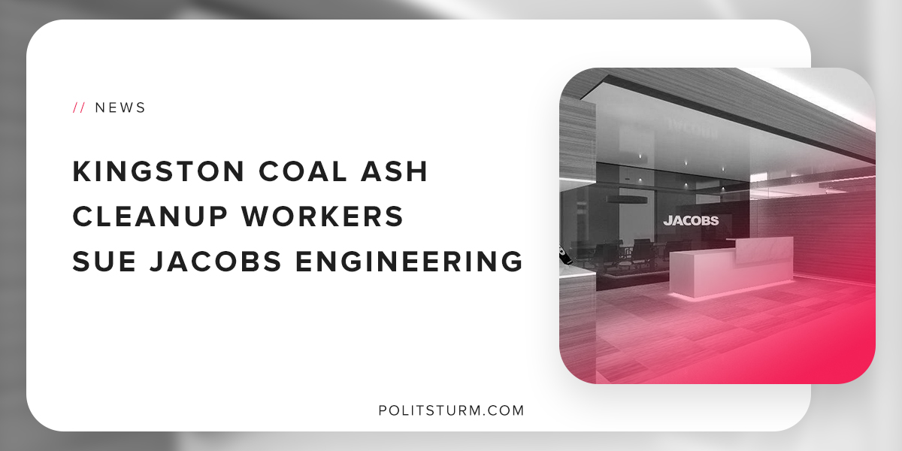

Original article
2018-11-11
1 min read

On December 22,2008 a structural problem caused waste generated by the Tennessee Valley Authority (TVA) Kingston Fossil Plant to contaminate the surrounding environment. The Tennessee Valley Authority contracted Jacobs Engineering to provide the technical services to clean up the waste.
Tennessee ratepayers paid Jacobs Engineering over $64 million to complete the project. During the cleanup, over 30 workers have died and over 250 are seriously injured and dying due to the horrendous working conditions.
Coal ash is a waste that is generated when coal is burned, in this case at the Kingston TVA electricity generating plant. Coal ash contains arsenic, lead, mercury, cadmium, and many other harmful chemicals which are too dangerous for human contact.
Exposure to coal ash can lead to serious injury and death. It is important to see the connection between the tragic outcomes and the capitalist economic system.
Money from the people of Tennessee is funnelled into private corporations who are solely concerned with making a profit. The employers cut corners with respect to the proper attention to worker safety, and workers are killed, hurt, and exploited unnecessarily.
The disaster of the initial breach is compounded by another disaster for the workers, the families, and community.
Sources: 1 2 3

Original article

