Helen Keller on Lenin
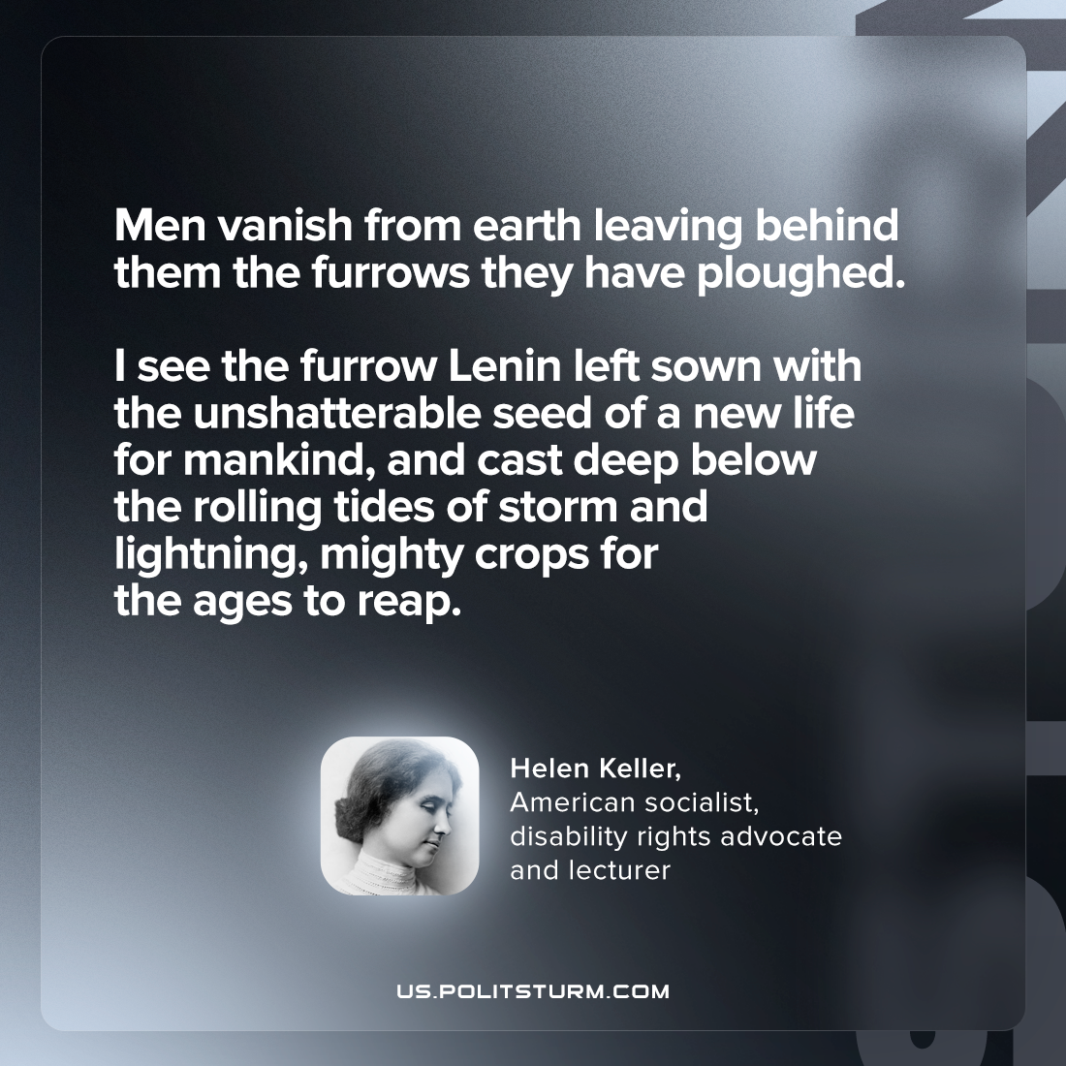

Original article
2022-07-21

Men vanish from earth leaving behind them the furrows they have ploughed. I see the furrow Lenin left sown with the unshatterable seed of a new life for mankind, and cast deep below the rolling tides of storm and lightning, mighty crops for the ages to reap.

Helen Keller, “The Spirit of Lenin”

Original article

