Keir Starmer Comes Under Pressure to Resign
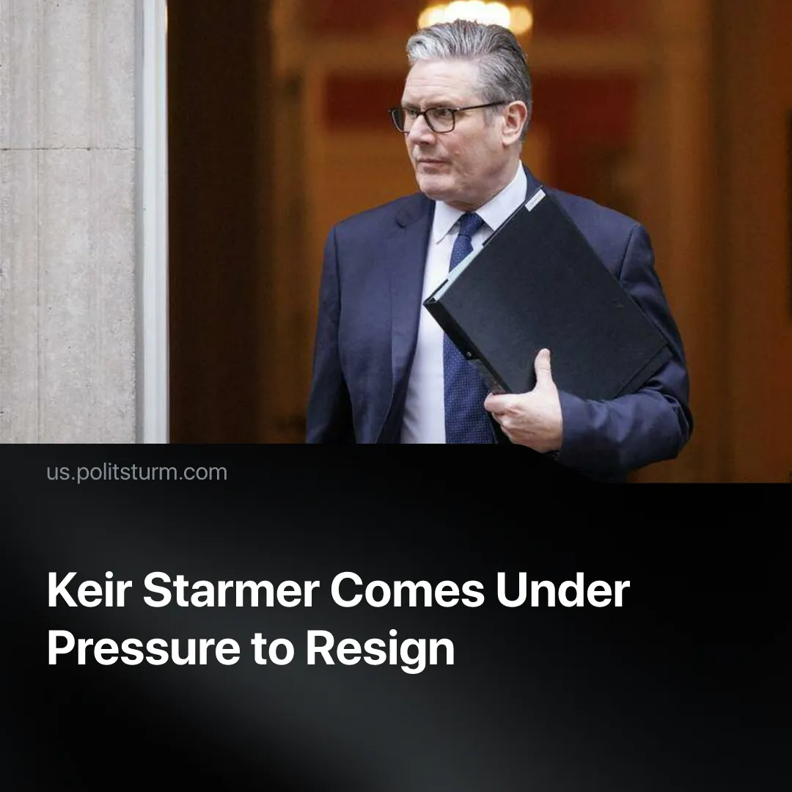

Original article
2026-02-12
1 min read

Senior Starmer ally calls for his resignation, reflecting weakening capitalist “democratic” rule in Europe.
Details. Scottish Labour leader Anas Sarwar has called for UK Prime Minister Keir Starmer to resign. Formerly a major backer, Sarwar now denounces the Labour government’s “too many mistakes” and demands a change in leadership.
► Labour-affiliated yellow unions, the right-wing opposition Reform UK and the Conservative Party, the Liberal Democrats, and the “left-wing” opposition Greens have also called for Starmer’s resignation.
► The Prime Minister responded that he will “never walk away.” Despite mounting attacks, the cabinet and most senior Labour politicians rallied to his defence. This included major internal rivals, who chose not to challenge Starmer for leadership yet – but the government’s position remains fragile.
Context. This UK political crisis was sparked by a scandal. The British ambassador to the US was revealed, through newly released FBI files, to have been a long-standing collaborator of American paedophile capitalist Jeffrey Epstein. Starmer knew of this when he appointed him.
► Within days, the Prime Minister’s chief of staff, his communications director, and his cabinet secretary all tendered their resignations due to their involvement.
► This follows another scandal, in which Starmer’s Deputy Prime Minister resigned after an investigation for tax fraud. Starmer is massively disliked with the British public – now reported as the most unpopular Prime Minister on record. Speculation about his resignation was already high in November, even before the Epstein revelations.
► Starmer’s government has overseen continued declines in living standards, expanded policing and surveillance, and renewed attempts to maintain or deepen austerity, before facing pushback from both the public and his own party.
► The previously ruling Conservative Party faced a similar crisis, rotating through multiple deeply unpopular Prime Ministers within months. This parliamentary crisis is not unique to Britain. France has seen its sixth government collapse in just two years, driven by Macron’s lack of a majority and repeated calls for snap elections. In Germany, the ruling liberal coalition abruptly shattered last year, triggering an election. In all three countries, far-right parties have recently topped the polls.

Original article

