Karl Marx on Revolutionary Class
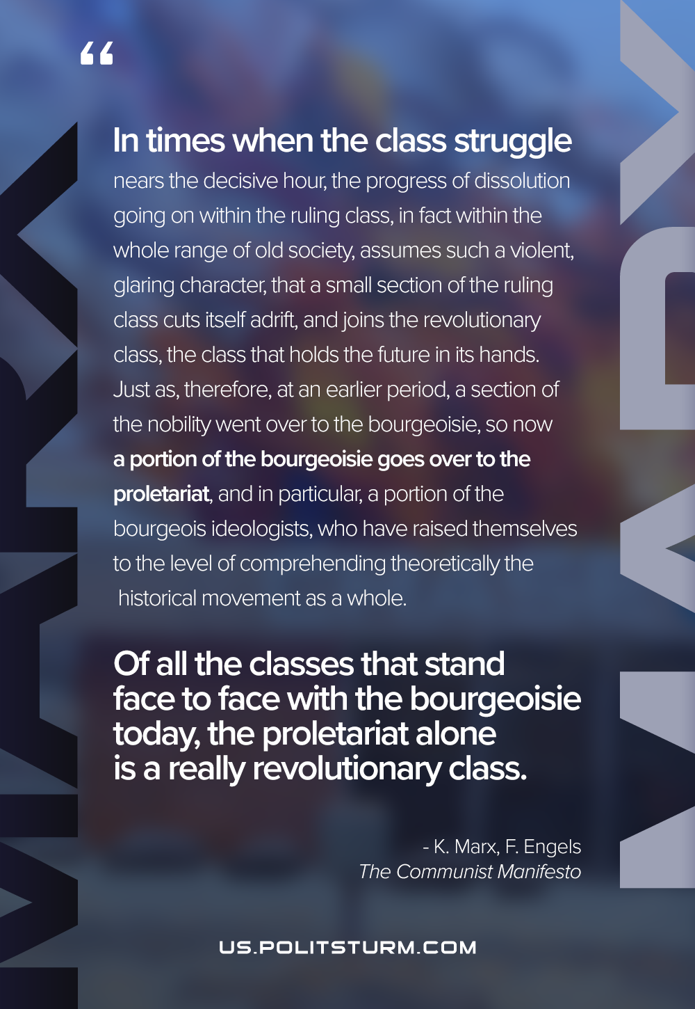

Original article
2021-05-06
1 min read

“Finally, in times when the class struggle nears the decisive hour, the progress of dissolution going on within the ruling class, in fact within the whole range of old society, assumes such a violent, glaring character, that a small section of the ruling class cuts itself adrift, and joins the revolutionary class, the class that holds the future in its hands. Just as, therefore, at an earlier period, a section of the nobility went over to the bourgeoisie, so now a portion of the bourgeoisie goes over to the proletariat, and in particular, a portion of the bourgeois ideologists, who have raised themselves to the level of comprehending theoretically the historical movement as a whole.
Of all the classes that stand face to face with the bourgeoisie today, the proletariat alone is a really revolutionary class. The other classes decay and finally disappear in the face of Modern Industry; the proletariat is its special and essential product.”
Karl Marx and Friedrich Engels, “Manifesto of the Communist Party”

Original article

