Marx on Fictitious Independence
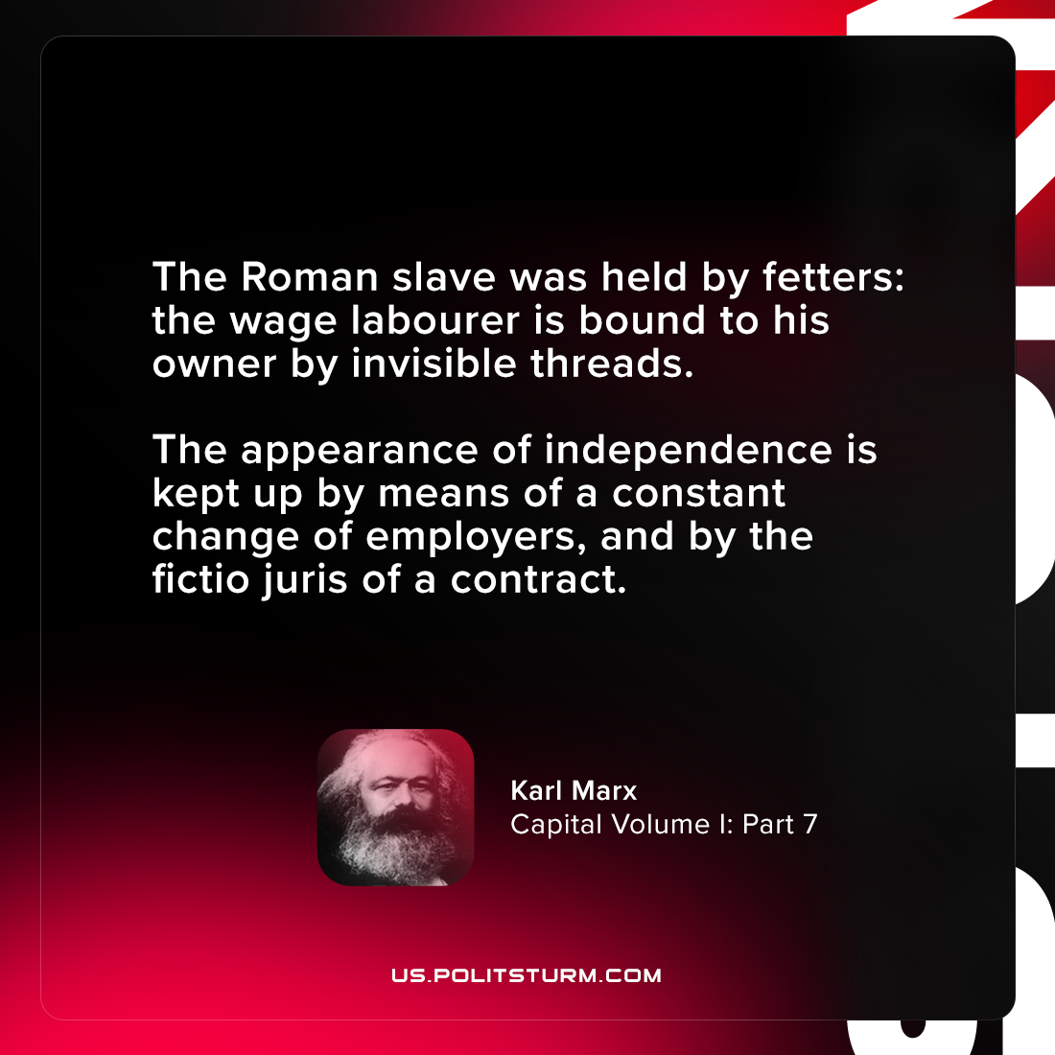

Original article
2021-07-18

The Roman slave was held by fetters: the wage labourer is bound to his owner by invisible threads. The appearance of independence is kept up by means of a constant change of employers, and by the fictio juris of a contract.

Karl Marx, “Capital Volume I: Part 7”

Original article

