Karl Marx – 204th Anniversary
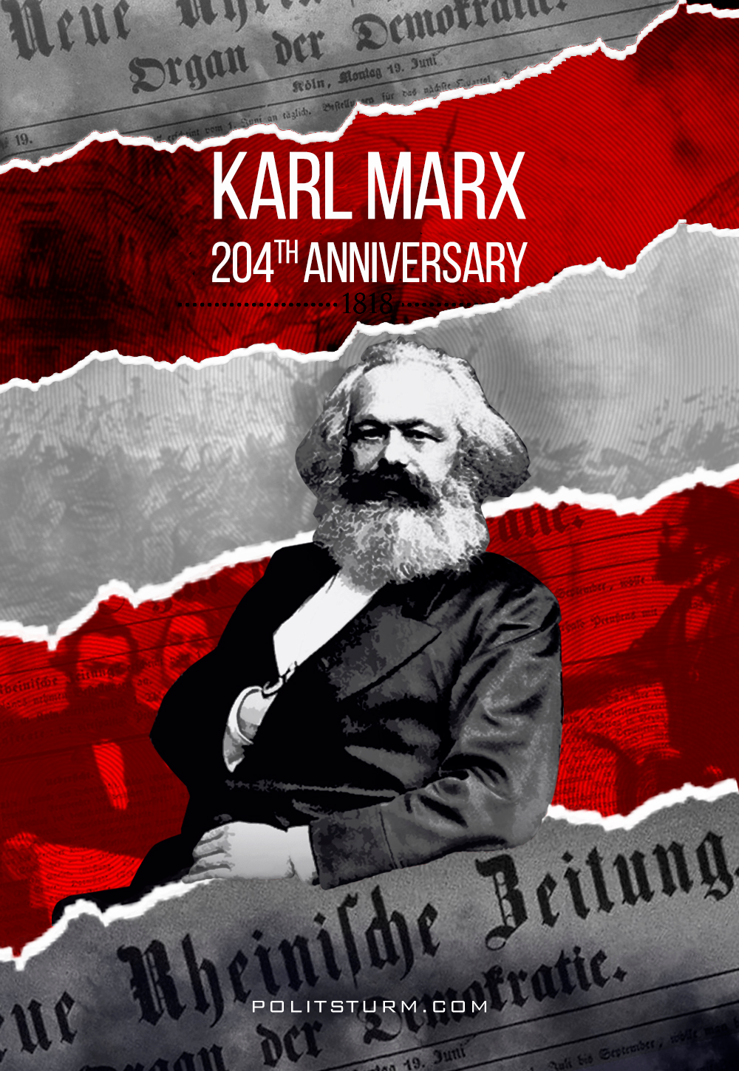

Original article
2022-05-05
1 min read

“Marx was the best hated and most calumniated man of his time. Governments, both absolutist and republican, deported him from their territories. Bourgeois, whether conservative or ultra-democratic, vied with one another in heaping slanders upon him. All this he brushed aside as though it were a cobweb, ignoring it, answering only when extreme necessity compelled him. And he died beloved, revered and mourned by millions of revolutionary fellow workers. Though he may have had many opponents, he had hardly one personal enemy. His name will endure through the ages, and so also will his work.“ – Friedrich Engels.
On the birthday of one of the greatest thinkers, philosophers, economists and figures in the history of humanity, teacher and leader of the world proletariat, whose ideas turned the world upside down and are still super relevant, we recommend everyone to read the article of his no less famous follower: “Karl Marx, A Brief Biographical Sketch With an Exposition of Marxism”

Original article

