Julius Fučík on Humanity
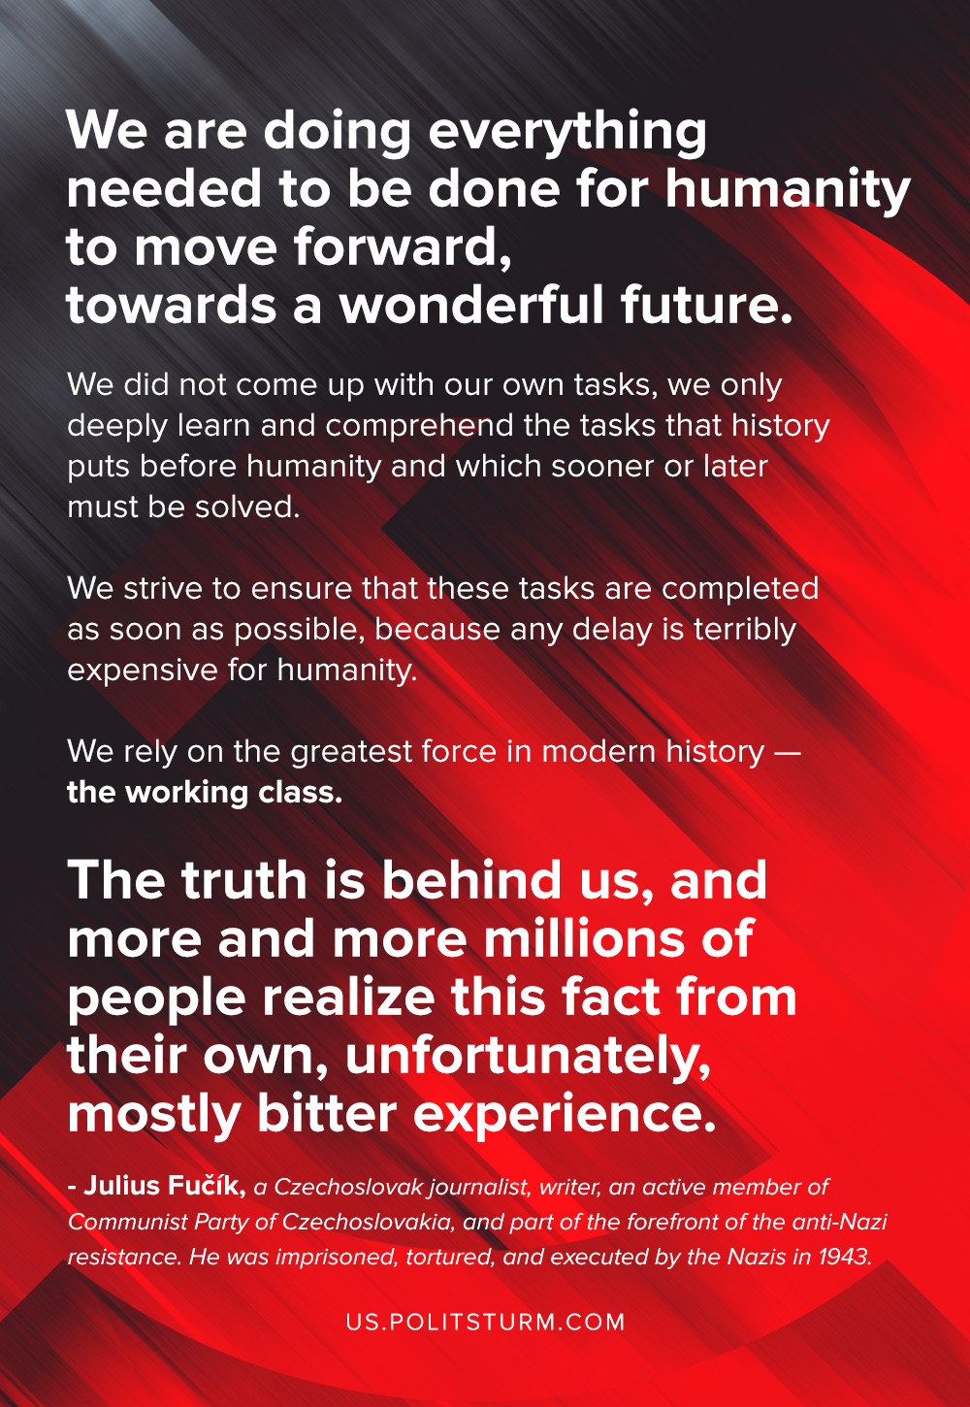

Original article
2020-09-15
1 min read

We are doing everything needed to be done for humanity to move forward, towards a wonderful future.
We did not come up with our own tasks, we only deeply learn and comprehend the tasks that history puts before humanity and which sooner or later must be solved. We strive to ensure that these tasks are completed as soon as possible, because any delay is terribly expensive for humanity.
We rely on the greatest force in modern history — the working class. The truth is behind us, and more and more millions of people realize this fact from their own, unfortunately, mostly bitter, experience.
Julius Fučík — a Czechoslovak journalist, writer, an active member of Communist Party of Czechoslovakia, and part of the forefront of the anti-Nazi resistance. He was imprisoned, tortured, and executed by the Nazis in 1943.

Original article

