Judge Dismisses Safety Amazon Worker Safety Suit
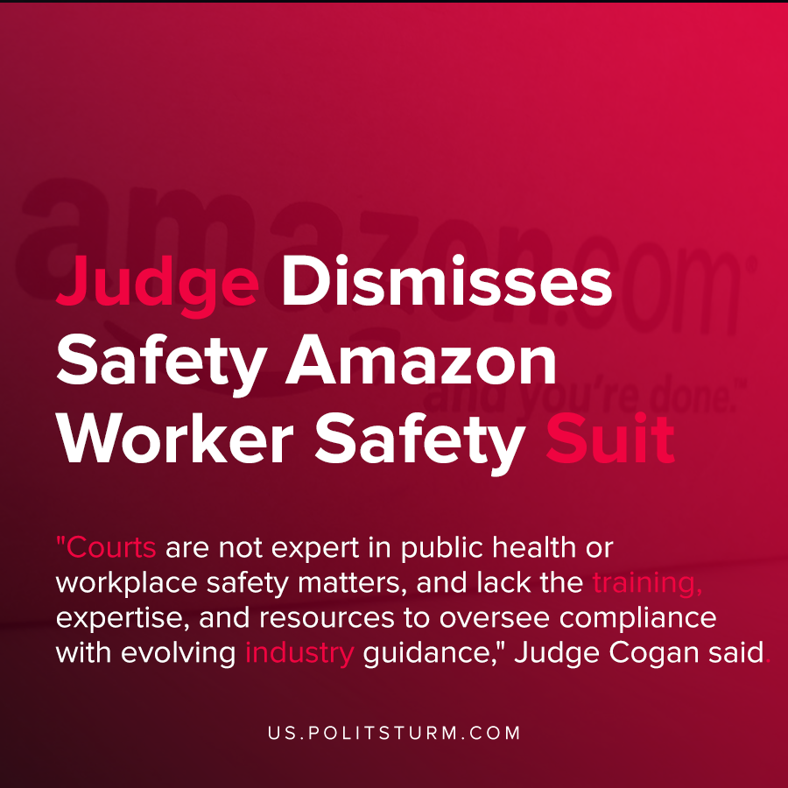

Original article
2020-11-05
1 min read

In June, workers at the JFK8 Amazon Fulfillment Center brought a lawsuit against Amazon alleging the company practices put worker safety in jeopardy in light of the COVID-19 pandemic.
The workers who brought the suit said that the company did not take adequate measures to sanitize surfaces, provide contact tracing, etc.
Even when it meant small decreases in worker productivity to ensure safety, the company would not take adequate safety measures to a degree that prevented serious harm and infection to its workers. The company even stated that almost 20,000 of its employees have been confirmed or presumed infected with COVID-19.
U.S Federal Judge Brian Cogan dismissed the claims made by the workers by alleging that it was not the place of the courts to discuss these matters.
“Courts are not expert in public health or workplace safety matters, and lack the training, expertise, and resources to oversee compliance with evolving industry guidance,” Judge Cogan said.
Cogan essentially pushed the dispute over to the regulatory Occupational Safety and Health Administration saying that the courts were not the proper avenue to provide a ruling.
Both the courts and the regulatory agencies are not independent and apolitical institutions, but rather serve a definite class function. The courts are unable to rule against the interests of the capitalists, nor are the regulatory agencies willing and able to protect the workers and their class interests. This ruling is further proof that the courts serve the capitalists, and not the workers.
Source: 1 , 2 , 3

Original article

