Joker: Ode to Rebellion
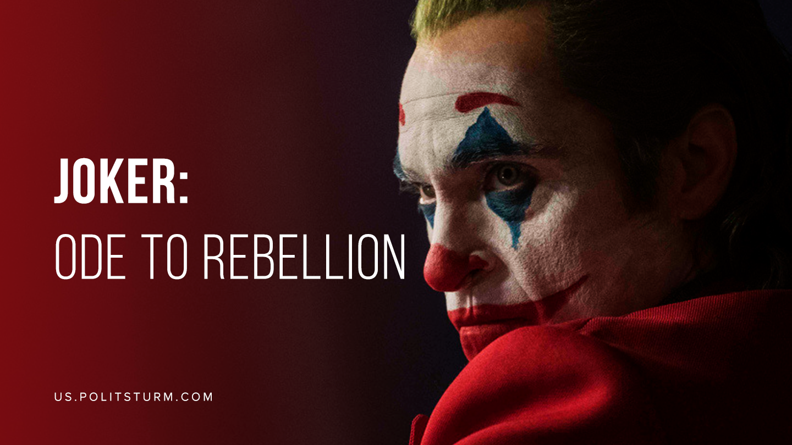

Original article
2019-11-02
9 min read

This fall the world saw the movie ‘Joker’ produced by Warner Bros. The movie tells a story of the anti-hero of the DC universe. It won the Golden Lion at 76th Venice International Film Festival, and it has many positive reviews. While some critics are right about the movie’s topic about class inequality, they still overestimate the significance of the movie. Indeed the movie has a particular meaning but it’s not the one people imagine it has – that’s why we are going to try to break it down from Marxist point of view. Note: the text below may contain spoilers.

Arthur’s Background
“Joker” tells the story of becoming an anti-hero and has two clear storylines: the story of the character himself and the world he lives in. Both storylines are interdependent: connected by a common narrative and idea.
Arthur Fleck, soon-to-become a villain, lives together with his ill mother who needs to be taken care of in a deprived area of an imaginary city of Gotham. The main character has a neurological (possibly psychiatric) disorder that makes the character laugh uncontrollably in stressful or overwhelming situations. To handle it the hero undergoes therapy and takes medications, prescribed by social services.
Error loading image
To take care of his mother and buy the medicine Arthur works as a clown, dreaming of becoming a popular stand-up comedian. He is inspired by the famous television comedian Murray Franklin. One day, at work, he is attacked by local gang; they break the poster and beat him badly. His co-worker, minding Arthur’s naivety, frames him up, convincing him to carry a gun for self-defense. While performing at a children’s hospital, he accidentally drops the gun and that becomes the reason for his dismissal. Depressed and frustrated, Arthur encounters drunks in the subway on his way home. They harass a girl who is looking at him asking for help. Caught up in a stressful situation, Arthur again breaks out of an uncontrollable laughter, which the drunks consider to be an insult and begin beating him. In the heat of passion Arthur kills them. All this worsens his general condition and leads him to becoming a villain.
Having stopped taking drugs and admitting the pleasure he receives from an act of violence, Arthur Fleck gradually turns into that crazy maniac – Joker. After committing his most high-profile crime live, he becomes an inspiration for extremely poor citizens and various marginalized groups of Gotham. The clown’s mask and the costume become the symbols of protests.
Gotham’s class realities
So, ‘Joker’ would have remained a typical story of a humiliated and devastated man, who is dissatisfied with his life, and gives up to the harsh circumstances and moves to the “dark side”. But here comes something that makes the 2019 ‘Joker’ stand out from a series of similar films, that evokes such an excitement. And this is an emphasis on the reasons that pushed the mentally unhealthy Arthur Fleck to the crimes he committed that are property inequalities and class antagonism related to it.
The whole story of Joker takes place in a fictional city that is a clear allusion to the modern bourgeois society. In Gotham there is a blatant stratification of property, and the city itself is literally cluttered with trash. The problem of garbage disposal and recycling is so acute that new species of rats inhabit the sewage system of Gotham and so there is never-ending civil disturbance because of these problems. And in the same city where impoverished proletariat lives there are also wealthy capitalists who cut down the social budget of the city in pursuit of profit and openly boast of their wealth.
Moreover, the entire political system is not interested in resolving the social and economic problems of the inhabitants. Tied to authority, the oligarchs increase their wealth and just fire social workers and cut off their funding. As a result, ill and obviously unhealthy people like Arthur Fleck are left without proper treatment.
Thus, Gotham is shown as a city where the class contradictions of the capitalist system are brought to an extreme limit, in fact, to a revolutionary situation. The tension and class hatred are so high that only one case of killing members from wealthy families is enough for the people to massively proclaim the killer to be a “scourge of the rich”, and wear similar clown costume, expressing approval of the very act of killing the rich.
The issue of poverty and growing intensity of class hatred among the inhabitants of Gotham are constantly mentioned on television and newspapers throughout the movie. In this regard, the director of ‘Joker’, Todd Phillips, clearly shows the class inequality theme of the movie, alluding to the fact that it is precisely material inequality, cutting social budget items, and private-proprietary egoism of the wealthy groups of the city that caused the conflict. But in the manner of any bourgeois producer, the producers of ‘Joker’ depict these problems from a purely bourgeois point of view.
As we already said, the film shows the existence of class contradictions by depicting a political conflict between the rich and the poor. However, despite bringing up the class inequality theme, ‘Joker’ still remains harmless to the bourgeoisie and bourgeois society. The “class war” shown at the end of the film that is riots organized by crowds armed with sticks and stones is petty-bourgeois, anarchist, and radical actionism.
Error loading image
It is true that in times of the bourgeois domination the film clearly shows events similar to those in Hong Kong: crowds smashing windows, beating the police, robbing and killing the rich. This is completely harmless to the bourgeoisie, since what is shown in the film has long been familiar to capitalist governments, and their methodology for suppressing riots has long been known.
The “rebels against the system” who have found themselves in a vivid image of such hatred that is the crazy clown killer do not pose a serious threat to capitalists. The “rebels” lack organization, a clear program of action from a theoretical point of view, and a vision for a future of the society. All they do is senseless cruelty, violence for the sake of violence. The inhabitants of Gotham don’t rebel against the capitalist system that oppresses them; their rebellion has no purpose, is followed by negative consequences for the rebels and only helps them to let off steam.
“Joker” romanticizes the spontaneous uprising of people against the rich, without giving at least some in-depth analysis of the processes taking place in the society, limiting themselves to their depicting. One of the last scenes of the film with a jubilant crowd gathered around Joker clearly confirms this. In this lies both the movie’s bourgeois meaning and the movie’s importance for contemporary art.
Being a bourgeois, filmed by people with a bourgeois outlook, the film does not answer the questions about the origin of property inequality in society, does not look into the reasons why some live in suburban villas and go to see luxury operas, while others are forced to live in ramshackle houses and visit the impoverished municipal hospitals.
But being a bourgeois movie in the modern world, it reflects the processes taking place in a society based on exploitation. It does not give answers to what causes them, but clearly states their presence. And this is what makes the movie so important for contemporary art, because it reflects people’s sentiments. And this importance is clearly stated in the movie. Because the movie is of a bourgeois art that speaks about a constant, hushed up, but continuing tense struggle of the two classes.
The creator exists in the real world and transfers social processes to their work. Even bourgeois art sometimes reflects the realities of the modern world, points to the fact of the existence of class contradictions and class struggle – and Todd Phillips’s movie “Joker” is an example of this.
Conclusion
In conclusion, it is worth saying that the movie actually turned out to be huge. Despite the obvious inconsistency, the message that it bears in itself – the contradictions of bourgeois society – is shown so clearly and visually, and this is something that rarely can be found in modern cinematography. Sure, advocates of an “extra-class approach” to art can always say that the film actually tells a story of an ill person and his metamorphoses.
But these people will never be able to give an unambiguously negative answer to the question of whether Arthur Felk would become a Joker if he lived in more financially secure conditions, in a society guaranteeing him the right to work and where there are no such deep class contradictions.
Error loading image
Conscious workers and communists learn a lesson from the movie. Bourgeois art once again reminds us that if we want to successfully conduct our fight against capitalist system and permanently leave it the past, we need a clearly developed theory, program of action and efficient coordination of actions. Otherwise, succumbing to class hatred and carried away by adventurism, we can repeat the fate of the Gotham revolt: as senseless and merciless as it is harmful, that is only wasting strength and energy of the working class.

Original article

