JBS Workers Charged For COVID Tests and Worked Sick
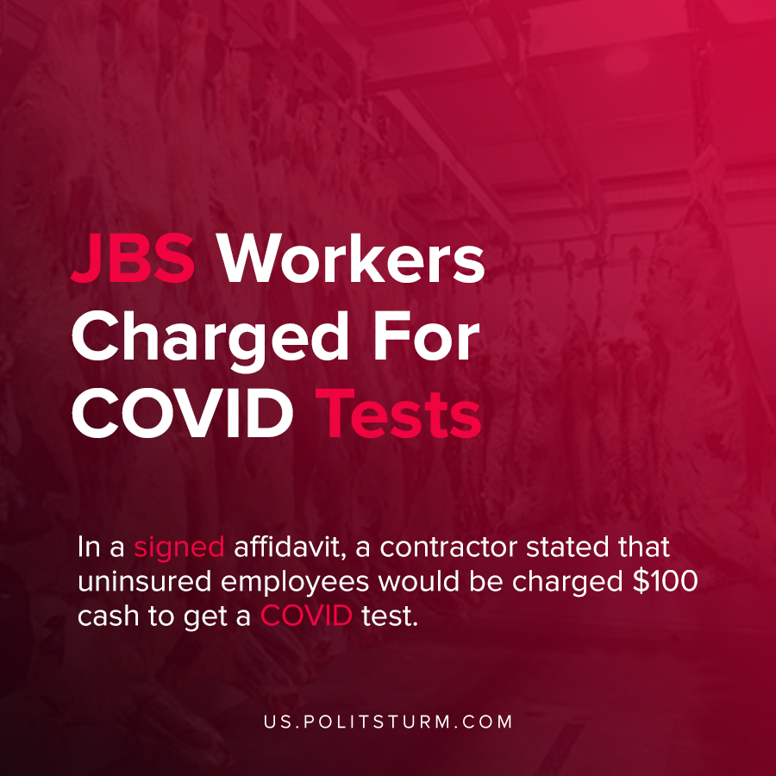

Original article
2020-10-28
1 min read

Whistleblowers at the JBS meatpacking plant in Greely, Colorado revealed the lax measures the employer took to protect employees from COVID-19. In a signed affidavit, a contractor stated that uninsured employees would be charged $100 cash to get a COVID test.
The contractor who was tasked with conducting screenings also said she witnessed employees experiencing COVID symptoms get sent back to work. In addition, it was reported that the equipment used to check employee temperatures was not functioning properly, and attempts to remediate this through the company were ineffectual.
The company spokesperson said that the claims were not true. “Despite unsubstantiated claims from a disgruntled temporary employee, our screening process has been reviewed and approved multiple times by local, state and federal entities, including the CDC”, said Nikki Richardson of corporate communications for JBS USA.
However, many of the claims made by the contractor were substantiated by another second contractor in a separate affidavit.
As the COVID-19 pandemic rages across the country, the capitalist class is still primarily concerned with profits over worker safety. Even employee tests during a pandemic are considered by the capitalists as a mere profit reducing expenditure. As long as the capitalist system continues to exist, profit will be the motivating factor of societal production.
Sources: 1 , 2

Original article

