JBS Fined $15,000 By OSHA After 7 Worker Deaths
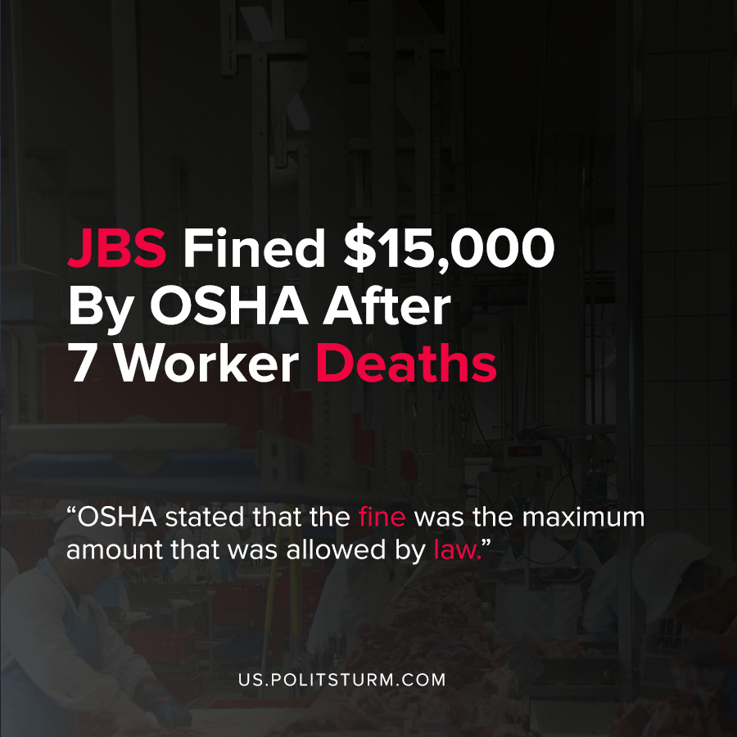

Original article
2020-09-19
1 min read

JBS Meatpacking company received a $15,615 fine from the Occupational Safety and Health Administration (OSHA) in response to exposure of its employees to the coronavirus. OSHA stated that the fine was the maximum amount that was allowed by law.
After factory inspections, it was determined that measures were not taken to prevent exposure to the coronavirus which lead to coronavirus-related death and illness.
Based on the Occupational Safety and Health Act of 1970, employers are technically required to provide for the safety of their employees. However, the fine that was assessed for non-compliance and allowing for harm to employees is very miniscule at only $15,625.
The goal of the Occupational Safety and Health Administration to reconcile the profit-maximizing interests of capitalists and the safety of workers. If the capitalist will only face minimal fines for non-compliance and the costs associated with compliance are greater they will make the decision that maximizes profits.
This minimal fine by OSHA is yet another example of the institutions designed to protect the workers interests serving the capitalist class. The safety and protection of the working class is subordinated to the needs of the capitalists by the extraction of ever-greater profits.
Source: 1 , 2 , 3

Original article

