Japanese Ministry of Defense Requests Record-High Military Budget for 2023
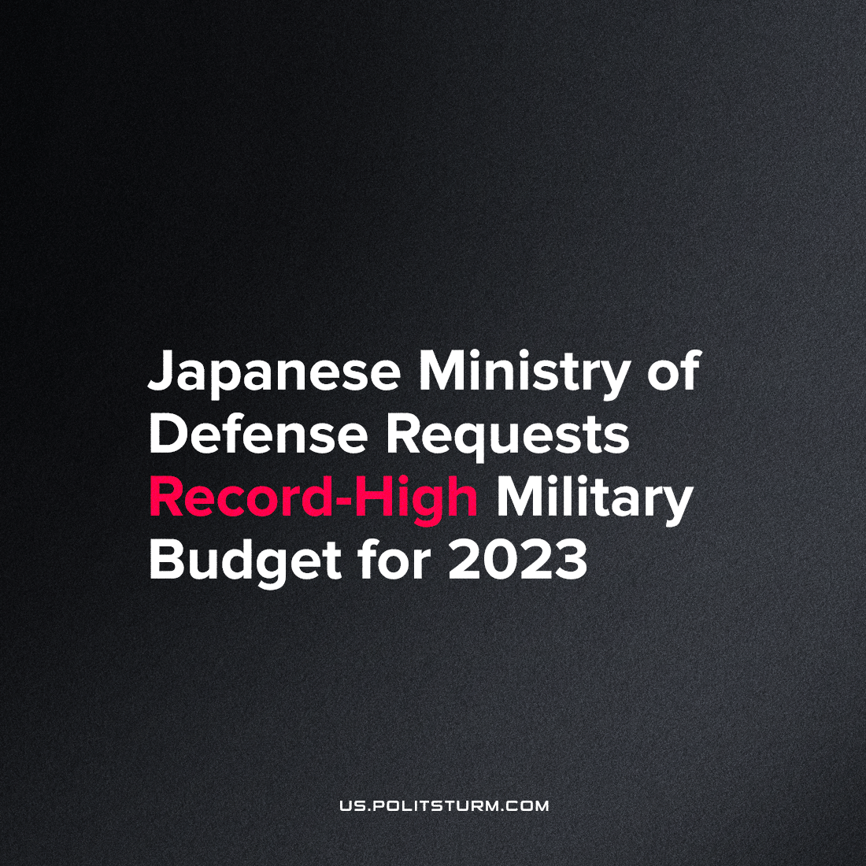

Original article
2022-09-07
1 min read

The Ministry of Defense of Japan requests around $40.4 billion for the new fiscal year (from 1st April 2023 to 31st March 2024). The budget volume would become the largest in the country’s history, if accepted.
According to the draft, it is planned to improve air self-defense and anti-missile protection systems. The ministry marked that it is necessary to upgrade destroyers equipped with American combat information and control system Aegis. Another share of the budget is planned to be allocated to the research in hypersonic missile interception, unmanned aerial vehicles (UAVs) development, cybersecurity and development of radio-electronic control systems.
The ministry added that the requested sum is only a part of the costs, those which can be disclosed. Another 100 projects require more funding which is not specified. The Japan Times mentions it to be significantly more than before. According to NHK, part of the costs will be associated with upgrading “ground-to-ship” missiles. The installation of new equipment from the US will increase the range of such missiles to 900 km (currently, it amounts to around 100 km).
Capitalist states worldwide are energetically inflating their already enormous military budgets, preparing to protect their interests against competitors represented by other countries.
The cost of this “necessary” “defense” of national interest cuts into workers’ livelihood, who will inevitably become expendables for them in the long run.
Here is what Lenin said about it:
“In thousands of ways, in thousands of newspapers, from thousands of pulpits, they shout and clamour about patriotism, culture, homeland, peace, and progress — and all to justify new expenditures of tens and hundreds of millions of rubles for all manner of weapons of destruction — for guns, dreadnoughts, etc.”

Original article

