Italy is Preparing the Ground for its Militarization
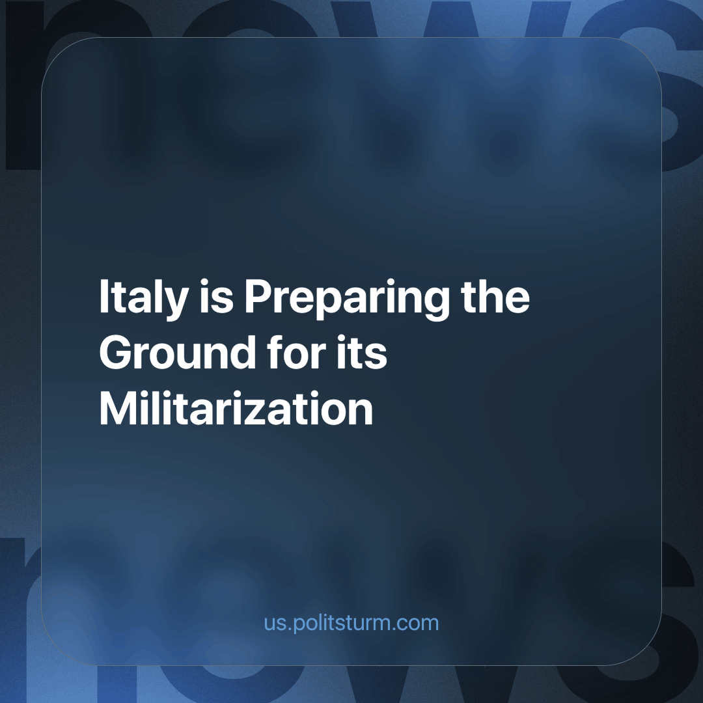

Original article
2024-04-26
3 min read

Andrea Margelletti, president of the Italian Cesi (Centre for International Studies), has expressed his concerns about Italy's security and its military underdevelopment. He has pointed out that war may be inevitable due to growing tensions, particularly in relation to the situation in Ukraine. Andrea Margelletti, warns that Italy is not sufficiently prepared from a defensive point of view and that additional investments in defence and an increase in the size of the armed forces are urgently needed. The importance of political involvement in a possible European military alliance and the need to be prepared for a deterioration in the political arena are noted.
It should be noted that Margelletti defends the interests of the Italian ruling class and the NATO bloc, using slogans about defending democracy to justify future militarisation and restructuring of the armed forces. He calls for active participation in international alliances and agreements, pointing to the need for political decisions on participation in coalitions and additional investment in the defence industry to upgrade weapons. This implies increased public spending on rearmament and partial mobilisation.
Italy is facing deepening contradictions - as shown by the renewed repression of students and demonstrators in Rome. These militaristic changes in the national economy will inevitably lead to crises and negative consequences for the already fragile Italian economy. The strengthening of the military industry will lead to shortages of basic necessities and lower wages for workers; education, medicine and other sectors of national importance will also suffer. Workers will be increasingly exploited, organisations opposing these reforms will be repressed and the existing so-called Italian communist parties cannot give the working class the right theoretical direction and leadership and are already playing into the hands of the ruling class. And this situation mirrors that of almost every other European country. The bourgeoisie will do anything for profit, even the shedding of blood. First and foremost, the companies that supply weapons, armed equipment, etc. will make super-profits out of all this.
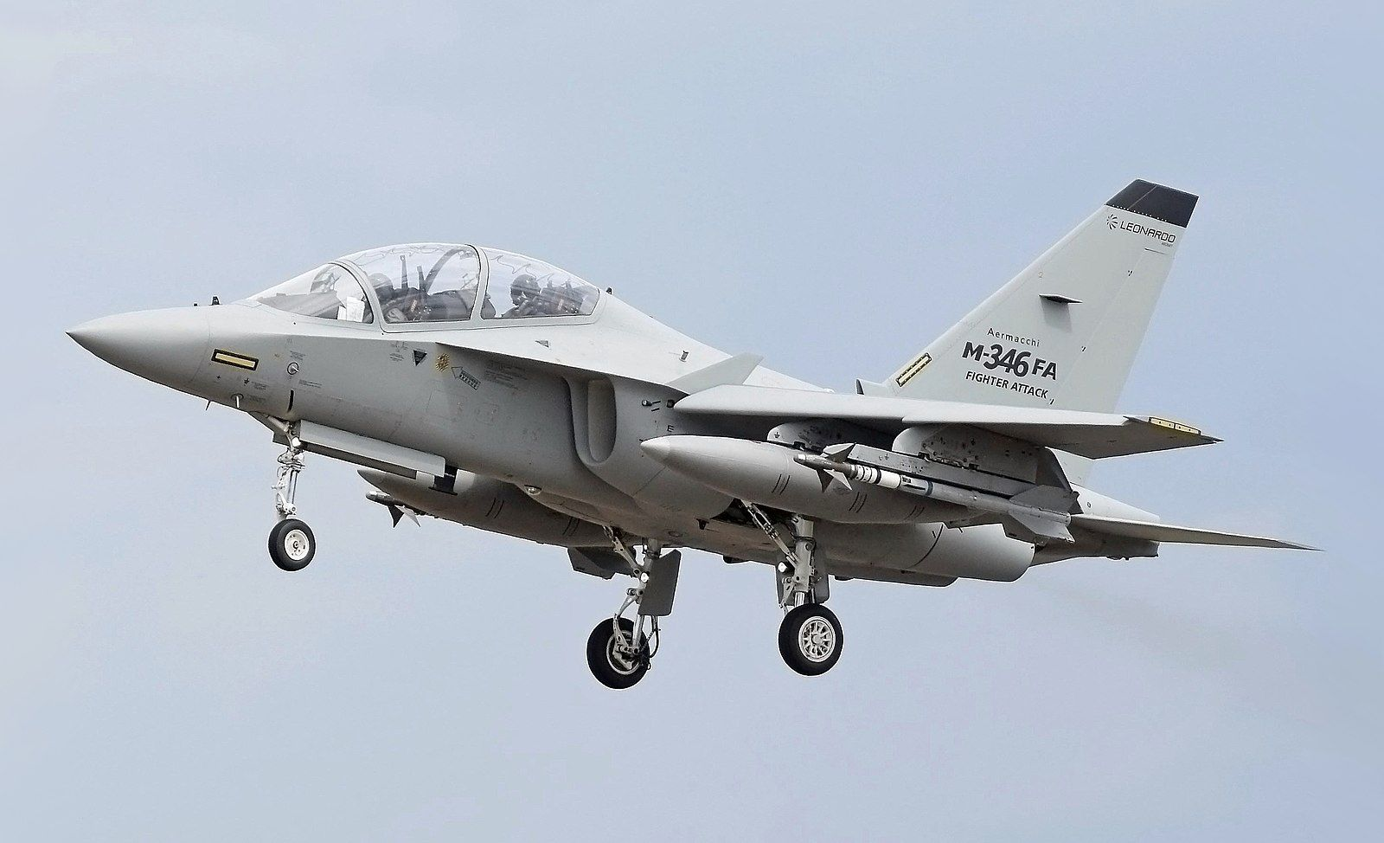
Italian Arms company Leonardo pulled in a revenue of €15.3 billion in 2023
In this context, the Italian elections to the European Parliament look like an opportunity for the ruling class to adopt the right-wing contingent on the issue of Italy's foreign policy and its prospects for reorienting the economy along militarist lines. In this respect, Margelletti's speech fits in perfectly with bourgeois propaganda, where rhetoric about the defence of the nation is in reality the defence interests of capital. This position of the capitalist elites, which is aimed at achieving their strategic goals at the expense of the working class for the implementation of the war programme, proves more and more that they discuss no real freedom for the vast majority of people, no democracy will ever be given to the workers.
"As long as there are working men, property-owners are in a position to profiteer, and indeed, as property-owners, are compelled to profiteer. We declare that there is no equality, that the well-fed man is not the equal of the hungry man, that the profiteer is not the equal of the working man." - Lenin, Ninth Congress of the R.C.P.(B.)
This tangle of contradictions that we can observe can not be resolved within the existing capitalist order. In order to solve them, we must first recognise the systemic reasons for all the events that are taking place, in order to understand the problem. Anyone who wants to change the situation can take part in the Communist work of educating themselves and the masses around them. Only conscious workers under the leadership of a genuinely Communist Party can radically change the situation.
Source:
milanofinanza.it - “L’Italia entrerà in guerra ma non è pronta: è l’allarme di Andrea Margelletti”

Original article

