Italy Takes a Step Forward in Establishing a Police State


Original article
2024-10-10
4 min read

On Sept. 18, the Chamber of Deputies approved Government Bill (DdL) 1660, known as the “Security” decree, with 162 votes in favor, 91 against and 3 abstentions [1], which, if approved by the Senate, would further transform the Italian state apparatus into a police state [2][3][4]. Now, therefore, the law is being considered in committee, after which it moves to a vote in the Senate. The law, however, is de facto already in use.
Precisely with the passage of the law:
- There will be criminal offenses, with penalties of up to 2 years in prison for those who organize or participate in roadblocks or strikes;
- All protests in prisons and CPRs (immigration centers) will be punished with penalties of up to 20 years in prison;
- Protests against infrastructure projects will be criminally sanctioned and punishable by jail time;
- Propaganda mentioning struggle (e.g. struggle against pollution, against dictatorship, against fascism or Meloni) will be considered “terrorism of speech”, with penalties of up to 6 years in prison;
- Occupations of property, vacant houses, or support for them will carry penalties of up to 7 years, with a sentence of up to 15 years for those actively resisting;
- Police personnel will be allowed to possess a second personal weapon, even off duty;
- Immigrants without permits will not be able to use cell phones and the purchase of SIM cards will be tied to the regularity of the residence permit;
- Article 18 includes light cannabis (used in various medicinal practices) as a narcotic substance.
The liberals claim that “democracy is in danger” because of these measures, but in reality, they only create an appearance of concern, because the democracy they are in such a hurry to defend is the democracy of the minority of property owners (and thereby the dictatorship of capital). It has and can only make things worse for the working class and improve those of the ruling class. It is precisely through their beloved liberal democracy that Meloni was elected and this bill passed.
Of course, bourgeois democracy has played a progressive role as it was an improvement over feudalism or absolutism, but it remains a democracy for the minority of capitalists who freely buy and sell politicians and in whose interests these politicians act. As capital centralizes in fewer and fewer hands, more and more workers are driven into desperate poverty, and as the capitalists prepare for a new war for the re-division of the world, they increasingly dispense with even the facade of democracy and resort to repression and eventually terror in order to maintain their rule. This is the process of fascization, that is ongoing throughout Europe.
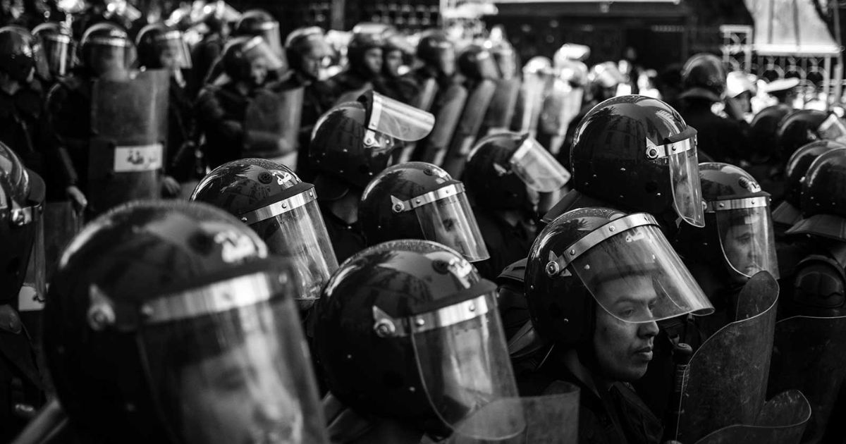
The improvement of living conditions and the development of socio-economic formations are two interconnected processes, they condition each other. Their development revolves around the class struggle and the replacement of one ruling class with another more progressive one. The more humanity accumulates knowledge and technology, the more advanced and free each subsequent system becomes. In class societies, rights are won only through struggle, and the outmoded ruling class and their system must be deposed. Capitalism, now, acts as a fetter on production and a brake on all real social progress. Production is overwhelmingly social, yet its fruits are privately appropriated largely by just a handful of billionaires.
The Italian “opposition communist” parties begin their activities with abstract slogans such as “against DdL 1660” [5]. We believe that such slogans are meaningless because they do not reveal the causes of the fascization of the country - which lies in the rule of capital. These so-called “communist parties” cover up the class essence of the state in naively believing that the state institutions alone (the Senate and the Chamber of Deputies) can be effective in opposing such laws if they include representatives of “leftist” parties and movements. This is a profoundly mistaken idea:
“[...] governments in capitalist society are but committees of the rich to manage the affairs of the capitalist class.” — James Connolly, The War Upon The German Nation.
The lack of a unified Marxist-Leninist theoretical basis and weak and fragmented organization lead to serious mistakes, which manifest themselves in the use of ineffective methods of struggle. That is not to say that Communists cannot utilize parliament under favorable historical conditions, for means of propaganda, fighting for reforms that assist the workers’ struggle while aligned with the end goal.
It is necessary to struggle “with one’s head one’s shoulders”, taking into account the study of the theory of revolutionary struggle, and the workers’ long-term goals and interests, and not succumbing to adventurism or reformism.
"Without revolutionary theory there can be no revolutionary movement." — Vladimir Lenin, “What Is To Be Done?”
While the other parties call for noisy actionism that will only make the situation worse, it is more important than ever to unite the struggles of the working class under a single theory that reflects their interest and will lead them to victory. This will only be possible under the leadership of a communist party that defends the interests of the working class and shows the right way to achieve its goals, however, such a party does not exist in Italy or in most countries around the world. We appeal to all conscious workers, not just from a single country but from each country, to join our organization to study the theory and prepare to transform the world.
Sources:
[1] camera.it - “Atto Camera: 1660”;
[2] senato.it - “Atto Camera n. 1660”;
[3] senato.it - “Atto Senato n. 1236”
[4] articolo21.org - “Stato di polizia” dated September 19, 2024;
[5] ilpartitocomunistaitaliano.it - “Contro il DDL 1660 sulla pubblica sicurezza” dated September 19, 2024.

Original article

