Italian Transport Workers Strike
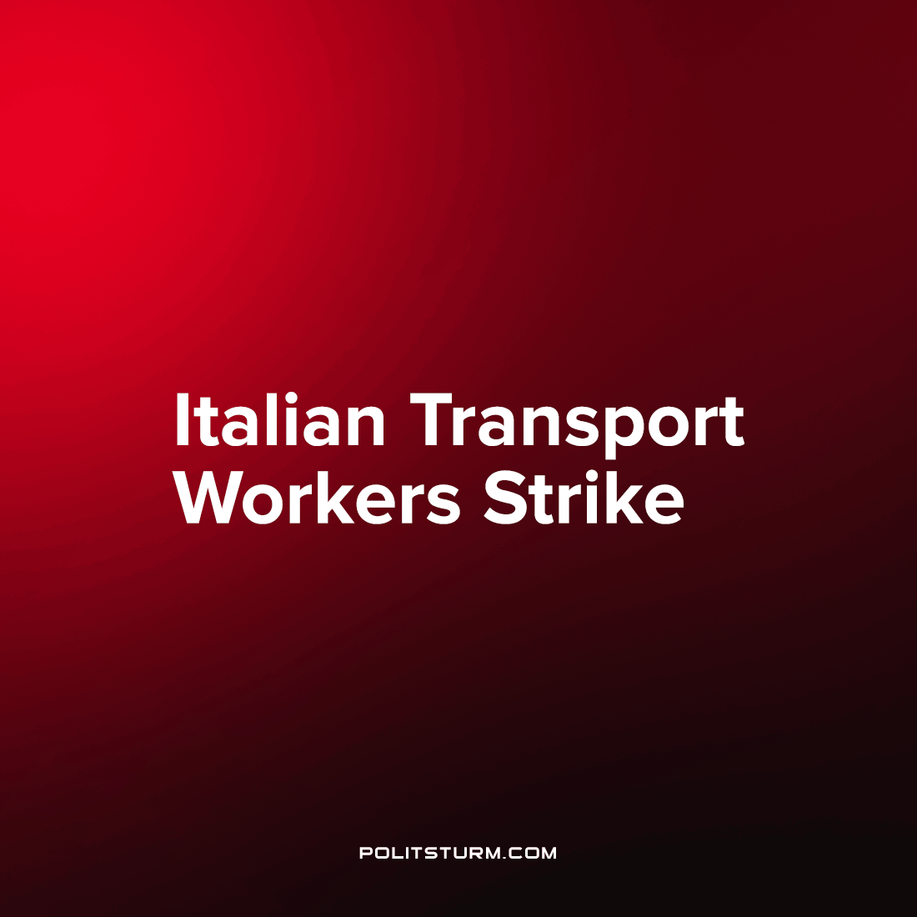

Original article
2022-10-22
1 min read

Friday October 21st, workers in the transport sector went on strike throughout Italy. Pilots, flight attendants, airport employees, railway workers, bus drivers and other public transport workers have supported the action.
Transport workers went on strike after an unsuccessful attempt to negotiate with the administration of various companies to increase employees’ wages. The day before, on October 20th, a meeting was held between representatives of the Italian trade unions FIM-CISL, UILM, FISMIC, UGLM and AQCF and representatives of automotive, engineering and transport companies. However, new agreements were not reached, as management refused to increase employee salaries despite the country’s record-high inflation rate (9% per annum this September).
The strike of transport workers has disturbed communication across Italy. In the north-eastern part of the country, in Friuli-Venezia Giulia and Veneto regions, railway workers stopped working for 8 hours. Buses stopped running through the streets of Rome from 8:30 am to midnight local time.
RyanAir, Al’Italia, Wizz Air, EasyJet, and Volotea airlines across Italy have seen their workers go on strike for 24 hours, causing more than 800 flights to be cancelled. In a joint message, the unions FILT-CGIL, FIT-CISL and Uiltrasporti apologized to all passengers affected by the strike. At the same time, they explained the need for the strike and warned that they would continue to protest until they achieved their goals.
The situation in Italy shows that the class interests of workers and capitalists are contradictory – the bourgeois class grows rich through exploiting the working class, and so they order their managers to keep their fist shut tight around wages. Strikes allow workers to assert their rights, to force the owner’s hand to open his wallet, but they can only lead to temporary improvements in living and working conditions. Qualitative changes can only be achieved when power passes into the hands of the working people and socialism is established.
Source: 1, 2, 3

Original article

