Italian Fascist Terror Plot Tied to Azov
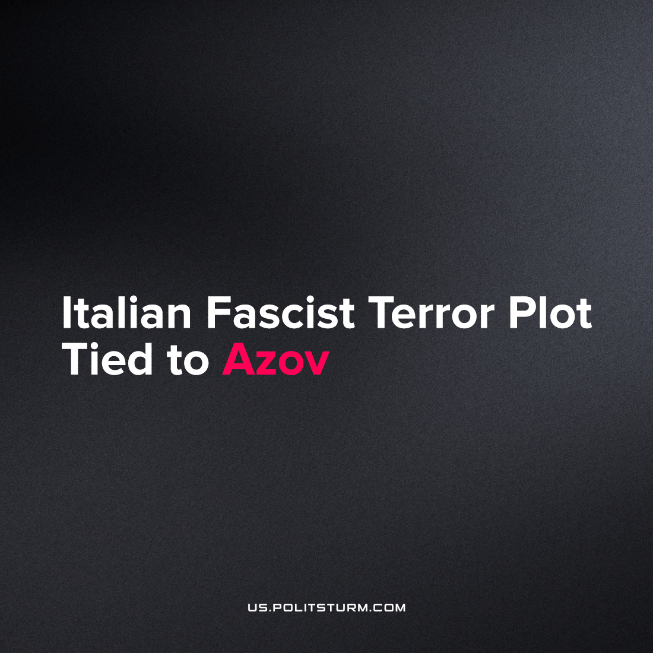

Original article
2022-12-09
1 min read

Police in the Italian region of Campania announced the arrest of four people on charges of planning a terrorist attack in Marigliano, near Naples. The suspects are members of the 'Order of Hagal', an organization that professes the ideology of neo-Nazism, white supremacy and Holocaust denial. For planning terrorist acts against civilian and police facilities, a criminal case was opened against the group.
According to available information, the 'Order of Hagal' maintains ties with Ukrainian neo-Nazis. One of those arrested, 25-year-old Giampiero Testa, was responsible for coordinating terrorist attacks with Ukrainian nationalists. In the course of the investigation, it turned out that during the arrest of Italian citizens, accomplices from the Azov battalion fled from Italy into Ukraine.
It is not surprising that the fascist organizations of various countries collaborate to carry out subversive activity and spread terror among the people trying to get power. Despite their rhetoric of national 'chosenness', the fascists are, in fact, expressing not the interests of the nation, but of capital. Being usually founded by national capitalists of different scales, they are often used to resolve "uncomfortable questions" or to impose their will. Therefore, on the way to power, they naturally cooperate with representatives of the interests of the capital of other countries.
At the same time, fascists are trying to delude the working class with ideas of racial superiority to distract them from their real enemy – imperialism. In order not to be misled, the working class must expose the harm that fascist ideology causes for working people and wage a consistent class struggle against these puppets of capital. We cannot be fooled that the liberal state will be our defense against these forces when we understand the capitalist roots of fascism.
Sources: 1, 2, 3

Original article

