Italian Prime Minister Strikes a Deal with Chinese President
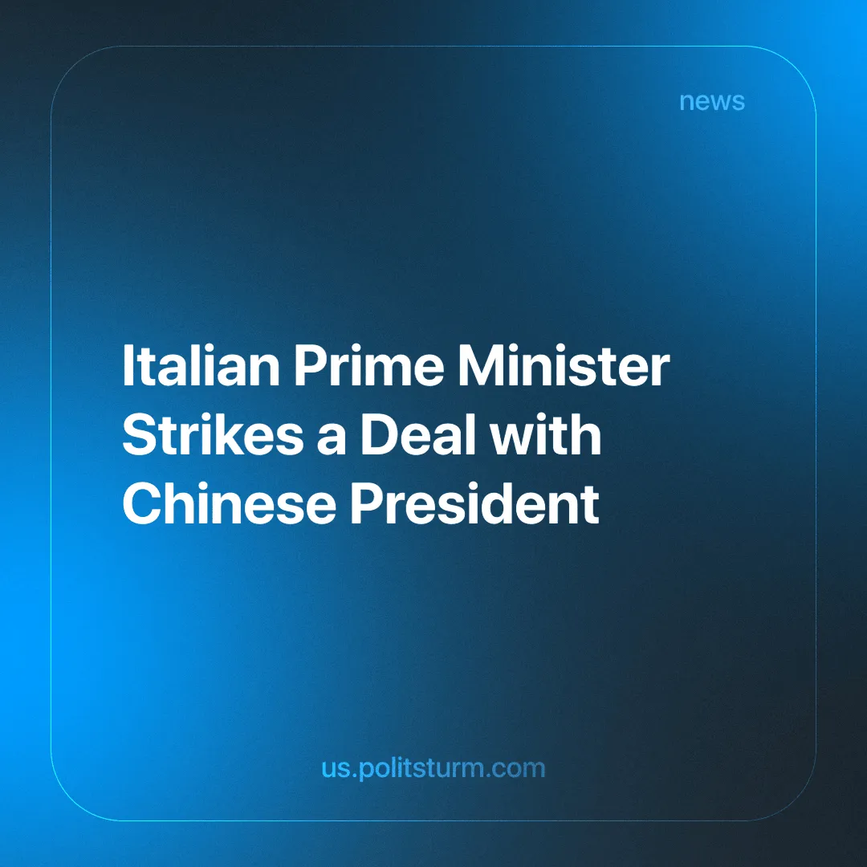

Original article
2024-08-06
3 min read

The meeting between Prime Minister Giorgia Meloni and Chinese President Xi Jinping marked a very important milestone in Italian-Chinese relations. After Italy's controversial withdrawal from the Belt and Road Initiative (BRI), the meeting in Beijing on July 28, 2024, was aimed at improving and strengthening relations [1] [2]. The BRI, China's comprehensive infrastructure program for the development of the New Silk Road, was adopted by Italy in 2019, the only G7 country to do so. However, due to pressure from Washington and Brussels and growing concerns about growing economic dependence on China and its political influence on the globe, it was abandoned in 2023.
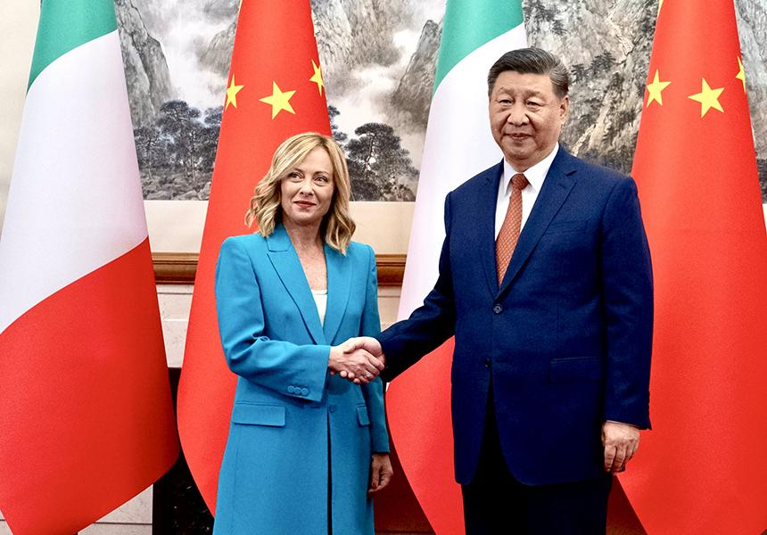
During the meeting, the two leaders signed a three-year economic agreement to promote cooperation in strategic sectors such as renewable energy, electric vehicles and artificial intelligence. Meloni particularly stressed the importance of balancing investment between the two countries, calling for greater equity in trade, as Chinese investment in Italy is currently significantly lower than Italian investment in China. In addition, the agreement provides for collaboration in areas such as manufacturing, aerospace and the creation of new technologies.
An economic forum was also held during the visit, attended by leading Italian companies such as Pirelli, ENI and Leonardo, as well as representatives from the luxury sector Dolce & Gabbana. The event provided an opportunity to assess new opportunities; in particular, Italy showed interest in attracting investment from Chinese electric car manufacturers. This is in line with the recent collaboration between Stellantis and Chinese startup Leapmotor [3] [4].
The issue of trade tariffs imposed by the European Union on Chinese products, primarily on automotive equipment, is the latest sore point. These tariffs have been implemented in response to accusations of dumping against China, that is, selling its products abroad at prices below cost in order to dominate the market. Although Italy agreed with these measures, the meeting was an opportunity to take measures and possible solutions to improve trade relations between the two countries involved.
The meeting between Giorgia Meloni and Xi Jinping is nothing more than a meeting between each county’s representatives of capital seeking favorable deals to maximize profits and maintain and advance their position on the hierarchy of global economic dominance by monopolies. The signing of the three-year cooperation plan gives Italian capital access to advanced resources and technologies at favorable and below-average prices.
By using such methods, particularly dumping, to enter foreign markets and create economic dependence in importing countries, Chinese imperialist (monopoly) capital seeks to consolidate its influence on the world economy. These kinds of methods of economic competition will lead to the further concentration of production and the displacement of competing producers, which will continue to open the way for Chinese monopolies. Through the export of goods and capital, these dynamics strengthen China as a world economic power and allow it to expand its sphere of influence both economically and politically. In particular, they are starting to make Italy semi-dependent on Chinese capital and producers.
Interestingly, in recent months Meloni has been careful not to mention China, Taiwan and the Indo-Pacific crises, which now have a global impact and are no longer limited to the Asian quadrant. This is just one demonstration of the geopolitical and ideological interconnections in which a country takes a neutral stance on sensitive issues such as Ukraine and Taiwan, in order to gain favorable financial and economic deals, even when talking about a deal with a country formerly belonging to an enemy bloc of political and economic influence. The same is true for China in its relations with Russia [5], as China itself seeks to benefit by avoiding US sanctions.
Only with a socialist planned economy run by workers to meet the needs of the vast majority of the population will they be able to eliminate the influence of foreign monopolies as it will not be dependant on foreign investment. This is because it can develop unprofitable (but necessary) heavy industry which is the basis for real national independence. To do this, the proletariat must take as its main task to build a communist party to lead the workers toward socialism. This is a task for both the Italian proletariat and the international proletariat. Our organization is already working in that direction, join us.
Sources: 1|2|3|4|5

Original article

