Issues in Russian Healthcare
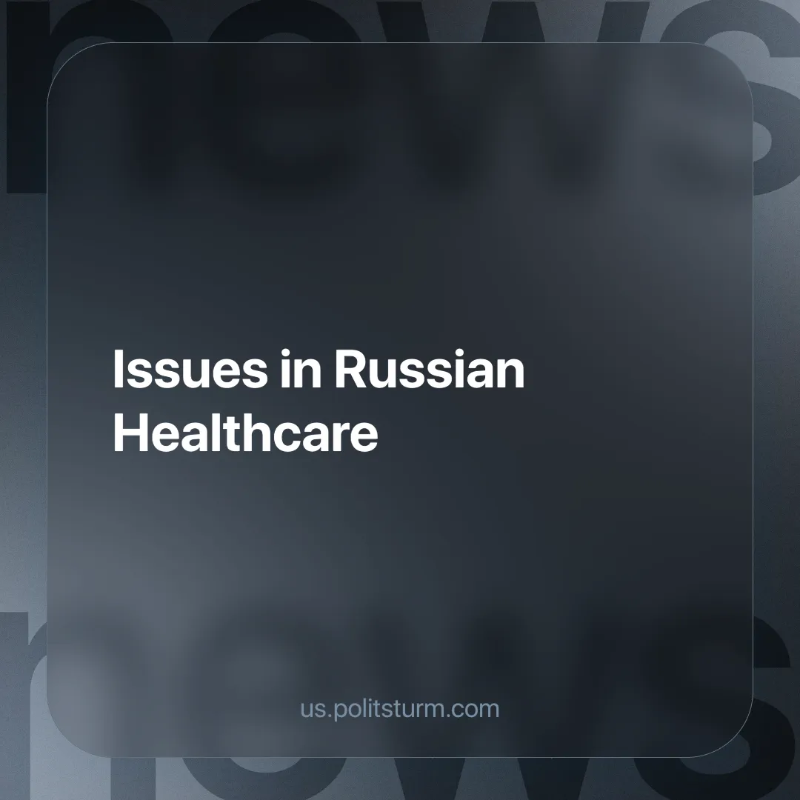

Original article
2025-01-01
5 min read

Russian healthcare continues to face several challenges that highlight the shortcomings of the current management and financing model. One of the most pressing issues is the salaries of medical staff. A case in point is the situation at the Moscow Region Ambulance Service, where more than 700 employees reported a decline in income [1].
They claim that their salaries have been delayed since July 2024 and that they have already lost between 10,000 and 50,000 rubles ($98-$492) per month. The medical workers accuse the management of violating labor laws and demand a reassessment of incentive payments, which are calculated using unfavorable coefficients. This situation raises broader questions: what are the real working conditions for medical workers in the municipalities and why are their grievances not being addressed at the local level?
The widespread issues of healthcare staffing are corroborated by data from other regions. For instance, in Yamal (a region of Russia), doctors express concerns regarding the violation of labor rights and the establishment of the “universal nurse” role, which is linked to staff reductions [9]. New positions are created without considering the actual need for personnel, and incentive payments are calculated with inaccuracies.
Such a policy focused on reducing costs instead of enhancing the quality of medical care leads to dissatisfaction among employees. Even affluent areas, like the Moscow Region, are not immune to the issue of staffing shortages. Although the authorities in the Moscow Region report the recruitment of 560 physicians through the “Bring a Friend” program [3], this initiative evidently does not address the problem at its core but merely redistributes the deficit among regions.
The issues of salaries and layoffs are not the only concerns; they also manifest within the pharmaceutical system. Currently, approximately 70-75% of active pharmaceutical ingredients used in Russia for drug production are imported [2]. This reliance on foreign suppliers for pharmaceutical substances renders Russian medicine susceptible to external economic shocks and political sanctions.
At the same time, the number of global challenges, such as drug resistance, is increasing. According to the World Health Organization, in 10 years, approximately 45 million people will die each year due to drug-resistant infectious pathogens [4]. In Russia, the situation is worsened by the irresponsible use of antibiotics, particularly in agriculture.
These complex issues necessitate a strategic approach, an active scientific inquiry, and the mobilization of all state efforts to address them. However, the commercial inefficiency in developing new medicines and reliance on imports threaten the health of every Russian citizen. Given these circumstances, along with ongoing price hikes and the impoverishment of the majority of Russian citizens, the outlook for the future appears grim.
Meanwhile, the government's methods of financing specific areas of health care also raise concerns. The Russian Orthodox Church suggested financially incentivizing doctors to focus on pregnancy management rather than abortions [5]. This proposal, grounded in an analysis of labor remuneration, indicates that current tariffs render abortion more lucrative for medical institutions than pregnancy management.
Information from the Pirogov Russian National Research Medical University (RNRMU) indicated that 1.8 million abortions were expected to be performed in 2022, aligning with this [6]. Such statistics sparked discussions about the moral and social aspects of this issue. Contemporary embryonic biology is actively employed in bourgeois debates about the "beginning of life," diverting attention from real material conditions. Addressing the issue of abortion from an ethical or biological perspective is a tactic used by capitalists to mask the low-income levels of the population, the lack of social support, and their inability to ensure access to quality healthcare.
Against the backdrop of these discussions, the Ministry of Health released a forecast: by 2030, an additional 180 thousand births are anticipated in Russia due to in vitro fertilization (IVF) [8]. This data illustrates the potential of reproductive technologies while also highlighting the necessity for enhanced state support for families and young parents. The pressing issue of accessibility and efficiency in emergency care demands immediate action from the government.
In the Oryol region, residents express frustration over lengthy waits for emergency medical assistance, which in some instances result in tragedies [7]. While local authorities discuss social payments for doctors, it is clear that this is insufficient. A similar scenario is noted in Altai, where deputies are once more addressing the need for increased compensation for ambulance personnel [10]. Regional initiatives, however well-intentioned, necessitate systemic support at the federal level.
All these facts converge to a singular conclusion — the healthcare system is in a state of profound crisis. Medical workers, patients, and society as a whole expect not reforms from the state, but a fundamentally new approach to organizing healthcare, centered on the needs of people. Contrary to this, the government's actions are focused on saving budget funds, achieved through the infamous "optimization".
This can also account for the decline in the incomes of medical workers, the reduction in staff and bed capacity, and the closure of polyclinics and dispensaries [1][7][9][10]. Such “reforms” have resulted in the flight of personnel from the public sector to the private sector, leading to a shortage of doctors and nurses in medical institutions [11]. These facts indicate that only commercial medicine is advancing, and not everyone can afford its costly paid services.
A socialist society has no commercial medicine. Instead, the system of free public health care is enhanced, ensuring that no individual is deprived of assistance due to financial constraints. The state assumes responsibility for planning and control, facilitating the uniform training and distribution of personnel and logistical resources nationwide. The rise in the number of doctors and nurses is accomplished through investments in education, targeted training programs, and improved working conditions.
Socialism addresses the root of the issue — private property as the legal foundation for appropriating the fruits of public labor to amass profit, which is the current economic objective. Instead, the primary principle shifts to caring for human beings and their health. Capitalist healthcare invariably serves the wealthy. The market will never resolve the issues faced by those who cannot afford it. Socialism, on the other hand, enables the establishment of a system where every citizen, regardless of their place of residence or income level, receives quality medical care.
To resolve the shortage of personnel, the wage gap, and the persistent underfunding of healthcare, we must establish socialism. Only then will quality healthcare no longer be a luxury and an unreachable dream for everyday people.
Sources:
[1] Medical Russia — "More than 700 employees of the Moscow Region ambulance station complained about a decrease in salary levels" — December 2, 2024.
[2] GxPnews — "About 70% of pharmaceutical substances in Russia are imported" — November 20, 2024.
[3] Medical Russia — "Authorities in the Moscow Region reported that they have lured 560 medical workers from other regions to their hospitals" — November 29, 2024.
[4] TASS — "The Russian Academy of Sciences predicted a mortality rate of 45 million people due to drug resistance" — November 27, 2024.
[5] Medical Russia — "The Russian Orthodox Church proposed financially incentivizing doctors to focus on pregnancy management rather than abortions" — November 28, 2024.
[6] Medical Russia — "The Pirogov Russian National Research Medical University reported 1.8 million abortions performed in 2022, calling it 'the destruction of human life'" — November 28, 2024.
[7] Medical Russia — "The Oryol Health Department announced the availability of social benefits for hospital doctors in response to reports of a shortage of ambulance medical staff" — November 28, 2024.
[8] Medical Russia — "The Ministry of Health stated that by the end of 2030, an additional 180,000 children will be born in Russia, but with the help of IVF" — November 28, 2024.
[9] Medical Russia — "Doctors from several hospitals in Yamalo-Nenets complained about layoffs amid the introduction of the 'universal nurse' position" — November 28, 2024.
[10] Medical Russia — "Altai deputies will again request an increase in payments to ambulance staff — this region has submitted the most video appeals to Putin" — November 27, 2024.
[11] Orgzdrav — "On the main problems of healthcare in the Russian Federation and measures to address them" — April 2023.

Original article

