Israel Passes Death Penalty Law for Palestinians
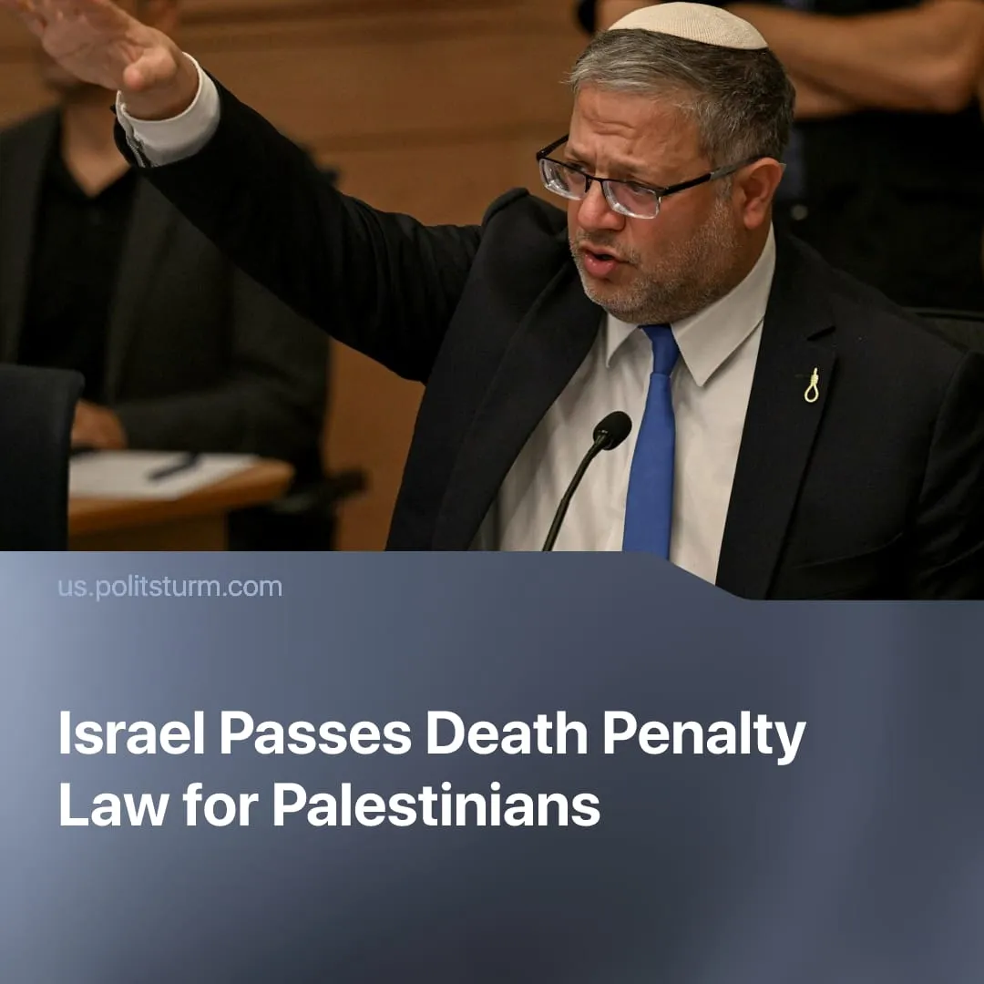

Original article
2026-04-15
2 min read

Far-right Israeli parties have passed a law imposing mandatory death sentences on West Bank Palestinians in military courts.
Details. The law mandates execution by hanging for Palestinians in the occupied West Bank who commit a fatal attack deemed an act of terrorism, with cases handled in military courts and a mandatory death sentence issued after conviction, to be carried out within 90 days with limited appeals. At the same time, prisoners tried inside Israel could have their sentences commuted to life imprisonment. The law does not apply to Israelis.
► It was passed by the Israeli legislature (Knesset) on March 30, 2026, by 62 votes to 48, backed by the governing coalition of Benjamin Netanyahu, including Likud (The Consolidation) and far-right parties such as Otzma Yehudit (Jewish Power), while opposition parties, including Yesh Atid (There is a Future) and Labour, voted against.
► Supporters presented it as a deterrent against future attacks, while opponents warned it would increase tensions and fail to improve security. 2024 polls indicate a 64.9% majority support among Jewish Israelis for the death penalty in such cases.
► The law drew international verbal condemnation. The EU called it “very concerning”, and UN officials warned it “violates international humanitarian law,” and urged them to repeal it, while eight muslim-majority governments in the region released a joint declaration, calling it a “dangerous escalation” that risks further inflaming the conflict.
► Far-right National Security Minister Itamar Ben-Gvir led the campaign around the law, declaring “whoever chooses terrorism chooses death”, using a noose symbol during debates and celebrating its passage publicly with champagne.
Context. The ruling Israeli nationalists are exploiting the broader destabilisation of the Middle East to manufacture nationalist hysteria, weaponising the fear of an internal and external Arab threat to bind the Israeli population to its expansionist agenda. Calls by figures like Ben-Gvir to expand the war to Turkey and Qatar reflect the continued demands of Israeli capitalists to sustain permanent conflict.
► Hamas’ provocative October 7 attack and the consequent offensive on Gaza directly fortified Netanyahu’s government, giving the far-right the cover to implement fascistic measures that previously faced mass resistance, such as militarization of civilians, media control, and personal device control.
► This law represents a continuation and acceleration of this process, building on an existing system of repression in which thousands of Palestinians are held in Israeli prisons, with over a third detained without trial.
For a deeper analysis of the US-Iran conflict, see the Marxist position on this subject: The Middle East: Architecture of War.

Original article

