Is Marxism Still Relevant Today?
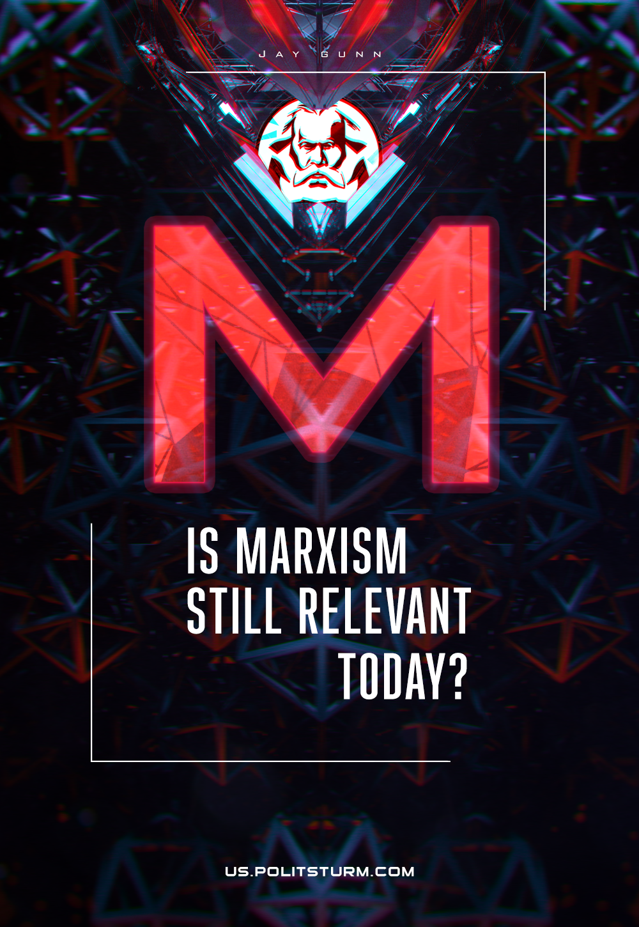

Original article
2021-11-01
14 min read

The last thirty years has brought more rapid historical and material changes than any other period in recorded human history.
Among the most significant was the dissolution of the socialist countries’ block culminating with the disintegration of the Soviet Union in 1991.
The Cold War was declared over in 1992 through which U.S. global influence no longer faced a serious challenge. The United States and its sycophantic allies and puppet regimes have experienced the unprecedented spread of its cancerous accumulation of financial and commercial markets without hindrance or serious threat.
Capitalist ideologues like to position themselves over the fragments and shards of the formerly socialist organized societies and claim victory for capitalism. They come even to the point of declaring that the end of human progress and history has been reached as capitalism ushers in a global utopia. The apologists for the deeply flawed and destructive ordering of society by capitalism smugly boast that Marxism has failed and that it is no longer relevant and is consigned to the garbage heap of history. Is it really so? Let’s take a look at the modern society.

The Modern Economy and World Politics
As the capitalists of all countries imposed their will on the exploited workers, the resulting reaction brought about social, economic, political, military crisis to the U.S. and the world such as the 9/11 attacks of 2001 and domestic social unrest. Further, the American and allied response to such attacks has resulted in the destruction of nations, refugee crisis, human rights violations, repression of political opponents at home and abroad, and the revocation of many bourgeois liberal rights in the name of protecting liberty.
Other capitalist blocs, such as the European Union, began to form as the seeds of new conflicts and struggles for labor, resources, and global profits took root and arose from these conditions.
During these last thirty years, the capitalist organization of economy has experienced its characteristic economic, social, and politically destructive cycles bringing greater economic inequality between the bourgeois capitalist ruling class and those presently in subjugation to them. The wealth, welfare, and political influence of those who possess vast amounts of capital has increased exponentially while the wealth, welfare, and political agency of the middle and lower strata of society has decreased. “According to Oxfam, the wealth divide between the global billionaires and the bottom half of humanity is steadily growing. Between 2009 and 2018, the number of billionaires it took to equal the wealth of the world’s poorest 50 percent fell from 380 to 26. Those with extreme wealth have often accumulated their fortunes on the backs of people around the world who work for poor wages and under dangerous conditions.”¹
Human Rights Watch observes, “For many residents living in poverty, certain human rights are out of reach. They may lack access to safe work conditions, housing, education, health services, or clean water and basic sanitation. They may be unable participate in political life or vindicate their rights in court due to their poverty. They may also suffer unequal treatment or discrimination due to their status as poor people. Finally, they may face unfair burdens of debt and unequal treatment due to state and local governments’ growing reliance on offender-funded systems of criminal justice. The persistence of these problems and of poverty…is unconscionable.”²
Since the 1980’s we have observed the rapid increase of the influence of corporate monopolies upon global markets, public policies, international relations, and of societies themselves. According to a 2018 New York Times article four media and tech giants, including Facebook and Google, spent a combined $55 million on lobbying to influence U.S. lawmakers and to protect their monopolies. Despite the anti-trust rhetoric by Congressional leaders, many took their ease and pleasure compliments of these capitalist titans.³
Throughout the world the governments of nations, though boasting of their freedoms and democracies, have become the servants of capitalists and not those of the majority of people as state monopoly capitalism has become dominant. Capitalist money funds and thereby influences, if not outright controls, candidates, parties, and public policies, particularly in the United States.
In his treatise “Imperialism: The Highest Stage of Capitalism,” written over a century ago, Vladimir Lenin accurately and relevantly stated that “state monopoly in capitalist society is merely a means of increasing and guaranteeing the income of millionaires…”.⁴ Lenin, through the analytical means of Marxism, wrote “As long as capitalism remains what it is, surplus capital will be utilised not for the purpose of raising the standard of living of the masses in a given country, for this would mean a decline in profits for the capitalists,…”.⁵
A majority of Americans now agree that large political contributions prevent Congress from acting in the interests of the citizens of the U.S. in such critical and urgent issues such as overhauling health care, global climate change, housing, and fully funding necessary social programs.
Furthermore, well before the conglomeration of various sectors of production and finance, Marxist theory heralded the ascension of the capitalist oligarchs who, by means of financial manipulation, would extract immense profits from the labors of workers and from the coffers of governments as well as gain effective control over world economies.
Open Secrets, a website dedicated to following money in politics, states that “The primary goal of much of the money that flows through U.S. politics is this: Influence. Corporations and industry groups, labor unions, single-issue organizations-together, they spend billions of dollars each year to gain access to decision-makers in government, all in an attempt to influence their thinking.”⁶
In 2020, for example, lobbying spending, that is the amount of money used to influence policymakers to act in favor of corporate interests, reached $3.53 billion. Among the top lobbying spenders were the National Associate of Realtors, Pharmaceutical Research and Manufacturers of America, Amazon, Facebook, and Blue Cross/Blue Shield.
Not far behind are U.S. defense industry giants such as Raytheon, Lockheed Martin, and Northrop Grumman. Additionally, “although the influence powerhouses that line Washington’s K Street are just a few miles from the U.S. Capitol building, the most direct path between the two doesn’t necessarily involve public transportation. Instead, it’s through a door—a revolving door that shuffles former federal employees into jobs as lobbyists, consultants and strategists just as the door pulls former hired guns into government careers.”⁷
In a 2017 article titled “Corporate Capture Threatens Democratic Government,” Liz Kennedy writes: “Currently, the domination of big money over our public institutions prevents government from being responsive to Americans. This certainly is not a new phenomenon—but it is growing.”⁸
Insofar as it concerns the freedom, representation, and political power of the working class, we can see that it is authoritarian predatory and imperialistic capitalism, not Marxism, that subdues and subverts the political influence and agency of the proletariat by seizing for itself control of the government for its own interests. Karl Marx and Friedrich Engels stated in the Communist Manifesto that “the bourgeoisie has at last… conquered for itself, in the modern representative State, exclusive political sway.”⁹
The twentieth century marked a turning point from the domination of industrial capital to the domination of finance capital; a dominance that has now subverted, subsumed, and has brought almost every form of democracy under its unaccountable imperialistic control.
Does any of this sound like progress or liberty for the mass of the working class?
Yet, when viewed with an honest critical eye, we know that all of this is far from the situation.

Are We Living in a Better World?
The world has entered into a cataclysmic environmental crisis, due in no small part to capitalism’s reckless disregard and exploitation of the resources and the planet, that has kicked off a mass extinction event and will inevitably lead to climate, social, political, and economic instability.
Can it be said, then, that capitalism has brought the world into a better epoch?
Bourgeois apologists of capitalism and historical revisionists perpetuate the claims that life within the U.S.S.R. and other socialist grounded countries was oppressive and totalitarian without any forms of democracy. These false claims not only obscure and distort the broad range of social benefits, freedoms, and democracy within these nations, they deflect critical and public attention of the bourgeoisie and the forms of state repression employed against the workers in order to preserve their political, economic, and social control.
How do we begin to interpret and make sense of these times of chaos, instability, and upheaval? How did we get here and where are we headed?
Under the gaily colored veneer presented as unity, freedom for all, the end of history, or the final and successful epoch in human and social development, lies capitalism. Understanding the capitalist structure and formation of most societies is necessary for accurately identifying and decoding the social, economic, and political dynamics that are presently at play.
The timeless proposition of Marxism, as summarized by Friedrich Engels is thus:

“That in every historical epoch, the prevailing mode of economic production and exchange, and the social organization necessarily following from it, form the basis upon which it is built up, and from that which alone can be explained the political and intellectual history of that epoch; that consequently the whole history of mankind (since the dissolution of primitive tribal society, holding land in common ownership) has been a history of class struggles, contests between exploiting and exploited, ruling and oppressed classes; That the history of these class struggles forms a series of evolutions in which, nowadays, a stage has been reached where the exploited and oppressed class – the proletariat – cannot attain its emancipation from the sway of the exploiting and ruling class – the bourgeoisie – without, at the same time, and once and for all, emancipating society at large from all exploitation, oppression, class distinction, and class struggles.” ¹⁰
The key to correctly and properly understanding the capitalist dominated world as well as the pathway to real human emancipation, progress, and social stability is found in Marxism.
Marxism exposes the reality of capitalism’s parasitism and anti-social toxicity. Indeed, in the preface to Capital, Marx writes that “It is the ultimate aim of this work to lay bare the economic law of motion of modern society, i.e., capitalist, bourgeois society,”¹¹
Presciently, Marx’ analysis of the development of capitalism led him to observe that capitalism perverts and subverts all previous social and economic orders leading to “naked, shameless, direct, brutal exploitation” in the name of “free trade.”¹² Throughout the world today, millions are subjected to capitalist exploitation and social reorganization in obvious and obscure expressions.
Through Marxist examination, a clearer, accurate view of the social, economic, and political conditions of the world emerges. For instance, from observing the material conditions of the relationship between capitalism and humanity, we understand that capitalism seeks to bring the whole of global humanity under its dominion and create “a world after its own image”¹³ and that nearly all the world’s social, economic, and political turmoil is a result of the inherent crisis that is characteristic within capitalist economic relationship. Throughout the development of capitalism, at every stage of its development, Marx’ theoretical and historical analysis of capitalism has proven correct.
This has become possible thanks to the philosophical and scientific cornerstone of Marxism, developed by Marx and Engels and commonly termed dialectical materialism. Joseph Stalin described dialectics in this way: “This dialectical method of thought, later extended to the phenomena of nature, developed into the dialectical method of apprehending nature, which regards the phenomena of nature as being in constant movement and undergoing constant change, and the development of nature as the result of the development of the contradictions in nature, as the result of the interaction of opposed forces in nature. In its essence, dialectics is the direct opposite of metaphysics.”¹⁴
Dialectical materialism asserts that all matter and phenomena is integrally connected and is in constant motion. Furthermore, these phenomena, whether material or social, often act in contradiction to other forces with which it is connected. Therefore, when considering subjects such as history, economics, politics, social phenomena, etc. they “should be considered not only from the standpoint of their interconnection and interdependence, but also from the standpoint of their movement, their change, their development, their coming into being and going out of being.”¹⁵ “In its proper meaning,” Lenin says, “dialectics is the study of the contradiction within the very essence of things.”¹⁶
Through dialectical materialism, then, we are capable of a rational understanding the rise and collapse of empires, and socio-economic structures throughout history as well as determining the interplay, struggle, and procession of present economic, social, material, and political conditions and factors. Dialectical materialism is the clearest and most rational way to comprehend the nature of things, their interplay, contradictions, antagonisms, and eventual change from one form into another. This practical scientific method remains accurate and invaluable for analyzing and interpreting history and as a guide through contemporary social, economic, and political conditions.

Is Marxism Obsolete?
While it is true that certain characteristics of social relations change according to the material conditions that influence them, the basis – the capitalist economy – remain. There remains those who extract profits from those who produce commodities and services without participating in that production themselves. There yet remains the bourgeois class who stand over and aloof from those who perform the labor of manufacturing and production.
While capitalism has changed in certain ways as it attempts to mitigate its own contradictions and crisis, including wars of imperialist aggression, the perversion of political systems, inequality and so forth, it continues to be capitalism, retaining all the characteristics and dynamics that Marx, Engels, and Lenin observed and explained.
Attempts to make Marxism appear irrelevant and the erasing class distinctions, even in the twenty-first century, is an effort to blunt, weaken, and dissolve class struggle against capitalism. History has clearly demonstrated that the only successful means to change this situation and establish a better, more just, and equitable world, is through the application of Marxism-Leninism by the revolutionary proletariat. Where the principle theories of this liberating social order have been practically applied, societies experienced the rise in literacy, increases in lifespan, technological advances, full employment, the enjoyment of basic human rights such as accessible and free medical care, housing, as well as greater political agency by the working class.
The transition to a new social formation is not an easy task. This is a difficult struggle of the working people, who are the only people capable of establishing these necessary changes to the existing order.
While the task of struggle and building new formations of social and productive relations is difficult and not without sacrifices, the cost is much less than what has already been paid by the working class while under the subjugation and exploitation of capitalism.
Fundamental to the liberation of the working class is unbreakable ideological, strategic, and tactical organization and solidarity, in step with the development and work of sound Marxist-Leninist theory and practices under the advocacy and assistance of an ideologically disciplined Communist party.
Marxism-Leninism, as history clearly presents, remains the way forward into the better world.
REFERENCES
¹ https://inequality.org/facts/global-inequality/
² https://www.hrw.org/united-states/poverty-and-economic-inequality
³ https://www.nytimes.com/2019/06/05/us/politics/amazon-apple-facebook-google-lobbying.html
⁴ “Imperialism: The Highest Stage of Capitalism” – V.I. Lenin. https://www.marxists.org/archive/lenin/works/1916/imp-hsc/index.htm
⁵ ibid.
⁶ https://www.opensecrets.org/federal-lobbying/top-spenders
⁷ https://www.opensecrets.org/revolving/
⁸ “Corporate Capture Threatens Democratic Government” – Liz Kennedy
https://www.americanprogress.org/issues/democracy/news/2017/03/29/429442/corporate-capture-threatens-democratic-government/
⁹ Manifesto of the Communist Party – Karl Marx & Friedrich Engels https://www.marxists.org/archive/marx/works/download/pdf/Manifesto.pdf
¹⁰ ibid.
¹¹ “Capital,” Vol. One – Karl Marx https://www.marxists.org/archive/marx/works/1867-c1/part0.htm
¹² “Manifesto…”
¹³ ibid.
¹⁴ “Dialectical and Historical Materialism” -J.V. Stalin https://www.marxists.org/reference/archive/stalin/works/1938/09.htm
¹⁵ ibid.
¹⁶ “Philosophical Notebooks” p. 265 – V.I. Lenin

Original article

