Islamic Revolutionary Guards Sanctioned by Canada
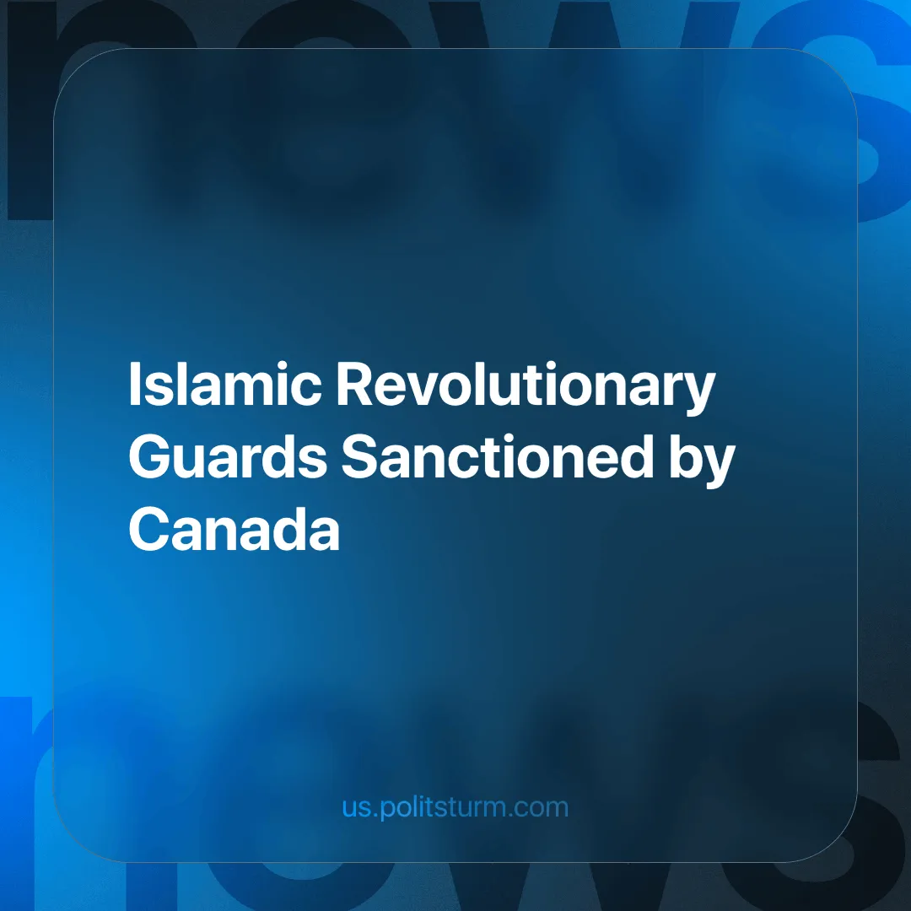

Original article
2024-06-28
2 min read

The Islamic Revolutionary Guard Corps (IRGC) has been officially sanctioned by the Canadian government. While Canada is not the first Western government to sanction the IRGC (it was designated as a terrorist organization by the U.S. in 2019), this represents a more competitive rivalry between the Western and Iranian ruling classes, as Canada has been considered a relatively safe haven for offshore accounts and assets by the Iranian bourgeoisie [1].
Although the Quds force, a branch of the IRGC, was previously designated a terrorist entity by Canada, Ottawa has apparently only recently discovered that the whole organization has "support for terrorism" and displays a willingness to disrupt "the international rules-based order" [2].
Founded by Ayatollah Khomeini immediately after the victory over the Pahlavi regime, the IRGC was initially tasked only with ideological defense and propagation of the 1979 Islamic Revolution. However, it has grown into a capitalist military-industrial entity active throughout West Asia [3]. For this reason, this designation is merely a measure of the broader project of replacing the current Iranian rulers with a group of capitalists aligned with America.
This fact coupled with recent talks for a more comprehensive cooperation pact between Iran and the Russian Federation in the "very near future" [4] signals an accelerating escalation in the inter-imperialist rivalry.
As Vladimir Lenin observed nearly 110 years ago;
"An essential feature of imperialism is the rivalry between several great powers in the striving for hegemony, i.e., for the conquest of territory, not so much directly for themselves as to weaken the adversary and undermine his hegemony" - Imperialism, the Highest Stage of Capitalism, Chapter 7
The Iranian bourgeoisie is no exception; it has been competing with the U.S. for hegemony in West Asia since 1979. This struggle is reaching a tipping point where the government in Tehran is planning to sacrifice the lives of the Iranian working class in an imperialist war, definitely in tandem with the Chinese and Russian states in their respective spheres. The alliances and battle lines are being drawn by the ruling capitalists for a new war for the re-division of the world.
Only by organizing in solidarity can the global working class prevent this coming carnage. The historical example of the Bolsheviks has shown us that revolutionary defeatism by workers and soldiers is the only correct course of action; that the workers of each country must view, as its enemy, its own ruling group of capitalists, instead of the workers of other countries.
However, it is not possible to carry out this measure without first building a class party of the proletariat, a task that remains unfinished in Iran.
Links: 1 | 2 | 3 | 4

Original article

