Child Laborers Rise to 3 Million in Iran
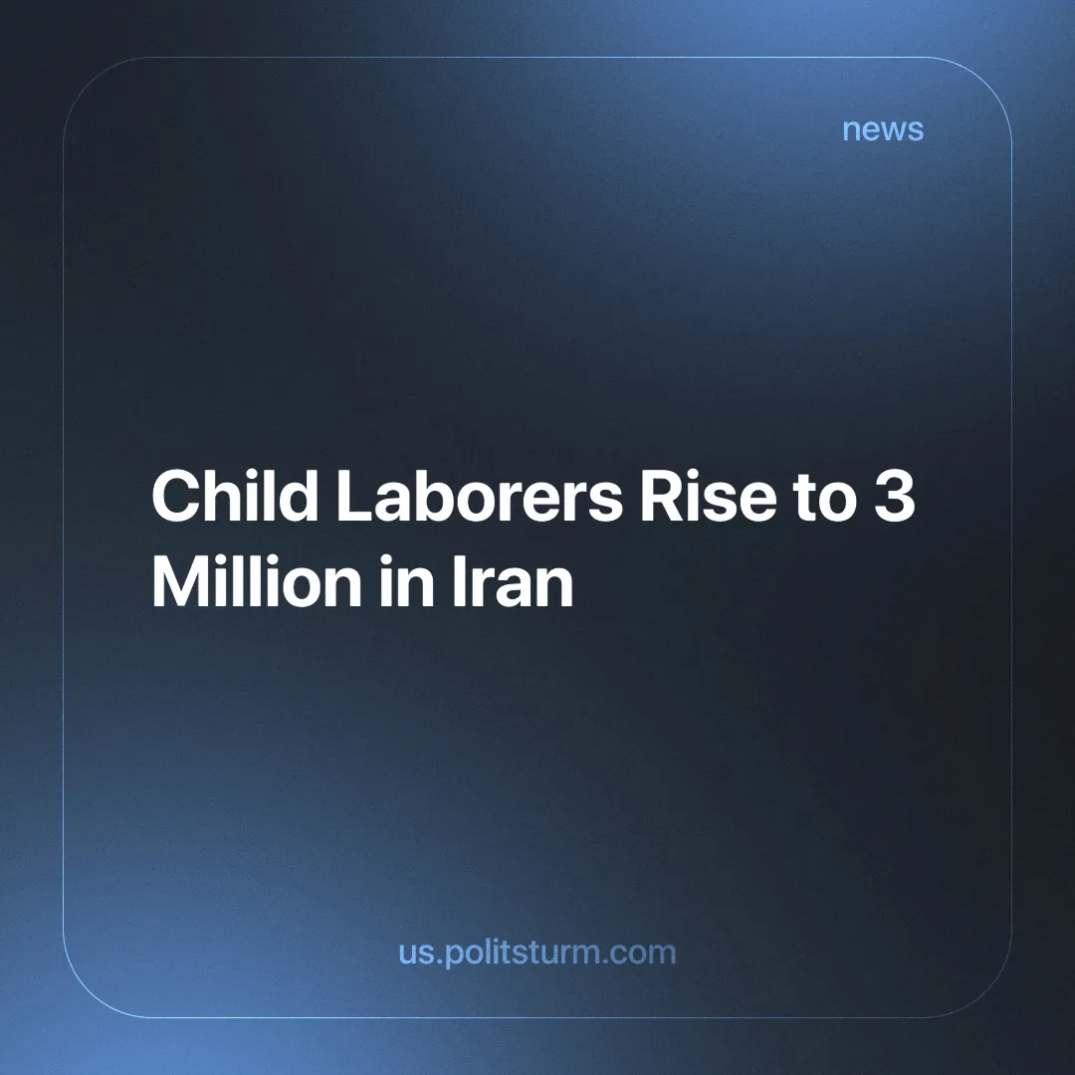

Original article
2024-06-23
2 min read

"The labor of women and children was, therefore, the first thing sought for by capitalists who used machinery." wrote Karl Marx (in Capital Volume 1, Chapter 15) almost two centuries ago about the inherent tendencies of Capitalism.
Child labor is a destructive phenomenon that has been declared illegal by many countries' ruling classes. However, it persists in practice because the socio-economic relations that gave rise to it remain intact.
The capitalists were never particularly compassionate about the lives of the child workers.
"… modern industry, on the other hand, through its catastrophes imposes the necessity of recognising, as a fundamental law of production, variation of work, consequently fitness of the labourer for varied work, consequently the greatest possible development of his varied aptitudes. " - Marx, Capital Vol 1, Chapter 15, Section 9.
Some of them saw an opportunity to reserve the childhood of the future proletariat for the purposes of basic education (to operate more advanced means of production) and indoctrination, while the technical necessities of other means of production compelled others to exploit children in this way.
It is estimated that 3 million child laborers exist in Iran [1], an astonishing fact for a state that could afford the largest shopping mall in the Middle East [2].
The state that Iranian child laborers find themselves in is not arbitrary. The capitalist system has led millions to desperation - as the wealth of the capitalists is built by the exploitation of the workers. Similarly, because labor is bought and sold on a market by them, there will always (in all capitalist countries) be many people who face long-term unemployment and are desperate for work. That is precisely why the Iranian child laborers come from families whose means of subsistence has become garbage collection, as their situation is dire, and they have few other prospects.
Exploited to the hilt, they are forced to scavenge for garbage on the streets of Tehran or, alternatively, to enlist in the Basij, the nationwide Islamist militia in Iran that helps suppress street protesters in times of emergency [3]. Similarly many of these child labourers are exploited by organized criminals to do menial work for little pay.
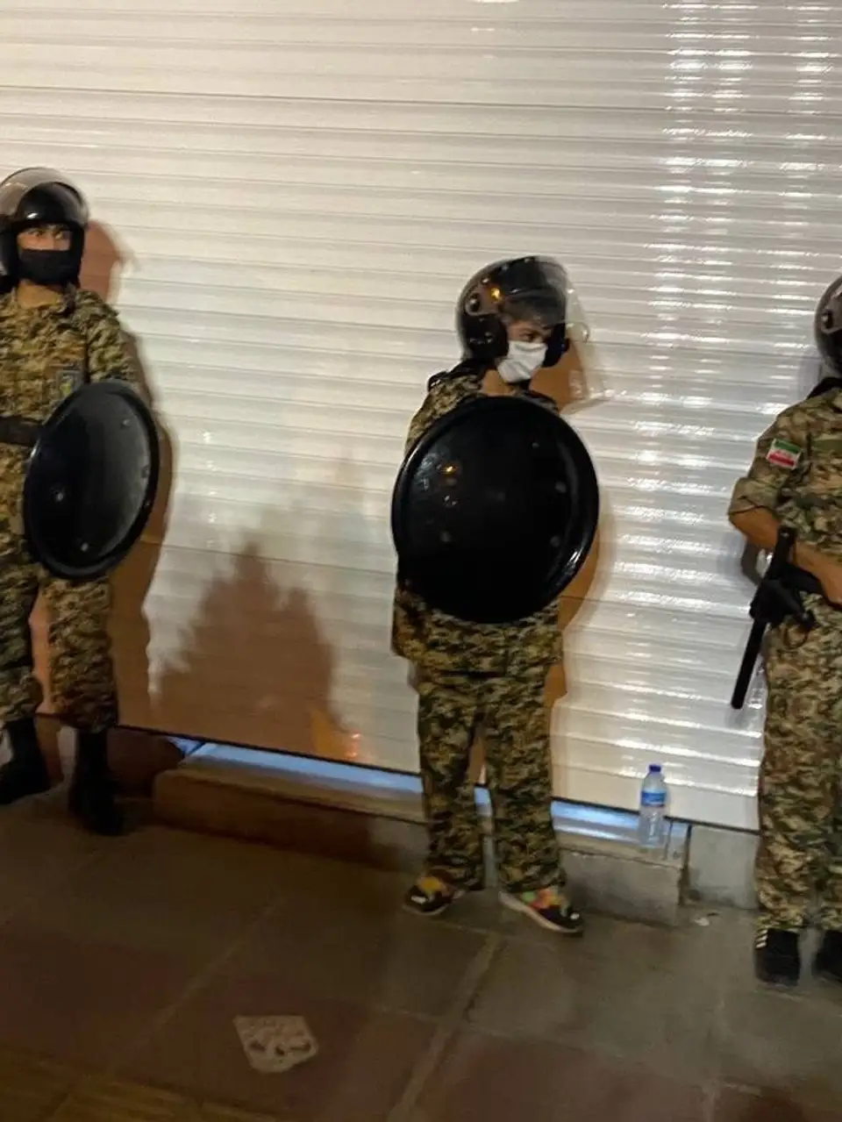
The working child is marginalized and hidden away to not offend the bourgeois mind, while the rich kids of Tehran study in elite schools and grow up to boast about their "self-made" success under the spotlight. It is only by removing such class distinctions that we can really abolish the labor of children in practice, not just in legislation.
Under socialism, with the absence of exploiting classes and the implementation of rational planned production and distribution management (for human use, and not exchange on a market), the collective labor of society is more than capable of providing for everyone. This is particularly the case when it comes to children, the future builders of a society where no childhood shall be stolen, bought or sold.
Links: 1, 2, 3

Original article

