'Iranians Ready to Sacrifice' Says Deposed Shah's Son
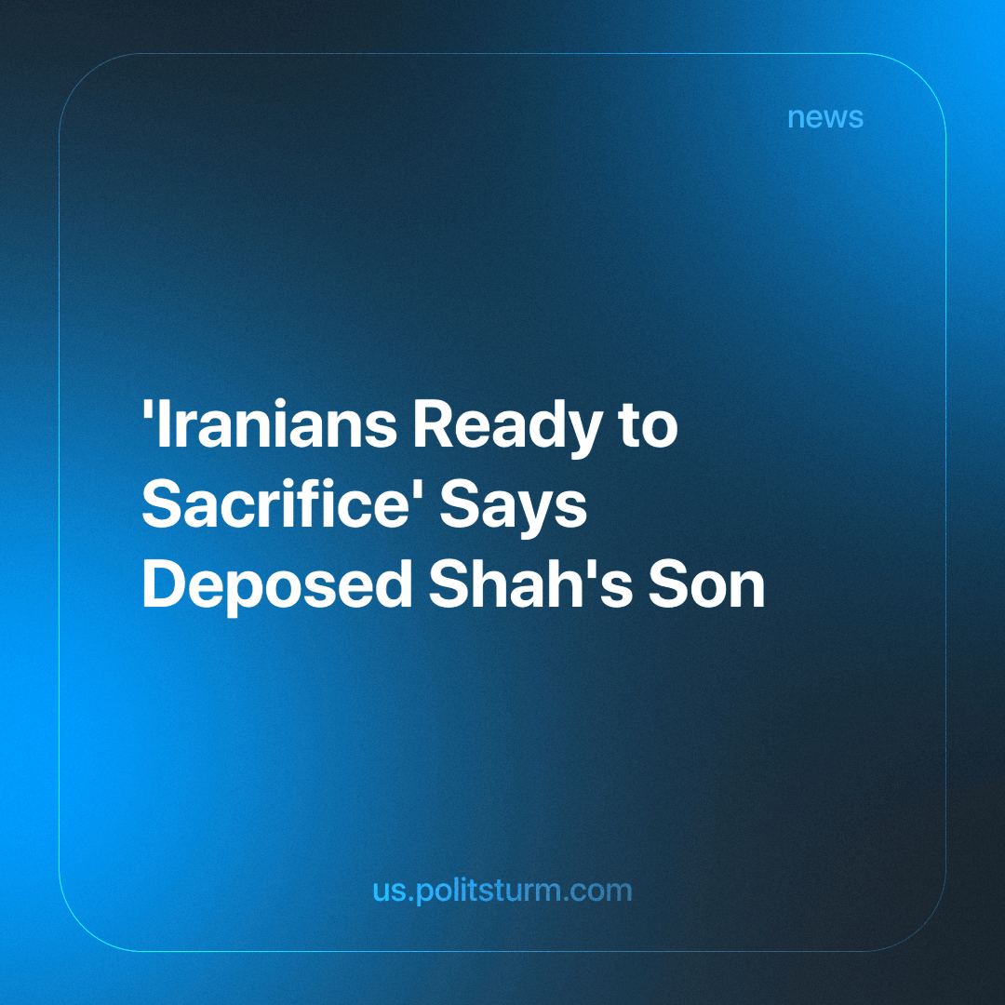

Original article
2024-06-16
2 min read

Over 4 decades have passed since a revolution in Iran overthrew the imperial state. However, the exiled Pahlavi dynasty hasn't lost all its relevance due to the possession of a huge amount of stolen state funds and the occasional media spotlight from Western and monarchist outlets [1].
The son of the last Shah, Reza Pahlavi, is living off what his father was able to steal, while calling for a US-backed regime change in Iran [2].
He has recently gone on a media tour [3] from US cable news, German tabloids, and UK broadcasters to Russian independent news stations or an Indian news channel. He has repeatedly proclaimed Iranians have reversed their previous stance on the legacy of the monarchy and that the younger generations want change!
Furthermore, Pahlavi asserts that the Iranian people are prepared to make sacrifices for a new 'revolution' to overthrow the Islamic Republic. It is clear that this foot soldier of Western imperialism is making a ridiculous claim. Iranians do not want to replace the mullah with the Shah. They want to abolish these outdated remnants of feudal relations that serve the bourgeoisie and do away with these ancient institutions.
He called out "radical Islamists and Marxists" for their "disproportionate exaggeration of facts" regarding SAVAK, the brutal secret police and intelligence service during his father's reign. Then, he went on to claim the intentions behind "exaggeration" by Marxists as being their "interest in discrediting the government, which was pro-Western and did not align with their ideologies" and concludes by delegating the task to bourgeois historians "to work this out".
Mr. Pahlavi is correct in stating that his father's regime did not align with Marxism. Marxists' immediate task was not only to denounce the repressions of the government, but to transfer power into the hands of the worker. Now that the working class has successfully overthrown his father's Western-backed regime, the only hope for our exiled prince to regain power lies in Washington, D.C. He has repeatedly called on "the world [i.e. western imperialism] to make a final decision on the subject [regime change]" [3].
The exiled Pahlavi prince is a pawn in the ongoing struggle between Western and Iranian capitalists. Will the USA succeed in reinstating a US-aligned group of capitalists to create another reserve for its interests in the Middle East? We don't know if they succeed or not, but we see that despite any of the sides winning, it's the workers, the broad masses of the people who lose anyway.
As long as the means of production are still privately held, the working class will be dominated by its national and international oppressors. The only real way of changing the system is through the social ownership of all means of production and the abolition of all class distinctions. However, the working class needs a Communist Party to lead them to this goal, and the task of forming such a Party in Iran has yet to be completed.
Links: 1, 2, 3

Original article

