Iranian Elections Upcoming: Who Will Succeed Raisi?
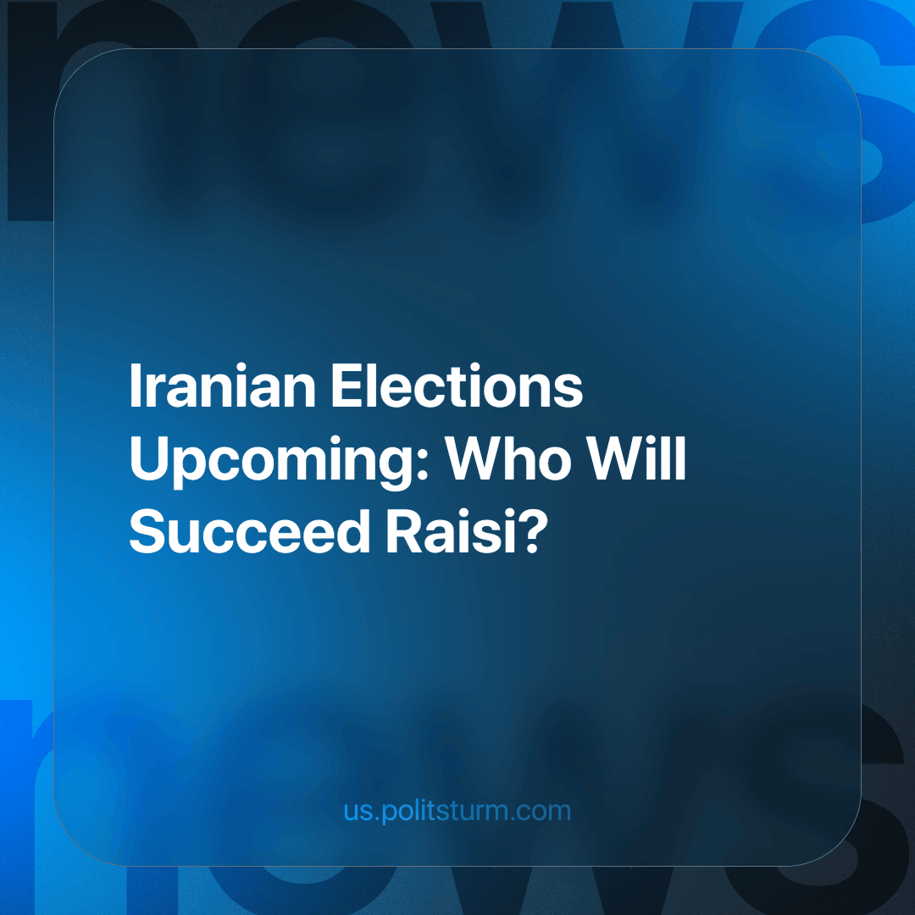

Original article
2024-05-31
3 min read

In the wake of President Ebrahim Raisi's sudden death, the Islamic Republic is gearing up for a pivotal election. With a real chance to succeed Khamenei, various factions and individuals are vying for the presidency, and the future direction of the country is at stake.
Given Ayatollah Khamenei's advanced age (born in 1939), the upcoming elections will not only determine the president but potentially the next Supreme Leader.
Raisi's death, contrary to what one might think, did not undermine the political order. The Islamic regime, with its extensive bureaucratic and military organization and a large network of officials numbering in the millions, will undoubtedly find a replacement for him without much difficulty.
The exact composition of the applicant pool is still unknown. Mohammed Mokhber, the vice president, has received approval from Ayatollah Khamenei to serve as acting president until the next scheduled elections.
With every Iranian over the age of 18 eligible to vote and voter turnout not mandatory, the unique blend of Iran's electoral system still has much in common with the Western model, but there are nuances. The 2021 presidential election saw a record-low voter turnout (48.8 per cent), reflecting the level of popular sympathy for the candidates. This is not surprising given the existence of a vetting process delegated to an appointed 12-member council of Islamic jurists called the Guardian Council. This council limits the pool of candidates to those who meet certain ideological criteria, such as being a male Shiite Muslim.
Once the election results are known, the Supreme Leader must sign the decree of the president-elect. If he refuses to sign, the president-elect doesn't take office. After that, the elected president must take an oath in a session of the Islamic Consultative Assembly. The oath includes a pledge to protect the official religion (Twelver Shia Islam), the Constitution and the Islamic Republic.
The Principlists, the currently dominant group, of which the late president was a proponent, with the support of both the Islamic Revolutionary Guard Corps (IRGC) and Khamenei himself, will most likely present the next president. Notable candidates are the current Majlis Speaker Ghalibaf and Tehran Mayor Zakani, who are committed to maintaining the status quo, resisting Western influence, and strict adherence to Islamic law. They represent the interests of the almost monolithic Iranian bourgeoisie in their struggle for dominance and control over the markets, labor and resources of the region.
On the other side of the spectrum (as thin as it is) are the "reformists". Once very popular with small business owners, college students and liberal feminists during the Green Movement of 2009. Former President Rouhani and his Foreign Minister Mohammad Javad Zarif were the latest culmination. The former was barred from running in the election, and the latter's intention to run is unconfirmed. They represent the hopes of a slim section of Iranian capitalists for rapprochement with the West, hoping to carve out a niche for themselves as profitable middlemen in the sale of their country.
Whatever their intentions and circumstances, the fuel subsidy cuts and the resulting 2019-2020 Iranian protests (the most violent and severe anti-government unrest since 1979) were the final nail in the reform movement's coffin.
There are also independent populists who appeal to the working and smallholder classes with promises of economic reform and social justice, often using nationalist rhetoric. However, they rarely differ significantly from the other trends. They had some success with the election of the former president Mahmoud Ahmadinejad, who was Principlist-adjacent.
In conclusion, the upcoming Iranian elections demonstrate the ongoing power struggle amongst sections of the Iranian capitalists. However, while the means of production remain in private hands, no matter which representative rules, they will inevitably represent the interests of capital. The only modern class capable of changing the system is the working class, as they directly produce social wealth, have the potential and interest in collective organization based on the consciousness of their class position, and their liberation requires the abolition of all class distinctions. However, the working class needs a Communist Party to lead them along this route, and the task of forming such a Party in Iran has yet to be completed.
Sources
https://www.president.ir/fa/113844
https://www.iranicaonline.org/articles/guardian-council
https://edition.cnn.com/2024/03/04/middleeast/iran-low-turnout-election-intl/index.html
https://www.nytimes.com/2019/12/01/world/middleeast/iran-protests-deaths.html
Abrahamian, History of Modern Iran, (2008), p.186

Original article

