Iranian Capitalists Seek US Détente After Humiliation in 12-Day War
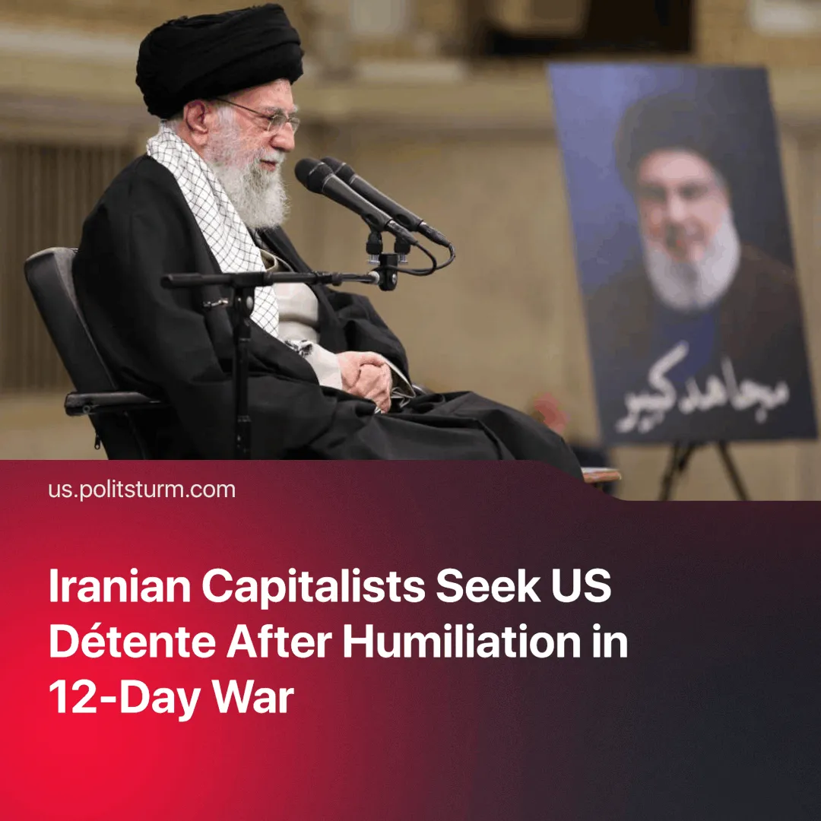

Original article
2025-07-13
2 min read

Despite US strikes in the “12-day war”, Iranian officials and economists have sought to establish ties with America.
Details. In an interview with Tucker Carlson on July 7, 2025, Iranian President Pezeshkian sought to downplay US involvement in the strikes, deflecting blame entirely onto Israel.
► On 8 July, Iranian Foreign Minister Araghchi accused Israel of sabotaging a 'historic breakthrough' in Tehran-Washington negotiations. However, Donald Trump had already acknowledged that the US was aware of Israel’s plans to strike Iran.
► That same day, 180 economists and high-profile officials issued a joint statement titled Time for a Paradigm Shift. Among the signatories were a former Minister of Roads and Urban Development (2012–2017), a leading architect of Iran's capital market, and other long-standing economic policymakers.
Quote: "Our strong recommendation is that in order to get out of the current situation, the path of diplomacy and constructive negotiations with the US and Europe be activated and the re-emergence of war and the continuation of economic pressure be prevented."
Context. Iran is experiencing the deepest and longest economic crisis in its modern history. Currently, between 27% and 50% of Iranians are living below the poverty line. "The country is like a powder keg, and further economic strain could be the spark that sets it off," an Iranian official told Reuters.
► Despite public condemnations of the US and Israeli strikes from Russia and China, neither country offered material support. Russia is busy with its so-called ‘Special Military Operation’ in Ukraine, and China is trying to avoid a crisis of overproduction. Additionally, Iran's network of proxies has been significantly weakened.
Important to Know. Tehran’s shift toward concessions reflects intensified pressure from the West. The ruling class aims to stabilise its grip on power and preserve its economic privileges. This is underscored by the dramatic increase in Iran’s dollar millionaire population—from 142,000 in 2021 to 246,000 in 2022—despite the country's economic freefall.
► In the broader geopolitical context, US imperialism is in decline, but this is not giving rise to a progressive alternative power. Multipolar rivalries are intensifying, and class struggles are sharpening. Iran's trajectory, unless it is condemned to a war of balkanization, reflects the broader reactionary consolidation of West Asian capitalist regimes such as Saudi Arabia, Turkey, and the UAE, which align themselves with US imperialist interests.
► During the conflict, the US and Israel had complete air superiority and remarkably targeted Tehran police HQ and an attack helicopter depot in Iranian Kurdistan. These sites were critical for internal repression and urban warfare. These strikes signal opportunities for military operations in Iran’s national minority regions, such as Kurdistan and Baluchistan. Therefore, the fragile truce could be broken by the US and Israel.

Original article

